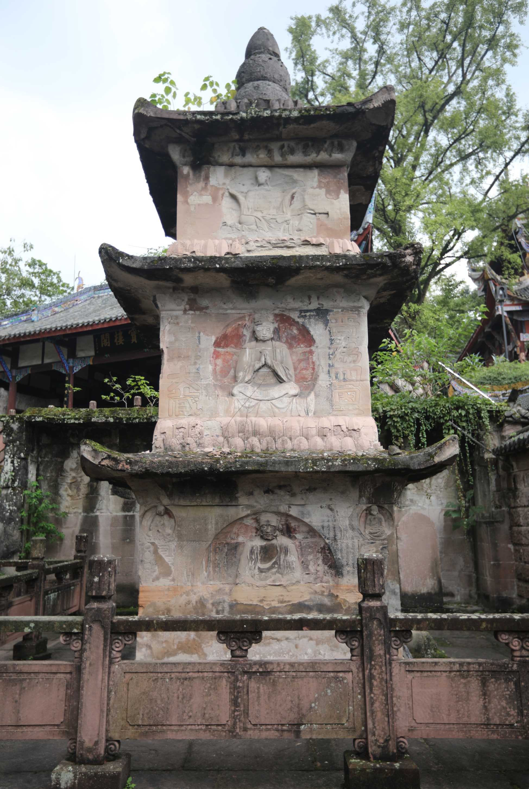
FIGURES
1. The Xiaofowan pagoda. Southern Song period. Photo, the author, 2019.
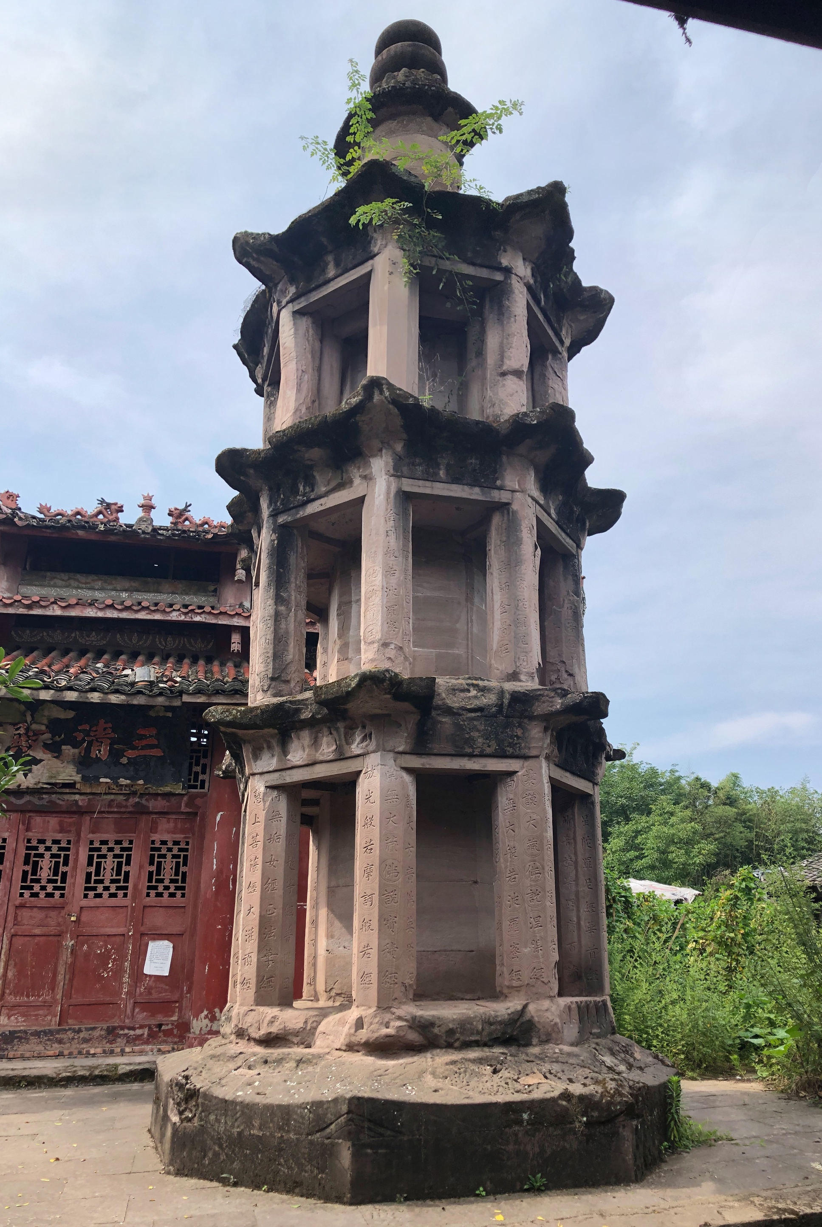
2. The Kongquedong pagoda. Southern Song period. Photo, the author, 2020.

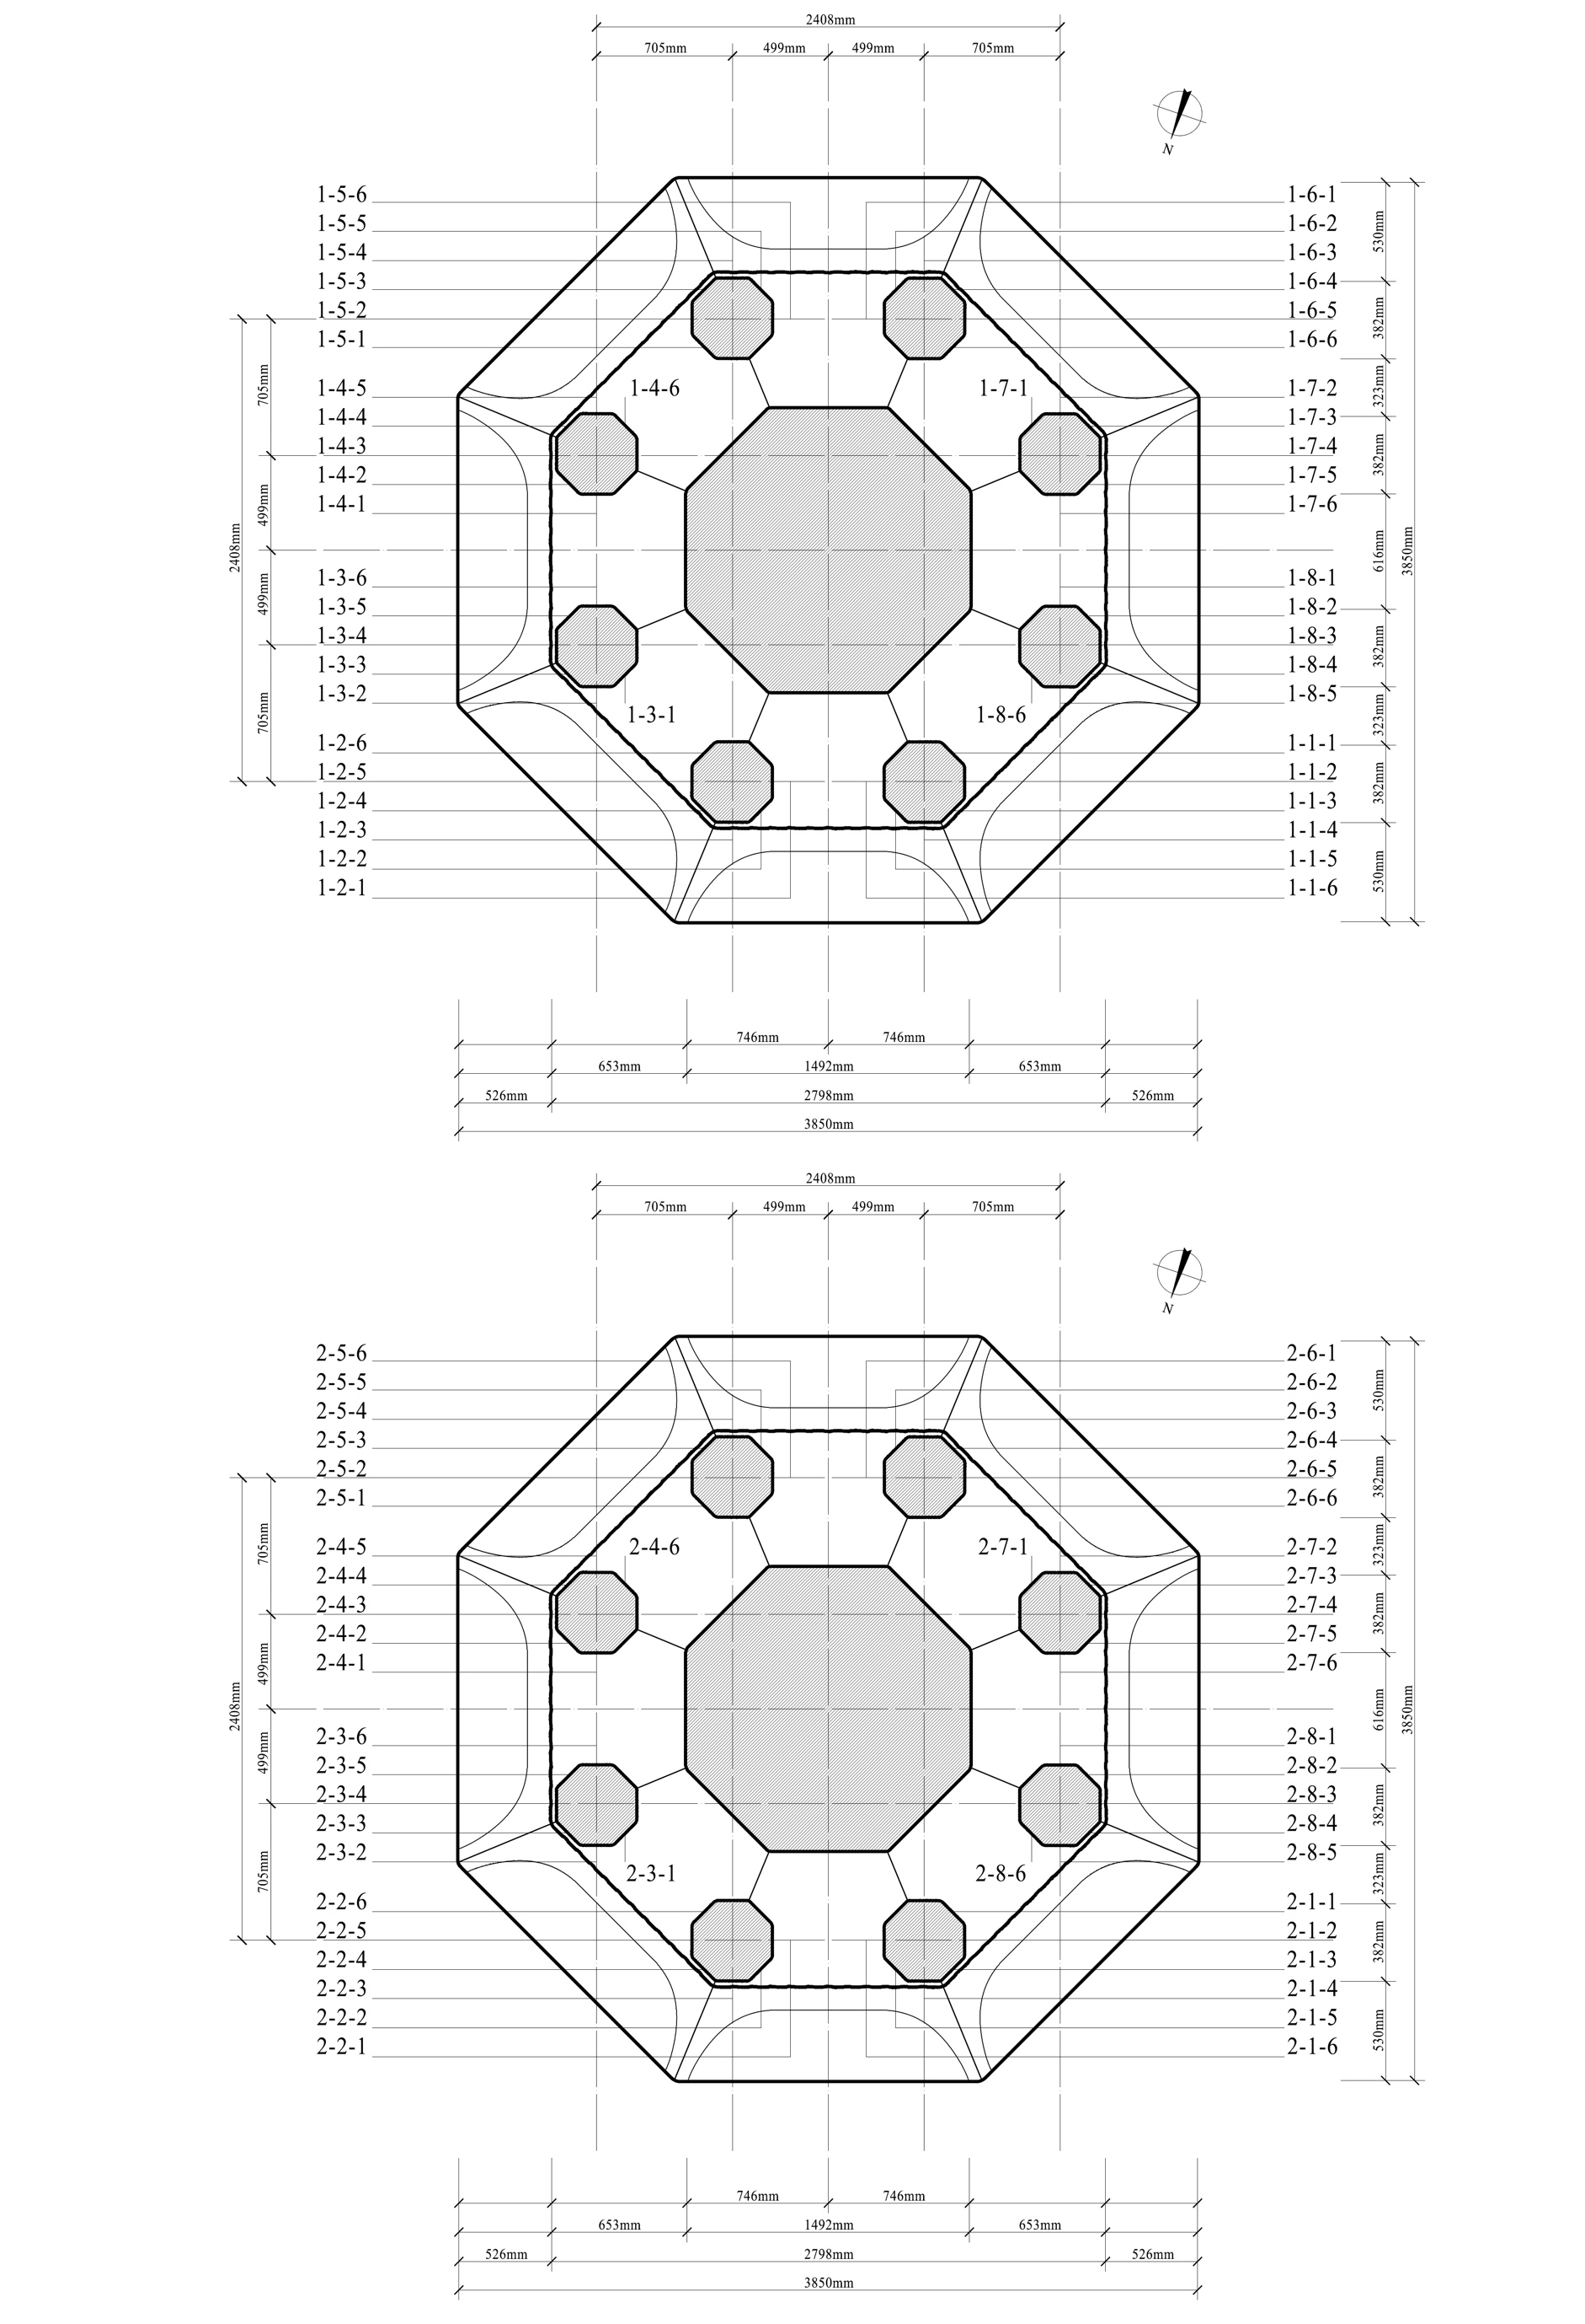
3. (Above) Plan of the Kongquedong pagoda’s ground story. Drawing and numbering, the author.
(Lower) Plan of the Kongquedong pagoda’s second story. Drawing and numbering, the author.
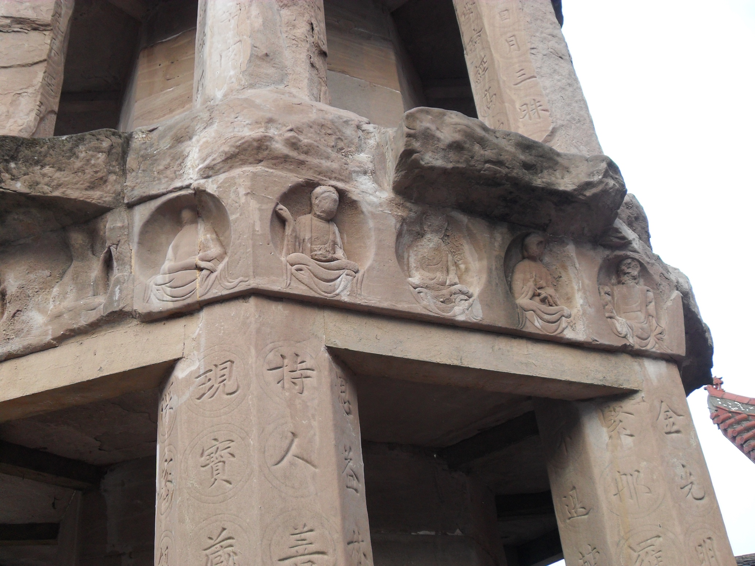
4. Seated buddhas carved on lintels of the Kongquedong pagoda. Photo, the author, 2013.

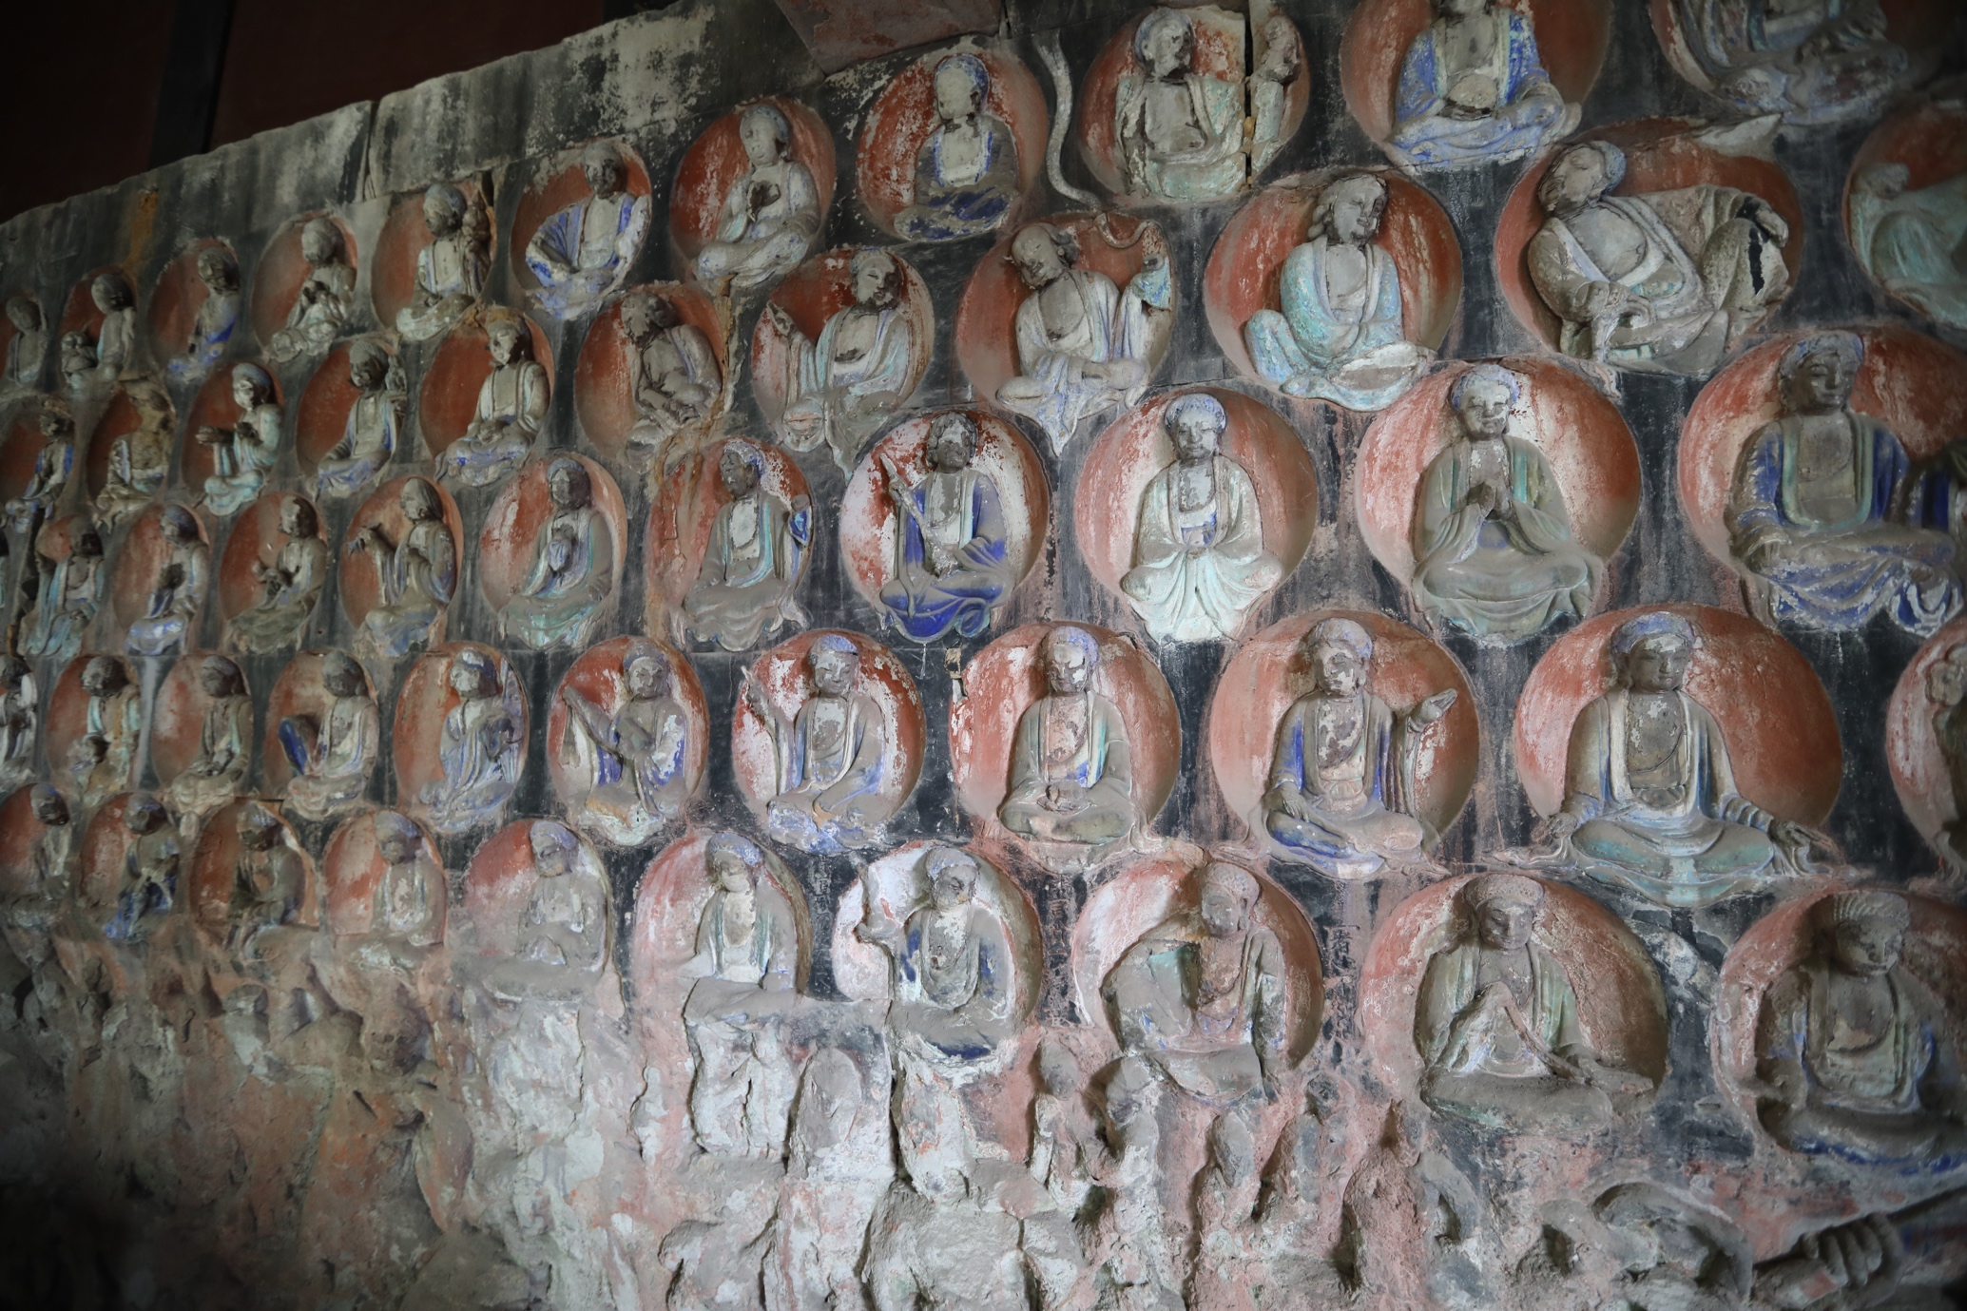
5. Seated buddhas carved at Xiaofowan. Southern Song period. Photo, the author, 2019.

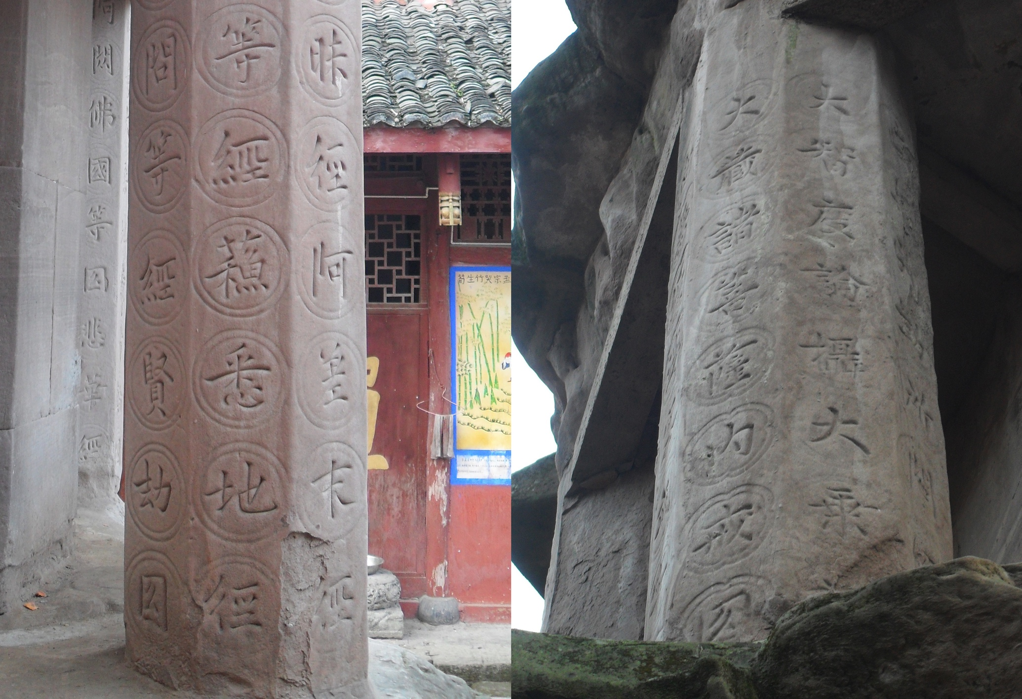
6. (Left) Decorative roundels on Column 1-4. Photo, the author, 2013.
(Right) Decorative quatrefoils on Column 2-3. Photo, the author, 2013.

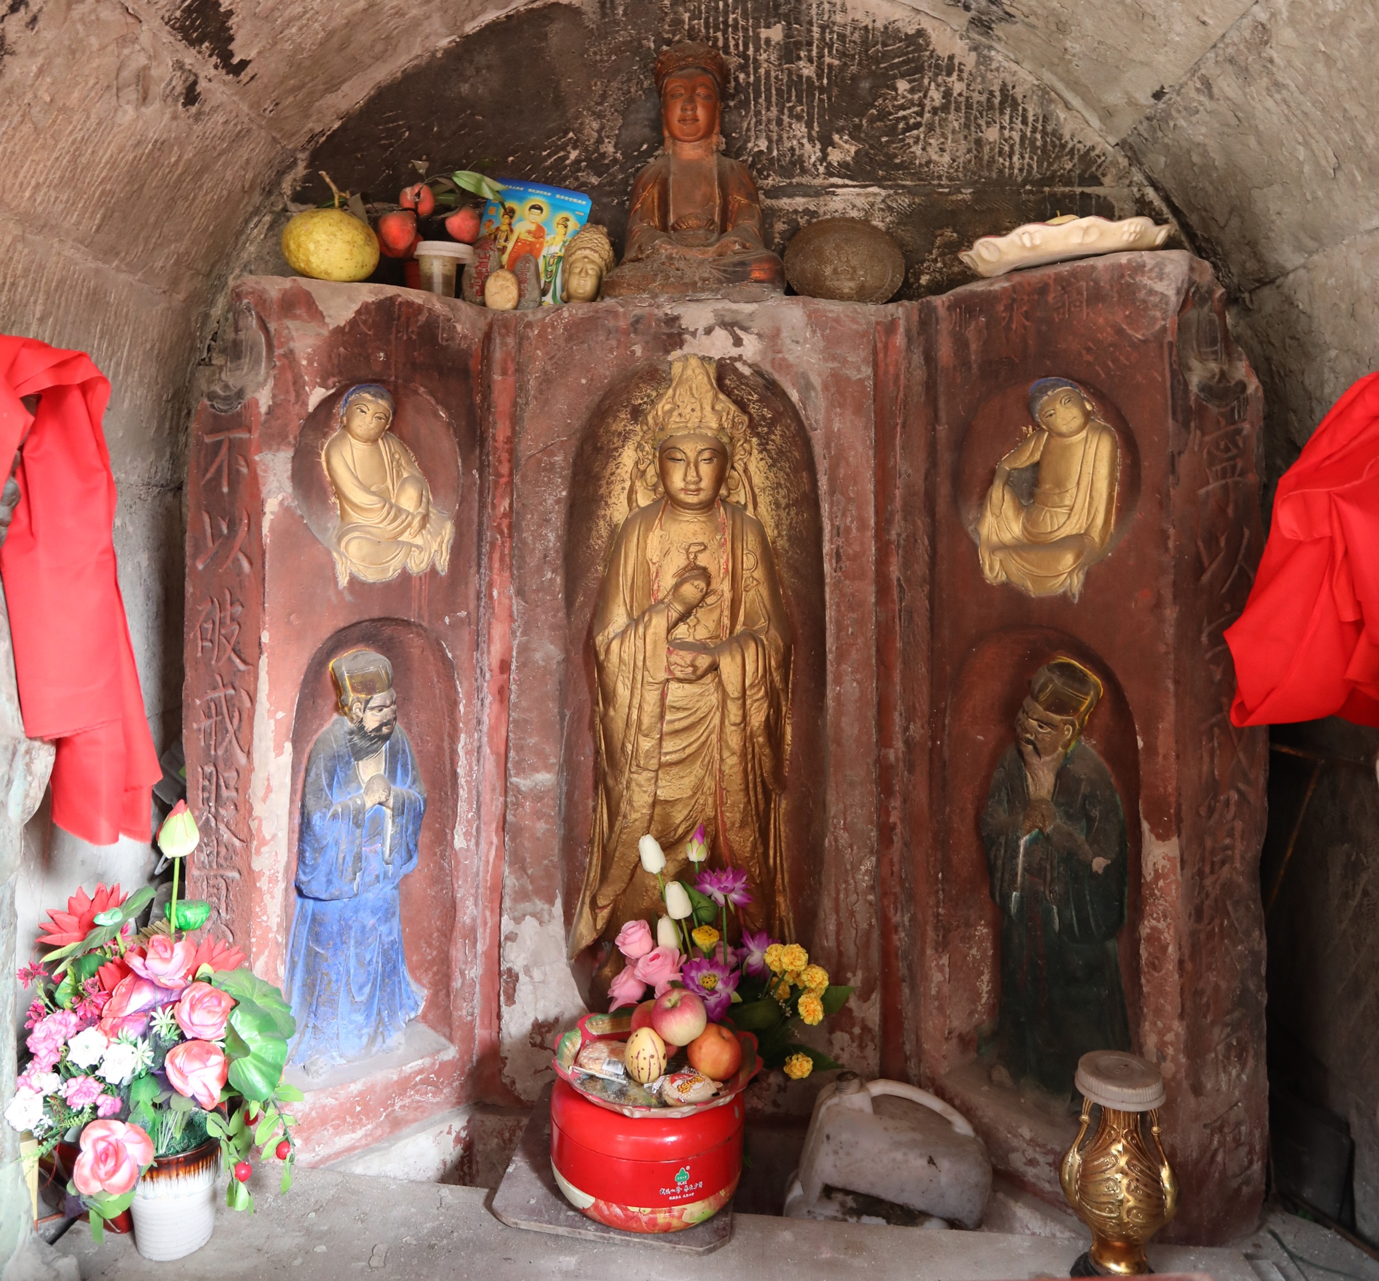
7. Triptych-shaped stela in Guandingjing. Southern Song period. Photo, the author, 2019.

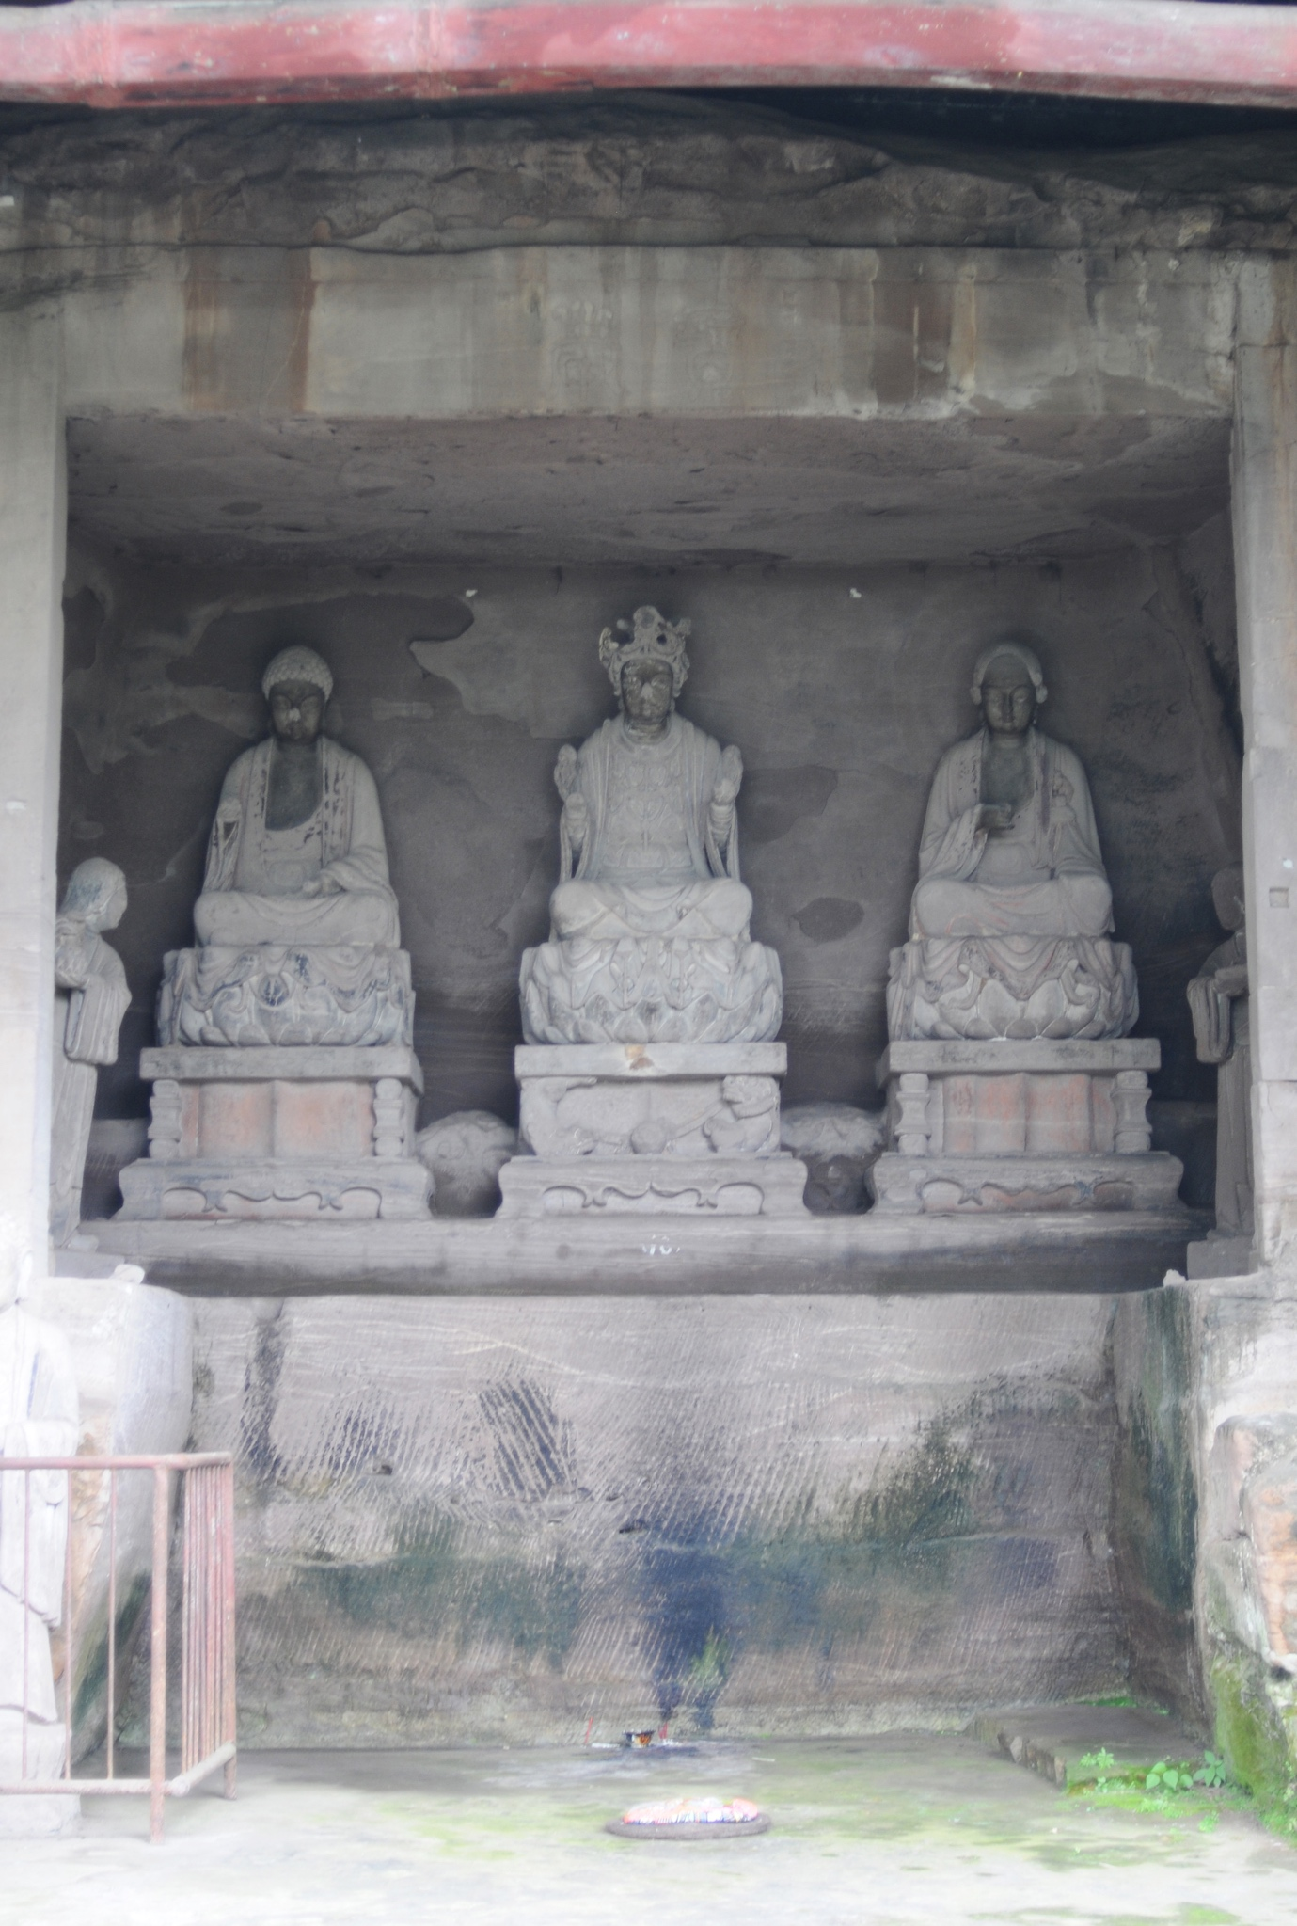
8. Triad in Cave 10, Piludong. Southern Song period. Photo, the author, 2007.
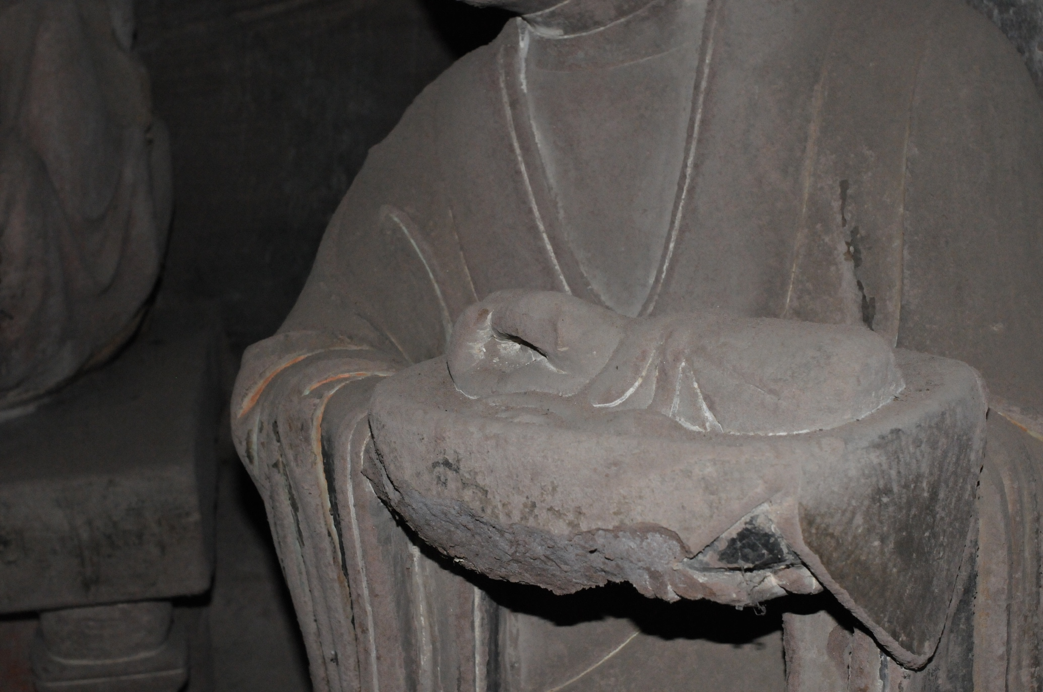
9. Severed body parts displayed on the tray held by Liu’s female attendant in Cave 10, Piludong. Photo, the author, 2014.

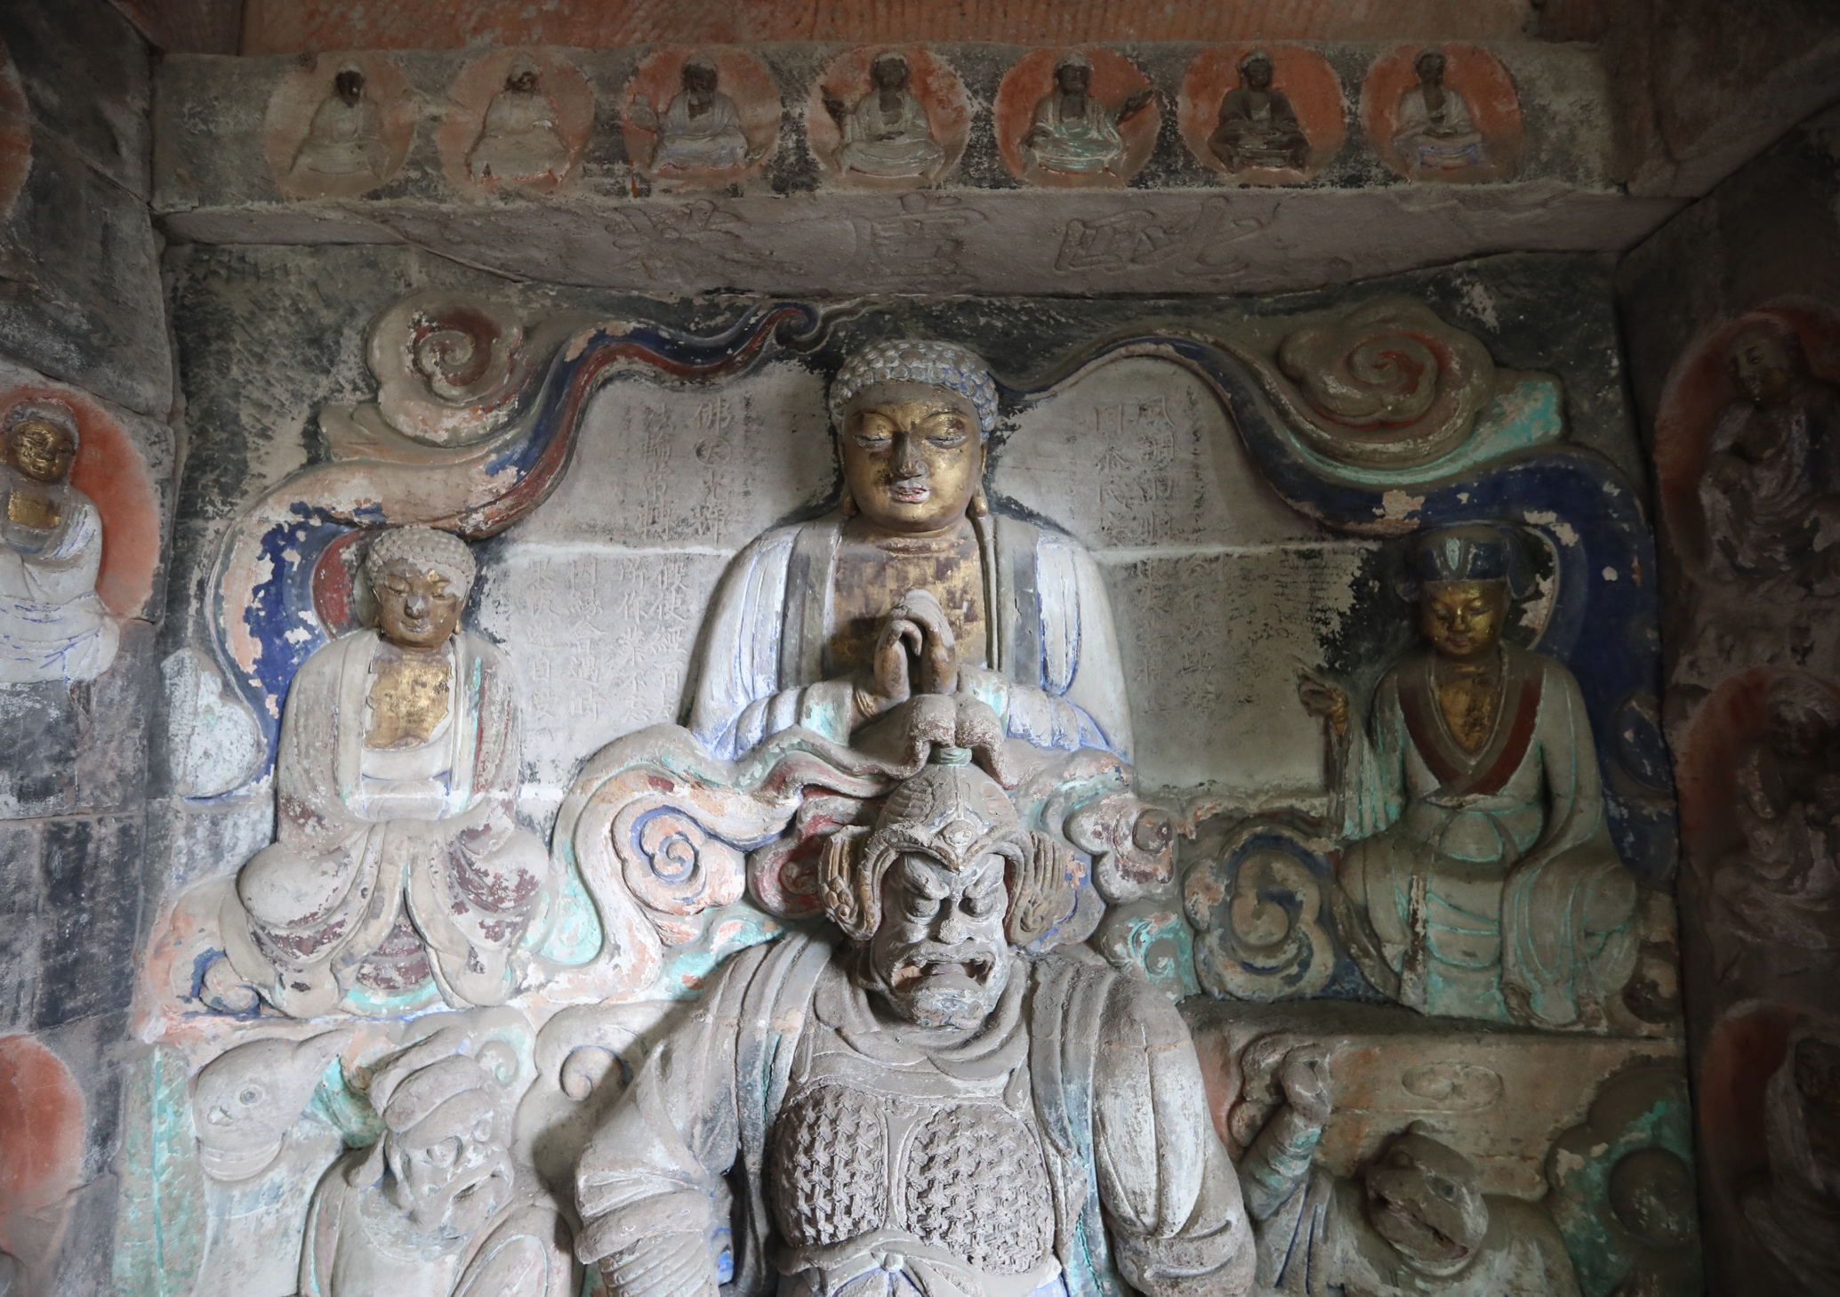
10. Vairocana triad in Niche 5, Xiaofowan. Southern Song period. Photo, the author, 2019.
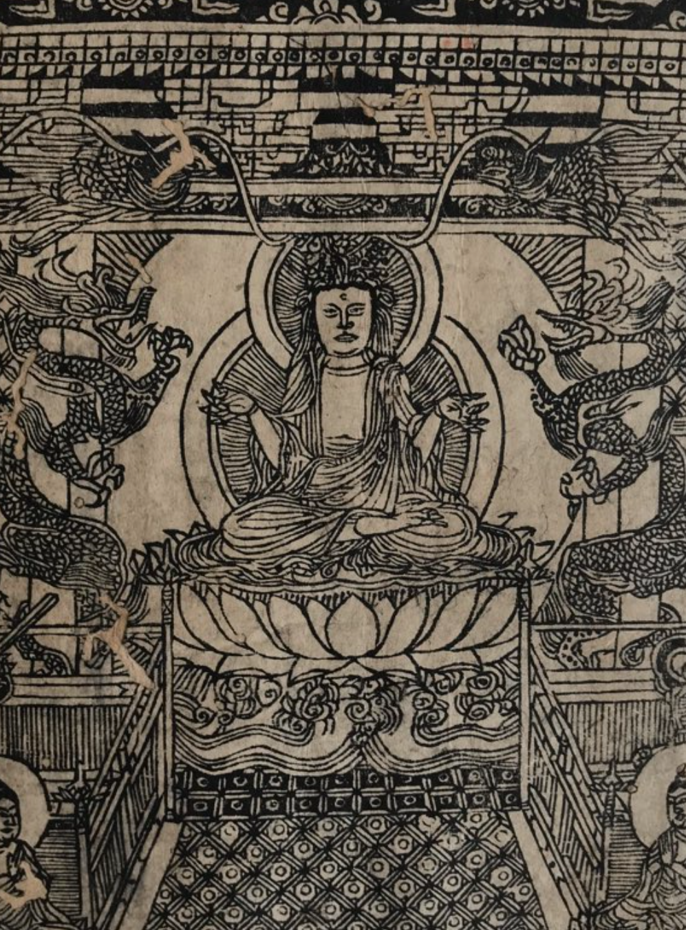
11. Seated Rocana, part of a 1248 replica of a Southern Song xylographic frontispiece to the Brahmā Net Sūtra. Fogg Art Museum, Harvard University. Photo, the author, 2018.

