Forty-Years of the Arab Law Quarterly Journal: A Bibliometric Analysis

M. Kabir Hassan
Professor of Finance, University of New Orleans, New Orleans, LA, USA
mhassan@uno.edu

Muneer M. Alshater
Postdoctoral Fellow in Islamic Fintech, IIUM, Institute of Islamic Banking and Finance, Kuala Lumpur, Malaysia
muneermaher@gmail.com

Aishath Muneeza
International Center for Education in Islamic Finance (INCEIF), Kuala Lumpur, Malaysia
muneeza@inceif.org

Abstract

Arab Law Quarterly (ALQ) is an English-language, scholarly journal of international repute about the laws of Arab states and related matters, which was first published in 1980. As ALQ is celebrating its 40th anniversary, an attempt has been made using bibliometric methods to analyze the journal’s key bibliometric and scientometric aspects, including most relevant countries, institutions, and authors published in ALQ during the past 4 decades. The objective of this research is to familiarize journal management, scholars and practitioners with ALQ’s development in terms of document productivity, citation growth, international metrics & ranking, and content analysis. Using network analysis in VOSviewer software, the findings depict various co-authorships, co-citations, co-occurrences and bibliographical coupling for countries–institutions–authors–keywords. Researchers have not only aimed to provide ALQ’s readers with a full overview of prominent topics and performance published since its inception but also tried to provide direction for future research.

Keywords

Arab law — Arab Law Quarterly — bibliometric — journal analysis — journal performance

- Introduction

Quality research has been described subjectively by various scholars, which is perhaps the reason why Milne described ‘quality’ as something like beauty that lies in the eyes of the beholder. For instance, acceptance rates for submissions were once considered a determining factor for quality in the sense that a low acceptance rate was considered an indication that a journal was publishing high-quality research. However, it was observed that this criteria was prone to manipulation as a journal’s editors might use their influence arbitrarily to determine what could be accepted or rejected based on their discretion. Thus impact factors have replaced acceptance rates to measure a journal’s quality. Bibliometrics is used for comparative quantitative analysis of publications and is a reliable measure to help enhance the quality of a journal in the future.
Arab Law Quarterly (ALQ) is an English-language, peer-reviewed journal first printed in 1980. Although papers published in the journal have mostly been in English, a number of papers and abstracts have appeared in French in the past. Brill Academic Publishers, The Netherlands, took over the scholarly journal and published Volume 1 in 1985.
According to the official website of Scimago’s Journal & Country Rank, ALQ is listed as an Q3 journal with a Scimago Journal Rank (SJR) 2019 impact factor of 0.14; from 1999 to 2018, ALQ has remained listed as Q4. In SJR’s system of ranking, Q1 journals have the highest and Q4 journals the lowest values. The objective of this research is to conduct a bibliometric study for ALQ, which has not been attempted to date.
During the past three decades, ALQ has been recognized as a scholarly journal offering influential articles on the laws and legal developments of the twenty countries in the Arab world: namely, Arab laws in trans-national affairs, commercial law, Islamic (Sharīʿah) law, and international comparative law. ALQ’s Abstracts and Indices can be found in Current Abstracts, Electronic Collections Online, Emerging Sources Citation Index (Web of Science), Index Islamicus, Foreign Legal Periodicals Index, International Bibliography of the Social Sciences, International Security & Counter-Terrorism Reference Center, Middle Eastern & Central Asian Studies, Periodica Islamica, Periodical Contents Index, Periodicals Index Online (PIO), Russian Academy of Sciences Bibliographies, Scopus, and TOC Premier.
SJR is a size-independent prestige indicator that ranks journals by their ‘average prestige per article’ based on the notion that ‘all citations are not created equal’. It measures the scientific influence of journals that accounts for both the number of citations received by a journal and the importance or prestige of the journals where such citations occur. According to its subject matter, ALQ is classified under social sciences specialized in law with an H-Index of 12. Over the years, ALQ has become a reputable journal known internationally as the leading English-language legal publication covering all aspects of Arab law, both Sharīʿah and secular. Today’s Editor-in-Chief of ALQ is Professor Dr. Haider Ala Hamoudi of the University of Pittsburgh School of Law, Pennsylvania, USA.
In Moizer’s opinion, over the years, publishing in social science journals has become a contest of sorts, a ‘fair game’ played by authors, reviewers, editors and bureaucrats in an attempt to prove that quality researchers are publishing in journals of excellence, which, however, might not be true in all cases. As a leading journal in the field of social sciences, ALQ has been published for decades while a bibliometric analysis has yet to be made to ascertain its performance. Thus, the objective of this article is to fill this gap by conducting a bibliometric analysis of the performance of ALQ since its inception to familiarize the journal management, scholars and practitioners with the journal’s development in terms of document productivity, citation growth, and international metrics and ranking.
Even today, finding a high-quality, high-impact journal focusing on Islamic law is a challenge as the number of Scopus-indexed journals focusing on Islamic law are limited. This is a challenge for researchers on Islamic law who have limited avenues for publication of their research as few journals in the field have been recognized internationally as high-impact journals. For instance, in the official website of SJR, a search using the keyword ‘Arab Law’ only found two results: ALQ and Brill’s Arab and Islamic Laws Series, which is a Q4-ranked book series. When the keyword ‘Islamic law’ was searched, only three results appeared: the Islamic Law and Society Journal, ranked Q3; Studies in Islamic Law and Society, which is a book series ranked Q3; and Brill’s Arab and Islamic Laws Series. While the keyword ‘Islamic’ only found 54 results, ALQ does not appear amongst them.
This article is organized as follows. After this Introduction, Section 2 discusses the methodology employed, while Section 3 presents the results and an analysis. Section 4 provides a graphical analysis of the content using VOSviewer software. Section 5 deals with cluster and content analyses. Section 6 details our conclusions.

2 Methodology

Bibliometrics is a branch of knowledge that examines the past and future growth of scientific work, enabling knowledgeable leaders and relevant stakeholders to draw conclusions with regard to a specific topic or field of inquiry. One — and perhaps the most important — step in conducting research is the accuracy of the collected data. In the social sciences, in- or exclusion of information in a chosen dataset is highly problematic and subjective, and filtering many topics is difficult due to the blurred borderlines between topics. In our research, this will not present a problem as we have accessed ALQ bibliographical data using the Scopus Database, which is the largest abstract and citation database of peer-reviewed research literature, widely recognized and frequently accessed for quantitative analysis. Scopus revealed 743 ALQ registered documents; however, some entries were missing from the data collected, especially before 1996 when Scopus coverage began. Thus whether results are correct will depend on the accuracy of journal entries to the database. Next, we used the Biblioshiny RStudio package as it offers a user-friendly graphical interface for non-coders. In addition we used VOSviewer and Excel software, considering that their analytical capabilities rank them among the best proper tools to conduct bibliometric studies. The results generated using Biblioshiny, VOSviewer and Comma Separated Values (CSV) files extracted from the database were triple-checked. We also occasionally referred to journal websites for sample checks. Data interpretation was based on our expertise in the field, as well as on manuals and handbooks for the software used.

figure 1. Study design.

The study design was carried out as shown in Fig. 1, following an approach employed by many previous researchers who have also applied such a technique to analyze journals and universities.

3 Results and Analysis

Section 3 will provide a comprehensive analysis of the content of ALQ based on the bibliometric method. Table 1 provides key data for the journal. An analysis of the data shows that ALQ published 743 documents between 1985 and May 2020: namely, 597 articles, 81 reviews, 15 short surveys, 7 conference proceedings, 40 editorials and 3 notes. It is noteworthy that most of the research papers (324) are single-authored, which differs from the current trend of increasing academic collaboration between researchers.

3.1 General Information
Table 1 provides general information about ALQ.

table 1. General Information about ALQ (1985 — May 2020)
Description | Results
Number of documents | 743
Beginning of Scopus Coverage | 1996
Average years from publication | 13.6
Average citations per document | 4.1
Average citations per year per document | 0.24
Number of references | 16 451
Type of Document
Articles | 597
Reviews | 81
Short Surveys | 15
Conference papers | 7
Editorials | 40
Notes | 3
Document Contents
Keywords Plus (ID) | 869
Author’s Keywords (DE) | 595
Authors
Authors | 473
Single-authored documents | 324
Multi-authored documents | 149
Author Collaboration
Documents per author | 564
Authors per document | 1.57
Co-authors per document | 1.03
Collaboration Index | 1.71

3.2 Increase in the Number of Documents over Time
The journal has witnessed ups and downs in terms of the number of documents published these past 40 years, with an average of 20.04 articles appearing in each volume especially during the last 15 years. Since 1985, Arab Law Quarterly has published one volume yearly, which is composed of four issues. Based on the historical trend it is most likely the journal will continue to keep this pace of publication in the upcoming 5 years (Figure 2).

figure 2. Document growth over time.

  - Increase in the Number of Citations over Time
Brill published ALQ’s 116-page Volume 1 in November 1985 that contain 8 articles, 3 conference proceedings and book reviews. Figure 3 shows a continuous, steady, slow rise in the number of citations since the journal’s inception. The nature of research in this field of inquiry probably explains the journal’s low number of citations. Scientometrics demonstrates that the field of study affects citation patterns. Scientists researching different topics cannot be compared; e.g., a biochemist will be cited four times more frequently than the average mathematician, which also applies to the arts, humanities and law. However, certain suggestions and procedures — if applied properly — might work to increase the journal’s impact.
It is worth noting that there were only 93 citations before 2004, while the total number of citations is 1099. This leads us to discuss journal metrics in the next section.

figure 3. Growth in the number of citations.

  - Journal Metrics from Scopus
Figure 4 provides a view of the journal’s metric development over time. ALQ shows a constant SJR pattern, with a slight increase in the CiteScore since 2011 and fluctuations in the Source Normalized Impact per Paper (SNIP) metric during the last decade. Recommendations to improve the journal’s metrics will be given at the end of this article.

figure 4. ALQ metrics and ranking.

3.5 Most Relevant Countries
Figure 5 compares the most relevant countries in terms of Arab law research productivity; namely, the UK, Malaysia and UAE are the top producers of scholarly articles in this field. This suggests that any effort to promote or market ALQ, its high-quality research articles, Special Issues, conference proceedings or other activities should take into account the relevant institutions in the countries shown below.

figure 5. Most relevant countries.

3.6 Most Relevant Institutions
Information retrieved from Scopus lacks much data, while RStudio also takes the countries of corresponding authors into consideration for country productivity. Accurate statistics can only be calculated when a journal updates all relevant information in Scopus and other databases. Figure 6 compares the most relevant institutions based on the Scopus dataset collected from the website. Regardless of the accuracy of the data, these institutions are still the most frequent contributors engaged with the journal.

figure 6. Most relevant institutions.

3.7 Most Productive Authors over Time
Of the 473 authors who have submitted research for publication in ALQ over the years, the 15 most productive amongst them are singled out in Figure 7: namely, M. Zahraa, N. Saleh, B.S.B.A. al-Muhairi, and M.M. Billah being the top performers.

figure 6. Most productive authors.

3.8 Most-Cited Documents
Table 2 shows the most-cited articles since the journal’s launch; the high number of citations in relatively new articles come from buzz and sensitive topics as we note in citations 1 and 2. Articles on Islamic finance, amongst other topics, appear especially interesting as we note in citations 3, 5, 10, 11, 13 and 17 and might suggest the need for additional focus by calling for papers in this field of inquiry.

table 2. Number of Most-Cited Articles listed according to Rank

 | Authors | Title | Year | No.
1 | A. Othman | ‘An amicable settlement is best’: Ṣulḥ and dispute resolution in Islamic law | 2007 | 48
2 | - al-Ramahi | Wāsiṭah in Jordan: A distinct feature of (and benefit for) Middle Eastern Society | 2008 | 30
3 | E. Mayer | Islamic banking and credit policies in the Sadat era: The social origins of Islamic banking in Egypt | 1985 | 24
4 | S.P. Ali-Karamali,  F. Dunne | The iǧtihād controversy | 1994 | 21
5 | N.D. Ray | The medieval Islamic system of credit and banking: Legal and historical considerations | 1997 | 18
6 | M.H. Kamali | Punishment in Islamic law: A critique of the ḥudūd bill of Kelantan, Malaysia | 1998 | 17
7 | M.H. Kamali | Methodological issues in Islamic jurisprudence | 1996 | 17
8 | R. Peters | Divine Law or man-made law? Egypt and the application of the Sharīʿah | 1988 | 17
9 | E. Hill | Al-Sanhūrī and Islamic law: The place and significance of Islamic law in the life and work of ʿAbd al-Razzaq Ahmad al-Sanhūrī, Egyptian jurist and scholar 1895–1971 | 1988 | 16
10 | M.T. Usmani | The concept of mušārakah and its application as an Islamic method of financing | 1999 | 15
11 | N.H.D. Foster | Islamic finance law as an emergent legal system | 2007 | 14
12 | M.H. Kamali | Legal maxims and other genres of literature in Islamic jurisprudence | 2006 | 14
13 | M. Anwar | Islamicity of banking and modes of Islamic banking | 2003 | 14
14 | M. Zahraa | Characteristic features of Islamic law: Perceptions and misconceptions | 2000 | 14
15 | N. Saleh | Civil codes of Arab countries: The Sanhūrī Codes | 1993 | 14
16 | O. Arabi | The dawning of the third millennium on Sharīʿah: Egypt's Law No. 1 of 2000, or women may divorce at will | 2001 | 13
17 | M.M. Billah | Islamic insurance: Its origins and development | 1998 | 13
18 | M. Zahraa | The concept of custody in Islamic law | 1998 | 13
19 | M. Zahraa | Legal personality in Islamic law | 1995 | 12
20 | A.H. Buang | Islamic contracts in a secular court setting? Lessons from Malaysia | 2007 | 11

3.9 Relevant Sponsors
Contributors to ALQ have received little funding from sponsors, as the percentage of funded articles reported is only 0.015%. Each of the following organizations has sponsored an author(s) and their research once. Shown in alphabetical order are: Academy of Scientific Research and Technology, Bank of Canada, Bank of England, Diabetes Research Center, European Central Bank, Islamic Development Bank, Ministry of Education — Singapore, Ministry of Higher Education — Malaysia, Qatar Foundation, and Qatar National Research Fund.

4 Graphical Analysis of Content using VOSviewer Software

VOSviewer is meant to create visualized networks of bibliographical data for exploring co-relations between study units; these can be countries, institutions, authors, documents and references. Maps generated from the software need interpretation, for which we will provide basic hints that are helpful in generating extra analysis. Anyone interested in greater in-depth usage is kindly advised to refer to the VOSviewer manual.
- The size of a label and the circle of an item are determined by the comparative weight of the item, which means the higher the weight of an item, the larger the label.
- The colour of an item is determined by the cluster to which the item belongs.
- Lines represent links between items; the bolder the line, the tighter the relation.
- The distance between two items in the visualization indicates the relatedness of the item in terms of the mentioned co-relation; e.g., if two authors or journals are closely related their ties are higher and relatedness stronger.
- The maps generated are based on thresholds as shown. As not all relations can be depicted on paper, maps are reduced to a certain threshold for clear visibility, unless mentioned otherwise. The following sections will address the topic ‘co-relations’.

4.1 Co-Citation Analysis
In 1981, co-citation was proposed as a significant branch of scientometrics by Drs. H.D. White and B.C. Grifith. The main purpose of this analysis is to map scientific domains by pointing out relations between units of study. Co-citation reveals the structure of knowledge on a macro-level by describing relations amongst research contributors.

4.1.1 Co-Cited References
Of ALQ’s 16,451 references, 323 have been cited more than twice. However, only 32 are connected as shown in Figure 7. In addition, as explanation, e.g., the red cluster shows the connectivity and how close the ties between those references are. The links going from these references to the book by Al-Shirbīnī (which is one of the most prominent and well-known books on fiqh and Imām Al-Shāfiʿī) shows how this reference is a vital, fundamental reference in many articles; it is considered a knowledge disseminator.

figure 7. Co-cited references.

4.1.2 Co-Cited Sources
Of the sources referred to more than 10 times, 14 are connected; these are the most-cited sources. Figure 8 shows their connectivity. One limitation here is that, while some sources may be more frequently cited, they are not connected to other sources used in the journal and thus should be neglected.
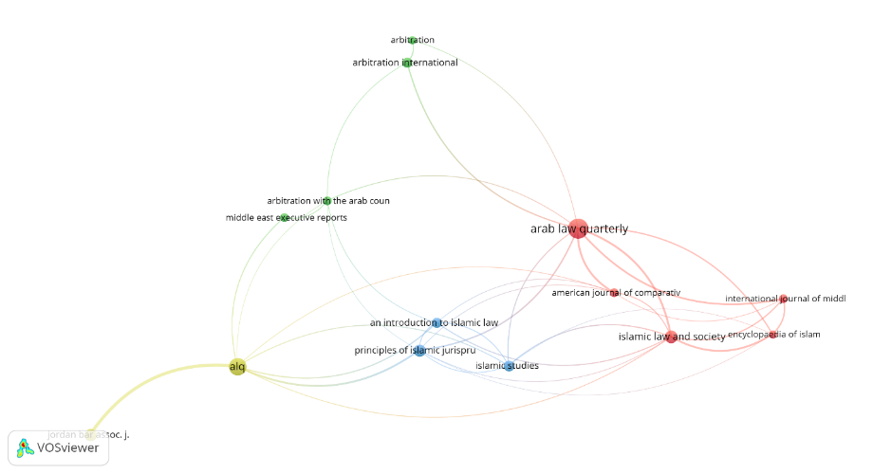
figure 8. Co-cited sources.

4.1.3 Co-Cited Authors
Amongst the authors cited more than 10 times, 56 met the criteria and 49 were only connected as shown in Figure 9. We have noticed that some items are incorrectly allocated in a coloured cluster, which may be due to erroneous data entries. We also noticed that religious authors show a greater connectivity: e.g., Al-Zuhaylī and Al-Boutī who were both religious Syrian scholars living during the same period.

figure 9. Co-cited authors.

4.2 Co-Authorship
Under pressure to ‘publish or perish’, international collaboration thrived after 1990. While the numbers of research papers were growing linearly, their international sources of origin were growing exponentially. While some people attribute this rise to the proliferation of interdisciplinary research, in an academic context, ‘co-authorship’ can be understood as one’s association, but not one’s authorship, with a document. Foucault described this well when he said: ‘Authors are writers, but not all writers are authors’. Co-authorship analysis is meant to explore the extent to which authorship in a certain platform or area of knowledge refers to a collaboration to produce a scientific publication. The following sections describe co-authorship patterns for ALQ.

4.2.1 Co-Authorship
Of ALQ’s 473 authors, only 9 are connected (Figure 10). We shall show all of them to appreciate the landscape of co-authorship in ALQ. Through proper cluster analysis of its published articles and main topics, the journal can encourage authors engaged in similar research to consider working together to boost productivity in their fields of inquiry.
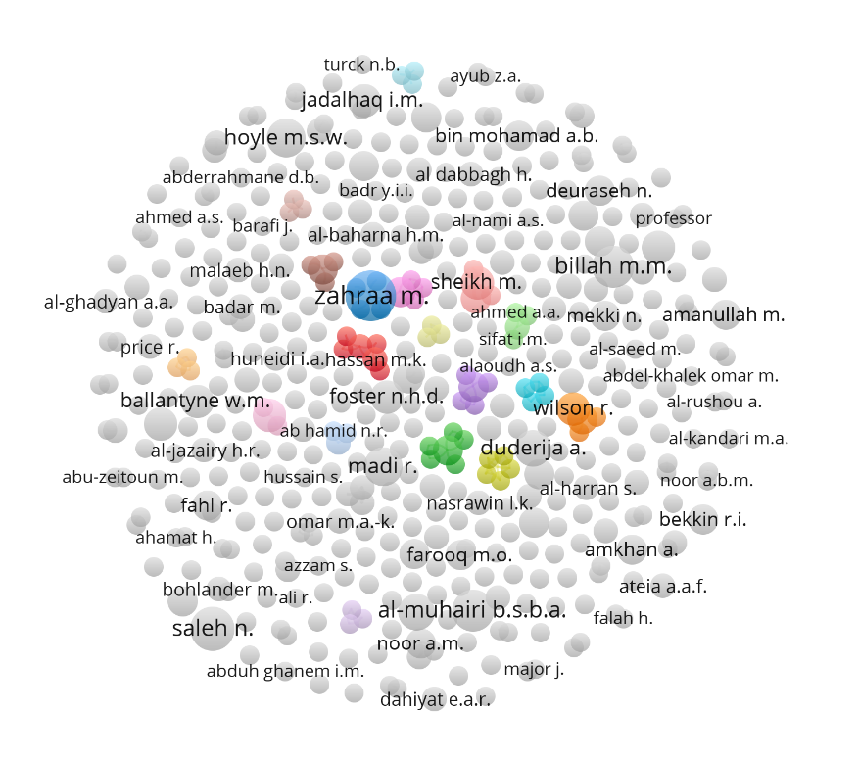
figure 10. Co-authorship.

4.2.2 Co-Authorship amongst Organizations
Amongst organizations, only 6 were connected (Figure 11). The rare occurrence of co-operation between both authors and organizations may be interpreted in various ways. When the scope of a journal is broad, then it is probable that writers from different specializations and organizations will work and publish on their own, while a narrower scope may help pinpoint a certain focus and encourage collaboration between researchers in the scientific community.
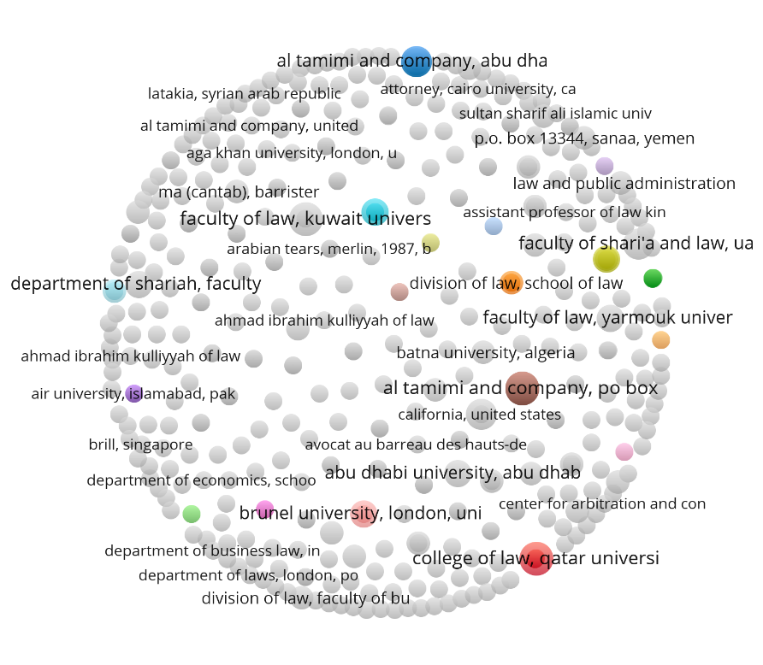
figure 11. Co-authorship amongst organizations.

4.2.3 Co-Authorship amongst Countries
Only 24 of the 64 countries were connected (Figure 12); we have noticed that Western countries have a greater tendency to collaborate (e.g., USA, UK, France, and Belgium).

figure 12. Co-authorship between countries.

4.3 Co-Occurrence Analysis
Keywords, which play an important role in scientific research, can reveal the existing state of research and knowledge structure. By using mapping techniques, a researcher can trace themes and unearth clusters to gain a clearer perspective for the future direction of their study. Co-occurrence analysis may help reveal the most relevant topics and their relations with other topics. Scholars recommend using co-occurrence analysis to foster systematic literature reviews and increase their efficiency, as such investigative research is considered tedious, time-consuming and manual in nature. The following sections will help clarify the importance of such an analysis.

4.3.1 Co-Occurrence of All Keywords
Of 869 keywords, with a threshold of five occurrences per word, 18 are shown in Figure 13. We find a clear connection between the terms ‘Islamic finance’, ‘Sharīʿah’, ‘tawarruq’ and ‘ribā’, which demonstrates that these topics are amongst the most frequently addressed issues in ALQ. Thus the reader can more readily grasp the relation between fiqh, law and Islamic finance, or capture the notion that Saudi Arabia is a country most interested in arbitration, or derive understanding that Islamic banking revolves around topics such as corporate governance and dispute resolution.

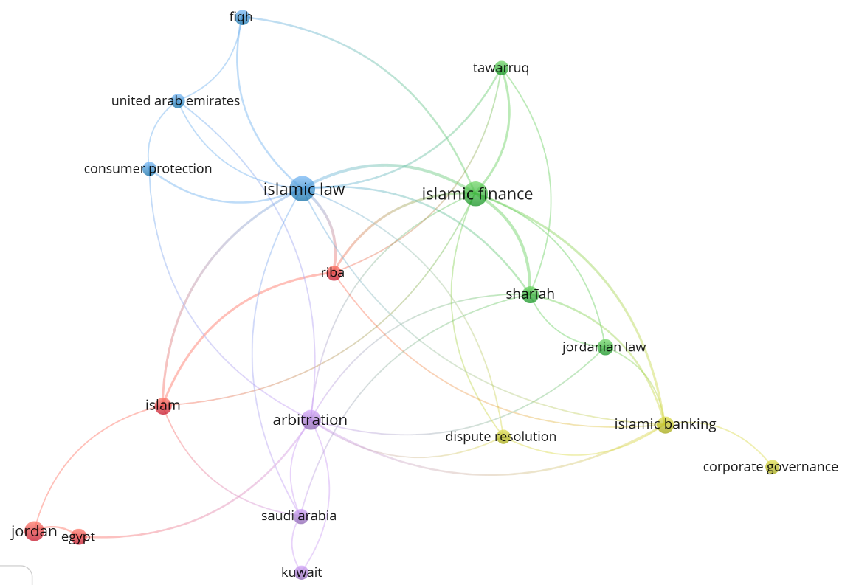
figure 13. Co-occurrences of all keywords.

4.3.2 Co-Occurrence of Authors’ Keywords
Of all the keywords used by authors, 595 are connected, but without a threshold specified. Figure 14 shows the full connectivity between authors’ keywords, which may be useful for both the journal as well as its readers.
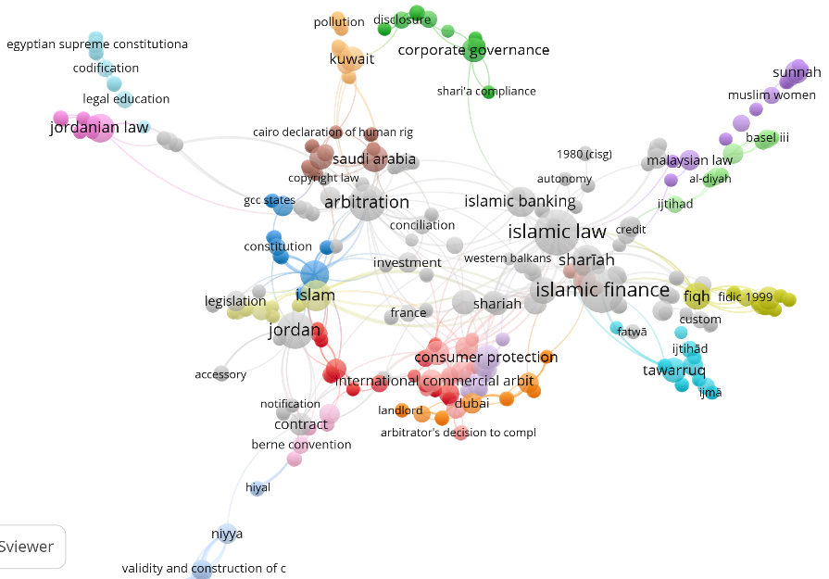
figure 14. Co-occurrences of authors’ keywords.

4.4 Bibliographic Coupling
When two research articles refer to the same reference in their bibliographies, the relation between both documents is called ‘bibliographic coupling’. It expresses a similarity between documents, which helps in science mapping, simplifies tracing clusters, and is more complementary to the co-citation cluster analytical method.

4.4.1 Bibliographic Coupling of Documents
Of the 744 research articles in ALQ, 142 are connected. Figure 15 shows all significant (strong) links connecting ‘core documents’ (strong and frequently coupled documents) in clusters with any other core document mapped.

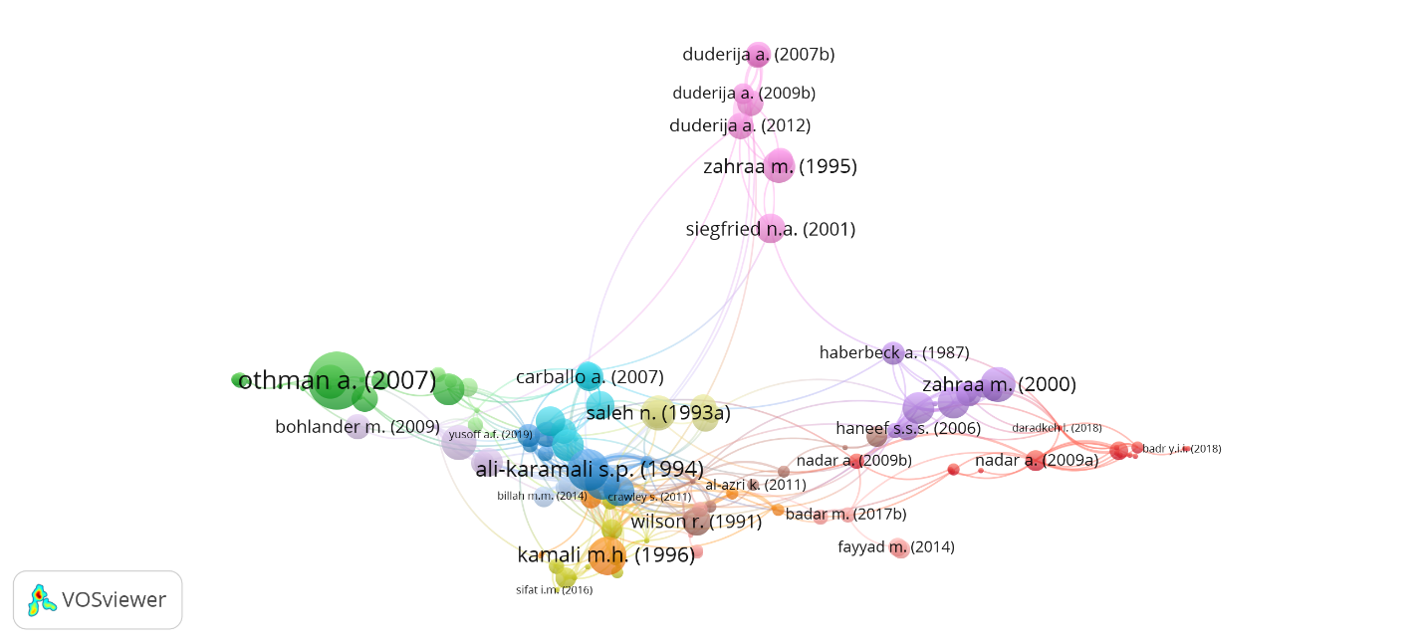
figure 15. Bibliographic coupling of documents.

4.4.2 Bibliographic Coupling of Authors
Of all the authors who have published in ALQ, those with at least a minimum of two documents are shown in Figure 16. Based on this analysis, there is a high probability that authors in each cluster are studying the same or similar topics.

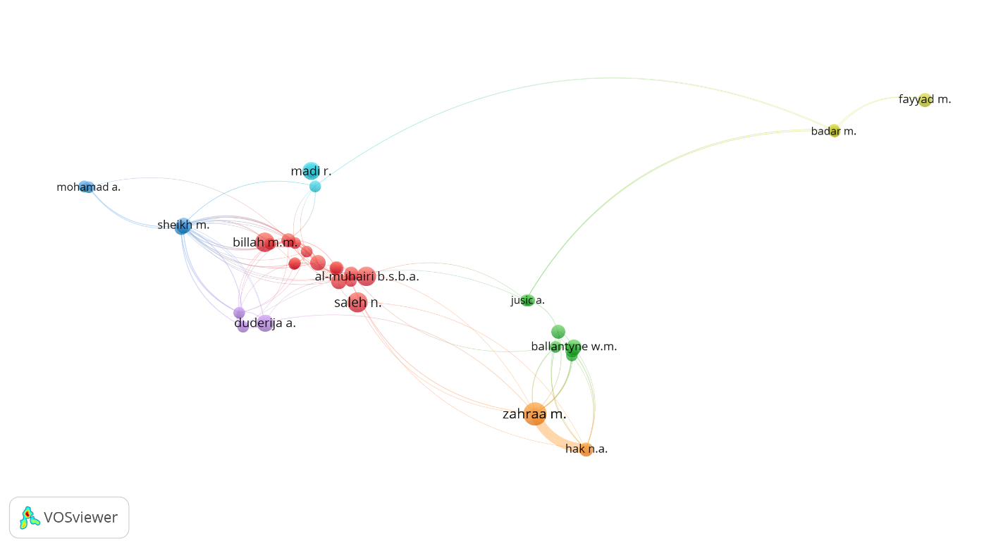
figure 16. Bibliographic coupling of authors.

5 Cluster and Content Analyses

5.1 Cluster Analysis of ALQ Publications
Cluster analysis has shown that the three significant clusters identified are (1) Islamic Law, (2) Arbitration, and (3) Islamic Finance (Figure 17). All three clusters fall within the ambit of the broad scope of the journal. Since the focus of the journal, and Arab law, is on Arab countries, it is imperative to discover how many papers that have been published relate to a geographical location. Analysis shows that certain jurisdictions have been researched more frequently: namely, Jordan, Saudi Arabia and other GCC States as well as non-Arab countries such as Malaysia and France. A search in ALQ titles shows that thirteen papers were related to Malaysia and France while two papers referred to France.

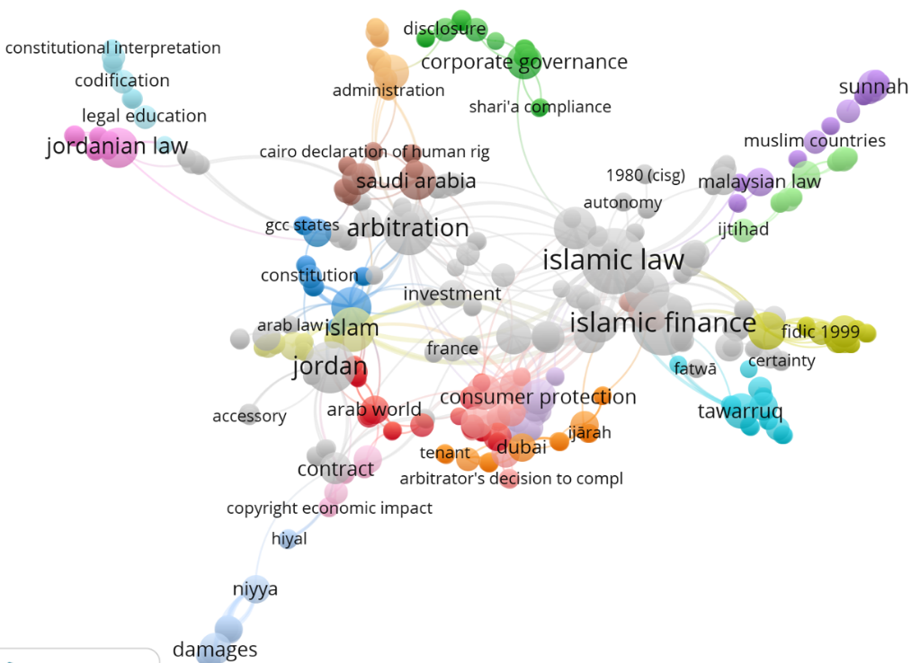
figure 17. Bibliographic coupling of keywords.

Regarding the geographical coverage of ALQ’s content, except for Comoros and Djibouti, all Arab countries have appeared in research papers published in the journal over the decades. Egypt, UAE, Jordan and Saudi Arabia are the countries that have most frequently been researched; not only scholarly research but also papers on legislation and case laws within these jurisdictions have appeared in the journal over the years.

5.2 Content Analysis or Major Themes
In this section the major themes chosen for content analysis are based on the findings provided in Section 5.1: namely, the three major clusters representing Islamic Law, Arbitration and Islamic Finance. We see that the content published in ALQ has evolved over the years to reflect contemporary issues in Islamic law.
Over the decades, it has become evident that ALQ has focused in a balanced way on the issues most relevant to the Muslim world. Although in recent years other journals have emerged which cater to Islamic law, ALQ is still considered the international journal for scholarly research on Arab law and has gained the trust of the academic community worldwide. A thorough analysis of ALQ’s content published over the decades is essential to grasp how the scope of the journal has evolved over time. In this analysis, we have divided the years during which the journal has been published into four distinctive timeframes: i.e., 1985–1989, 1990–1999, 2000–2009, and 2010–2019. Such a division is important if one aims to discover evolving micro-areas of focus over a longer period of time.
From 1985 to 1989, ALQ mainly focused on Islamic law-related issues. It is noteworthy that, in ALQ’s official website, there is no information given for 1986 issues. Although Volume 1 was issued in 1985, the next volume did not appear in print until 1987.
For topics published in ALQ from 1985 to 1989, see Tables 3–5 below.

table 3. Clusters of Major Topics in Islamic Law 1985–1989

Commercial Law, Consumer Protection, Trademarks, Broadcasting Law, and Electronic Commerce
1985 | Kuwait: The taxation of international commercial transactions, 1(2): 141–157
1985 | The New Civil Code of the United Arab Emirates: A further reassertion of the Sharīʿah, 1(3): 245–264
1985 | Freedom of Contract: The doctrine of frustration, and sanctity of contracts in Sudan law and Islamic law, 1(1): 51–59
1987 | The Sharīʿah: A speech to the IBA Conference in Cairo, on Arab Comparative and Commercial Law, 15–18 February 1987, 2(1): 12–28
1988 | A contribution to the study of the Koranic sources of Saudi Arabian Business Law, 3(2): 132–150
1988 | The Bahrain Bankruptcy and Composition Law, 3(3): 254–273
1989 | Trademark protection in the United Arab Emirates, 4(1): 31–47.
Corporate Law, Trade & Investment Law, Joint Ventures, Financial Market and Bankruptcy
1987 | Legal aspects of doing business with Algeria, 2(2): 148–157
1987 | Commercial litigation in the Yemen Arab Republic with special reference to marine insurance, 2(3): 230–264
1987 | Proposed law to regulate technology transfers in Egypt, 2(1): 3–11
Legal System, Constitution, International Law, Conflict of Laws
1985 | Regulation of business under the developing legal system of the United Arab Emirates, 1(2): 119–139
1985 | The States of the GCC: Sources of law, the Sharīʿah and the extent to which it applies, 1(1): 3–18
1985 | The mixed courts of Egypt: An anniversary assessment, 1(1): 60–68
1988 | Divine Law or man-made law? Egypt and the application of the Sharīʿah, 3(3): 231–253
Islamic Criminal Law
1987 | Liability of the carrier in courtesy carriage and gratuitous carriage, 2(2): 105–128
1987 | The mixed courts of Egypt 1896–1905, 2(1): 57–74
1989 | An Islamic Conseil d'État: Saudi Arabia’s Board of Grievance, 4(2): 128–137
Islamic Jurisprudence, and Fatāwāʾ
1989 |  | The development of the Hadawī Doctrine, the Neo-Rationalists of the Zaydī School since 1948, and the current role of ʿIlm al-Kalām (or Scholasticism) in Yemeni courts, Part 2, 4(1): 3–19

table 4. Clusters of Major Topics on Arbitration 1985–1989
Enforcement of Arbitral Awards and Foreign Judgments
1985 | The recognition and enforcement of foreign arbitral awards in the states of the Arab Middle East, 1(1): 19–31
1985 | The ICC Court of Arbitration: Recent developments and experience related to Arab countries, 1(3): 280–298
1988 | The enforcement of arbitral awards and foreign judgments in the Yemen Arab Republic, 3(1): 81–82
Application of UNCITRAL Model Law and Arbitration Laws applied in the Context of Different Countries
1985 | The ICC Court of Arbitration: Recent developments and experience related to Arab countries, 1(3): 280–298
1988 | International commercial arbitration in perspective, 3(1): 3–18
1988 | The Draft Arbitration Law in Egypt, 3(2): 119–131

table 5. Clusters of Major Topics on Islamic Finance 1985–1989
Islamic Banking
1985 | Islamic banking and credit policies in the Sadat era: The social origins of Islamic banking in Egypt, 3(1): 32–50
Takāful (Islamic Insurance)
1989 | Insurance and Islamic law, 4(3): 199–205

The following topics were first addressed in ALQ from 1990 to 1999: namely, women’s issues and Islamic insurance. During this period, Issue 3 of 1999 was entirely dedicated to Islamic finance cases, focusing specifically on mušārakah or Islamic transactions.
For topics published in ALQ from 1990 to 1999, see Tables 6–8 below.

table 6. Clusters of Major Topics in Islamic Law 1990–1999
Commercial Law, Consumer Protection, Trademarks, Broadcasting Law, and Electronic Commerce
1990 | The impact of the UAE Civil Code on commercial litigation, 5(2): 143–144
1991 | Protection of copyright under Sudanese law, 6(2): 161–189
1994 | Fading vestiges of Sharīʿah in commercial agency/distributorship: Termination and compensation, 9(1): 91–106
1995 | Termination for breach in Arab Contract Law, 10(1): 17–30
1996 | Broadcasting Law in Lebanon, 11(2): 161–164
Corporate Law, Trade and Investment Law, Joint Ventures, Financial Market and Bankruptcy
1990 | Some legal aspects regarding business associations: British and Algerian Law, 5(4): 241–258
1990 | International construction joint ventures in the Middle East, 5(1): 3–24
1990 | The manager of a limited liability company under Kuwait Commercial Companies Law: A comparative study, 5(3): 163–210
1990 | Some current legal issues concerning trade and investment in Egypt, 5(2): 124–136
1991 | Foreign capital investment in Member States of the Gulf Cooperation Council, 6(3): 231–266
1992 | Company Law in Yemen, 7(4): 237–248
1992 | Contemporary mercantile jurisdiction in Oman, 7(1): 3–32
1992 | Commercial and civil companies in UAE Law, 7(3): 159–174
1995 | The banking system in Saudi Arabia, 10(3): 207–237
Legal System, Constitution, International Law, Conflict of Laws
1991 | Sources of law under English, French, Islamic and Iranian Law: A comparative review of legal techniques, 6(1): 33–67
1991 | Resolution of disputes in Saudi Arabia, 6(1): 3–32
1993 | The constitutional system of Saudi Arabia: A conspectus, 8(1): 30–36
1996 | The development of the UAE legal system and unification with the judicial system, 11(2): 116–160
1996 | The position of Sharīʿah within the UAE Constitution and the Federal Supreme Court’s application of the Constitutional Clause concerning Sharīʿah, 11(3): 219–244
Family Law, Inheritance, Women, Labour Law, Human Rights
1993 | The Islamic inheritance system: A socio-historical approach, 8(1): 13–29
Islamic Criminal Law
1991 | The Common and Islamic Law of Duress, 6(2): 121–159
1995 | The rights of the accused in Islam, 10(1): 3–16
1996 | Islamisation and modernisation within the UAE Penal Law: Sharīʿah in the modern era, 11(1): 34–49
1999 | Homicide in Islam: Major legal themes, 14(2): 159–168
Islamic Jurisprudence, and Fatāwāʾ
1990 | The rulings for the donation of human organs in the light of Sharīʿah rules and medical facts, 5(1): 49–87
1992 | Are the validity and construction of legal acts affected by cause (sabab)?: A comparative study under Islamic and Arab laws), 7(2): 116–140
1993 | Fatāwāʾ in Malaysia 1960–1985: Third Coulson Memorial Lecture, 8(2): 93–105
1996 | Methodological issues in Islamic jurisprudence, 11(1): 3–33
1996 | Mercy killing in Islam: Moral and legal issues, 11(2): 105–115

table 7. Clusters of Major Topics on Arbitration 1990–1999
Enforcement of Arbitral Awards and Foreign Judgments
1992 | Claims against Iraq: The current status, 7(1): 64–68
Application of UNCITRAL Model Law and Arbitration Laws applied in the Context of Different Countries
1991 | Final Report of the Proceedings of Euro-Arab Arbitration, 6(1): 79–85
1992 | The Tunisian Draft Law on international arbitration, 7(3): 175–196
1994 | The settlement of foreign investment disputes by means of domestic arbitration in Saudi Arabia, 9(3): 217–237

table 8. Clusters of Major Topics on Islamic Finance 1990–1999
Islamic Finance Law, Governance, Dispute Resolution
1997 | The medieval Islamic system of credit and banking: Legal and historical considerations, 12(1): 43–90
Islamic Finance Contracts and Instruments
1991 | Islamic financial instruments, 6(2): 205–214
1999 | The role of mušārakah financing in the Agricultural Bank of Iran, 14(3): 245–256
1999 | The experience of the Islamic Republic of Iran in mušārakah financing, 14(3): 231–244

The following topics were first addressed in ALQ from 2000 to 2009: namely, family planning in Islam including jurisprudence of birth control, principles of ġarar in electronic contracts, developing and teaching law courses online, medical negligence in Islamic law, online dispute resolution, formation of contract using automated message system in Islam, intellectual property rights in cyber space, internet banking, re-takāful, specific performance, police liability, sales of good under Islamic law, privatization, Islamic law methodology and the validity of modern legal and social science research methods for Islamic research, environment law, concept of money under Islamic law and tort law including Islamic tort law broadening the scope of the journal.
Furthermore, during this period, Arab countries such as the UAE, Egypt and Tunisia developed electric commerce laws that were published in ALQ. The Lebanese Draft Law on e-signature, prohibition of money laundering and website terms and conditions in the UAE were also published during this decade as well as an article on the emergence of Islamic banking in the UK.
ALQ only published three issues in 2003, one issue in 2004, and no issues in 2005. Publication resumed in 2006 after a one-year break. Issue 1 from 2008 is not available online in the journal’s official website.
For topics published in ALQ from 2000 to 2009, see Tables 9–11 below.

table 9. Clusters of Major Topics in Islamic Law 2000–2009
Commercial Law, Consumer Protection, Trademarks, Broadcasting Law, and Electronic Commerce
2006 | Computer Law of Tunisia: Promoting secure E-commerce transactions with electronic signatures, 20(3): 240–267
2009 | The dominance entry of the principles of ġarar in electronic contracts, 23(2): 207–216
Corporate Law, Trade & Investment Law, Joint Ventures, Financial Market and Bankruptcy
2000 | The legal environment for investment in Egypt in the new millennium, 15(2): 117–130
2000 | The suitability of US security laws and regulations to serve as a Model Law for Egyptian financial markets, 15(1): 5–47
2006 | Anatomy of the Case of Arab Countries and the WTO, 20(2): 110–151
Legal System, Constitution, International Law, Conflict of Laws
2000 | Constitutional and statutory provisions regarding the appointment and removal of judges in the United Arab Emirates, 15(2): 156–167
2004 | The legal status of Garuh and Umm al-Maradim Islands, 19(1): 125–146
2004 | Saudi Arabia: The duality of the legal system and the challenge of adapting law to market economies, 19(1): 91–124
2007 | Judicial reform and the possibility of democratic rule in Jordan: A policy perspective on judicial independence, 21(2): 135–169
2007 | The law of the Dubai International Financial Centre: Common Law oasis or mirage within the UAE?, 21(1): 91–104
2007 | The Role of Traditionalists and Modernists on the Development of the Saudi Legal System, 21(3): 191–229
Family Law, Inheritance, Women, Labour Law, Human Rights
2001 | The dawning of the third millennium on Sharīʿah: Egypt’s Law No. 1 of 2000, or women may divorce at will, 16(1): 2–21
2006 | Tahkīm (arbitration) in Islamic law within the context of family disputes, 20(1): 2–42
Islamic Jurisprudence, and Fatāwāʾ
2003 | Is birth control permissible by Islamic law (Sharīʿah)?, 18(1): 90–97
2006 | Legal maxims and other genres of literature in Islamic jurisprudence, 20(1): 77–101
2006 | An Islamic perspective on IVF and PGD, with particular reference to Zain Hashmi, and other similar cases, 20(2): 152–180

table 10. Clusters of Major Topics on Arbitration 2000–2009
Enforcement of Arbitral Awards and Foreign Judgments
Application of UNCITRAL Model Law and Arbitration Laws applied in the Context of Different Countries
2000 | A critical approach to the Kuwaiti Law of Judicial Arbitration No. 11 of 1995 with reference to the UNCITRAL Model Law on international commercial arbitration, 15(1): 48–62
2004 | Arbitration in Iraq, 19(1): 267–276
2007 | Administrative contracts and arbitration, in light of the Kuwaiti Law of Judicial Arbitration No. 11 of 1995, 21(1): 35–63
2008 | The application of UNCITRAL Model Law Principles in the Middle East region, 22(3): 219–269
2009 | Respect for party autonomy under current Saudi Arbitration Law, 23(1): 31–57

table 11. Clusters of Major Topics on Islamic Finance 2000–2009
Islamic Finance Law, Governance, Dispute Resolution
2007 | Islamic Finance Law as an emergent legal system, 21(2): 170–188
2009 | Islamic finance and dispute resolution: Part 1, 23(1): 1–29
Islamic Banking
2003 | Islamicity of banking and modes of Islamic banking, 18(1): 62–80
Takāful (Islamic Insurance)
2000 | Insurable interest: Can the modern law be adopted in takāful operations?, 15(2): 206–209
2007 | Islamic insurance: National features and legal regulation, 21(2): 109–134
Islamic Finance Contracts and Instruments
2001 | Istiṣnāʿ and its application in Islamic banking, 16(1): 22–48

The following topics were first addressed in ALQ from 2010 to 2019: namely, the comparison of Jordanian and Australian laws on criminal liability, comparative studies on French, EU and American laws as well as a case study on Pakistan. Research papers were also published on Sharīʿah analysis of derivatives, corporate governance from an Islamic perspective, global food accessibility and food security, succession rights of Muslim women, recycling regulations, the legal position of electronic agents under Islamic law, Sharīʿah system of governance, waqf, imposing zakat on legal entities, and the criminal status of rape in Islam. In 2011, ALQ only printed 3 issues.
For topics published in ALQ from 2010 to 2019, see Tables 12–14 below.

table 12. Clusters of Major Topics in Islamic Law 2010–2019
Commercial Law, Consumer Protection, Trademarks, Broadcasting Law, and Electronic Commerce
2010 | Colour and sound marks: A brief overview of civil protection in light of Jordanian legislation, 24(1): 41–72
2014 | Measures of the principle of good faith in European consumer protection and Islamic law: A comparative analysis, 28(3): 205–230
2014 | Consumer protection under Saudi Arabia law, 28(2): 158–175
2016 | Intellectual property and development in the Arab world: A development agenda for Libyan intellectual property system, 30(1): 1–33
Corporate Law, Trade & Investment Law, Joint Ventures, Financial Market and Bankruptcy
2013 | Corporate personality from an Islamic perspective, 27(2): 125–150
2014 | Current disclosure and transparency practices in Saudi corporate governance, 28(2): 176–192
2019 | The effects of the trade-related investment measures agreement on the Egyptian economy, 33(3): 209–246
Legal System, Constitution, International Law, Conflict of Laws
2010 | The Constitutions of the Gulf States: A comparative study, 24(2): 158–176
2011 | The implications of the cheque issuing date in light of trade law provisions and the high court decisions: A comparative study between Jordanian and English law, 25(2): 147–175
2013 | Are Emirate rulers immune from civil suits in English courts?, 27(2): 97–124
2013 | Regulation of conflict of laws in the United Arab Emirates, 27(1): 1–27
2013 | Palestinian Ṣulḥa and the Rule of Law, 27(2): 151–170
2015 | The new Lex Mercatoria in the Sudanese legal system, 29(1): 1–30
2017 | The Caliphate State in theory and practice, 31(2): 163–186
2018 | The applicability of the 1980 Hague Abduction Convention in Muslim countries: Particular reference to the Malaysian position, 32(2): 99–128
Family Law, Inheritance, Women, Labour Law, Human Rights
2010 | Sex discrimination within Kuwaiti Family Law. Part 1, 24(2): 119–190
2010 | Sex discrimination within Kuwaiti Family Law. Part 2, 24(3): 225–292
2012 | Rights of a wife in the case of conversion to Islam under Family Law in Malaysia, 26(2): 227–239
2012 | Compliance with philosophy of exemption from notification at termination of contract: Study in light of the Jordanian Labour Law, 26(1): 1–45
2013 | Stumbling blocks to the secularization of Personal Status Laws in the Lebanese Republic (1926–2013), 29 (Judicial Reform and the Possibility 1): 31–55
2014 | The Arab Charter on Human Rights: Main features, 28(1): 40–63
2016 | An Arab Court of Human Rights: The dream desired, 30(1): 34–52
2016 | International labour standards and Islamic teachings: The principles of the basic entitlement package for migrant workers in Arab countries, 30(3): 199–223
2018 | Procedure of issuing religious divorce and resolving matrimonial disputes at Sharīʿah councils in the UK, 32(1): 1–32
Islamic Criminal Law
2010 | Withdrawal and criminal liability under the Criminal Laws of Jordan and Australia: A comparative study, 24(1): 3–40
2011 | Legal analysis of the new Saudi procurement regulations, 25(1): 103–114
2012 | Custom and society in Islamic Criminal Law: A critical appraisal of the maxim ‘Al-ʿĀdah Muḥakkamah’ (Custom is authoritative) and its sisters in Islamic legal procedures, 26(1): 75–97
2013 | Two surprising aspects of Islamic Saudi liberalism in public and private law, 27(1): 87–95
2017 | Kuwait’s administrative risk-based model for the prevention of money laundering: Costs and benefits of compliance with the Financial Action Task Force (FATF) Standards, 31(2): 101–133
2017 | The radical application of the Islamist concept of takfīr, 31(2): 134–162
2018 | Sufficiency of Omani laws to suppress cybercrimes in light of the UN comprehensive study on cybercrimes, 32(2): 158–184
2018 | The impact of Islamic Criminal Law on the Qatari Penal Code, 32(1): 60–79
Islamic Jurisprudence, and Fātāwaʾ
2010 | Liability exemption for failure to perform under both the Vienna Convention for International Sale of Goods 1980 and Islamic jurisprudence, 24(1): 73–103
2013 | Triple talāq in one session: An analysis of the opinions of classical, medieval, and modern Muslim jurists under Islamic Law, 27(1): 29–49
2014 | Igtihād and ikhtilāf: Re-interpreting Islamic principles in contemporary times, 28(1): 85–98
2017 | Duress and its impact on contracts in the UAE Law on Civil Transactions: Analytical study in the light of Islamic jurisprudence, 31(1): 30–53

table 13. Clusters of Major Topics on Arbitration 2010–2019
Enforcement of Arbitral Awards and Foreign Judgments
2015 | Ruling of Dubai Court of First Instance calls into question UAE courts’ recent acquis on international enforcement of foreign arbitral awards, 29(1): 56–75
2017 | Two ICC arbitrations disturbed by two court orders: The impact of ignoring the power of the ICC Court to extend the time limit for the award, 31(3): 203–244
2017 | The enforceability of the unfair arbitration agreement in consumer disputes before Dubai courts, 31(1): 1–29
2018 | The grounds for setting aside arbitral awards under the Egyptian Arbitration Code: Unresolved choice of law issues and unwanted extra territorialism, 32(1): 33–59
Application of UNCITRAL Model Law and Arbitration Laws applied in the Context of Different Countries
2015 | Case Comment: The unconstitutionality of Article 51 of the Jordanian Arbitration Law No. 31 of 2001, 29(2): 190–197

table 14. Clusters of Major Topics on Islamic Finance 2010–2019
Islamic Finance Law, Governance, Dispute Resolution
2011 | An examination of the principles of corporate governance from an Islamic perspective: Evidence from Pakistan, 25(1): 27–50
2012 | Islamic finance in the Western Balkans: Prospects and regulatory challenges, 26(2): 193–210
2013 | Sharīʿah governance system in Islamic financial institutions: New issues and challenges, 27(2): 171–187
2016 | Contemporary attempts to harmonize usury with Islamic law: A study of Al-Sanhūrī’s Civil Codes, 30(1): 72–89
Islamic Banking
2011 | Qarḍ Ḥasan, Wadī ʾah/Amānah and bank deposits: Applications and misapplications of some concepts in Islamic banking, 25(2): 115–146
2015 | Oman’s Islamic banking regulatory framework: The corporate governance of Sharīʿah compliance in a new jurisdiction, 29(2): 101–137
2018 | Sustainable financing and enhancing the role of Islamic banks in Malaysia, 32(2): 129–157
Takāful (Islamic Insurance)
2011 | The concept of waqf and its application in an Islamic insurance product: The Malaysian experience, 25(2): 2013–219
2016 | Surplus distribution in current takāful operations: A critical Sharīʿah perspective, 30(3): 224–244
Islamic Finance Contracts and Instruments
2014 | Mushārakah: A realistic approach to the concept in Islamic finance and its application to the agricultural sector in Pakistan, 28(1): 1–39

5.3 Future Direction for Researchers
The future direction for researchers, who wish to publish in ALQ, is an important point for analysis after 40 years of the journal’s successful publication in the field of Arab law and related matters and in light of this recent bibliometric analysis. Content analysis has derived three main clusters: i.e., Islamic Law, Arbitration, and Islamic Finance. In the future, these clusters could be expanded to more areas such as the ḥalāl ecosystem and technology-related issues on Islamic law and Arab countries, including other Muslim or secular countries with Muslim communities. In terms of the research methodology adopted, it appears that research has generally focused on qualitative research methodology. However, in the future, published research could adopt quantitative research methodology or even mixed modes of research. In general, many social scientists sense that the moment research is conducted on an Islamic law-related theme, a qualitative methodology ought to be employed. Therefore, as a leading journal in Islamic law, ALQ can play a vital role in changing this mindset by providing more opportunities for Islamic law-related research using mixed modes of research methodology.
Moreover, ALQ could balance the number of papers published according to the broad themes of Islamic law as well as encourage and provide space for innovative research in Islamic law. To this end, it is recommended that focus be aimed at contemporary commercial jurisprudential issues as well as governance issues. ALQ needs to broaden what is now listed online for authors as pertinent topics for publication so that prospective researchers with innovative ideas will dare feel that they too can publish in this renowned scholarly journal. With regard to geographical jurisdictions, ALQ has focused on Arab countries, with the exception of Comoros and Djibouti, as well as on several non-Arab countries. Therefore, it would be an appropriate strategy for ALQ to focus on Arab countries in a balanced manner and include research on Islamic law issues within those countries that have been less widely represented in former volumes. Introducing special issues on certain themes also would be an effective way to go forward.

- Concluding Remarks

Using bibliometric analysis, this study has examined the past and suggested avenues for the future growth of Arab Law Quarterly that began in 1980 but truly got its start in 1985 under the auspices of Brill Academic Publishers. This is the first bibliometric study of ALQ, and its findings have pinpointed the strengths and weaknesses of the journal as well as ways in which it can increase its impact.
Although Scopus coverage of ALQ only began in 1996, we know that a total of 743 documents with 16,451 references have been published since 1980. ALQ has published six types of documents over the years: namely, 597 articles, 81 reviews, 15 short surveys, 7 conference proceedings, 40 editorials and 3 notes.
Furthermore, 473 authors have contributed to ALQ. In terms of articles published, the journal has produced 1 volume yearly, each comprised of 4 issues, averaging 20.04 articles per volume during the past 15 years. Based on this historical trend, ALQ will most likely continue to keep this pace of publication in the upcoming 5 years. During the past years, ALQ has been cited 1099 times. Its slow increase could be explained by the fact that ALQ falls under the category of social sciences and law.
As for ALQ’s metric data, the SJR for the journal has shown a constant pattern with a slight increase in the CiteScore since 2011 and fluctuations in the SNIP metric during the last decade. The most relevant countries in terms of productivity within the scope of ALQ’s focus are the UK, Malaysia and UAE and, therefore, it is recommended that ALQ aims its marketing towards these countries, their scholars and institutions. The most productive authors have been M. Zahraa (11 articles). N. Saleh (8 articles), B.S.B.A. al-Muhairi (7 articles), and M.M. Billah (7 articles). ALQ’s most frequently cited document published in 2007 has been referred to 48 times. Generally speaking, contributors to ALQ have received little funding (only 0.015%). Of the 16,451 references in ALQ, 323 have been cited twice or more while only 32 are connected. Of the sources cited more than 10 times, 14 are connected while only 9 of the 473 authors are connected.
To improve the journal’s metrics, it is recommended that ALQ consider Open Access that would boost scholars’ opportunity to cite their papers as accessibility would not be an issue. It is also recommended that the journal’s content be organised based on topics as finding related articles in individual volumes is more problematic. One limitation momentarily encountered in this regard is the cost incurred in accessing ALQ. While Open Access could prove beneficial, a potential constraint might be the financial cost for the journal itself. However, authors could be given the option whether to pay for Open Access or rather for papers published by the journal. A fee could be charged if ALQ chose to become a full Open Access journal. Alternatively, ALQ could consider giving Open Access to certain papers for a specific period of time.
Furthermore, with regard to Open Access, citation patterns for ALQ’s areas of research could be analyzed and calls for papers made accordingly. Strategies could be developed to empower authors and promote their work. For example, awards for research could be introduced to recognize the work of authors and indirectly promote the journal. ALQ’s recognition of its most-cited authors could also motivate authors themselves to encourage others to cite their work. Such recognition would create a win–win situation for both the journal as well as its authors, their universities or institutions. Such an undertaking would improve ALQ’s ranking and positively influence key performance indicators (KPI) for authors, as well as the university or institution’s reputation in the field of research concerned. It is also recommended that one issue each year be affiliated with international institutions such as the Islamic Development Bank or the World Bank which would increase ALQ’s visibility as well as make known its practical fields of inquiry. Such a special issue could focus on research being carried out on a specific theme and one fitting for the broad scope of the journal.
While researching material for this article, we found neither a consistent format nor availability of abstract papers from the journal’s website. This is an area that needs improvement. ALQ’s advanced publication of articles online has been observed as a good practice which should be continued.
It is evident from the foregoing discussion, as demonstrated by this bibliometric analysis, that the journey which has led ALQ to develop, and still continue to strive, to become the leading, internationally prominent, English-language scholarly publication covering all aspects of Arab law, both Sharīʿah and secular, and Arab law-related matters that publishes four issues per year. Over the decades, ALQ has published research covering almost every Arab country.
We can conclude that, in the future, technology linked with Islamic law and Arab law research needs to be focused and aligned to reflect the practical developments and relevant issues that societies face in today’s world. We anticipate that the results presented in this bibliometric analysis will help identify the most significant and influential trends occurring in ALQ and will assist this journal in shaping its future as an influential Islamic indexed Journal. As it is currently indexed in Emerging Source Citation Index (ESCI) and Scopus, prudent editorial guidance in the areas of content most sought after, and special issues on currently debated areas of law will soon lead the ALQ in Social Sciences Citation Index (SSCI).

M.J. Milne, The Construction of Journal Quality: No Engagement Detected, available online at https://www.researchgate.net/publication/228306651_The_Construction_of_Journal_Quality_No_Engagement_Detected (accessed 12 August 2020).
T. Krueger & J. Shorter, ‘Bibliographic measures of top-tier finance and information systems journals’, Journal of Applied Research in Higher Education (2019): 2050-7003, available online at https://doi.org/10.1108/JARHE-12-2018-0257.
A. Van Rann, ‘Performance-related differences of bibliometric statistical properties of research groups: Cumulative advantages and hierarchically layered networks’, Journal of the American Society for Information Science and Technology 57(14) (2006): 1919–1935.
Scimago Journal & Country Rank, ‘Arab Law Quarterly’, available online at https://www.scimagojr.com/journalsearch.php?q=7100153147&tip=sid&clean=0 (accessed 12 August 2020).
Ibid.
Ibid.
Brill Academic Publishers, Arab Law Quarterly, available online at https://brill.com/view/journals/alq/alq-overview.xml?contents=editorialContent-17627 (accessed 12 August 2020).
Scimago, supra note 4.
P. Moizer, ‘Publishing in accounting journals: A fair game’, Accounting, Organizations and Society 34 (2009): 285–304.
J. Abbas, I. Hussain, S. Hussain, S. Akram, I. Shaheen & B. Niu, ‘The impact of knowledge sharing and innovation on sustainable performance in Islamic banks: A mediation analysis through a SEM approach’, Sustainability 11(15) (2019): 4049, available online at https://doi.org/10.3390/su11154049.
L. Xie, Z. Chen, H. Wang, C. Zheng & J. Jiang, ‘Bibliometric and Visualized Analysis of Scientific Publications on Atlantoaxial Spine Surgery Based on Web of Science and VOSviewer’, World Neurosurgery 137 (2020): 435–442, available online at https://doi.org/10.1016/j.wneu.2020.01.171.
D. Wong, ‘VOSviewer’, Technical Services Quarterly 35(2) (2018): 219–220, available online at https://doi.org/10.1080/07317131.2018.1425352.
C. Ye, (2018). ‘Bibliometrical analysis of international big data research: Based on Citespace and Vosviewer’, in 14th International Conference on Natural Computation, Fuzzy Systems and Knowledge Discovery-ICNC-FSKD 2018 (Huangshan, China), available online at https://doi.org/10.1109/FSKD.2018.8687153.
F.J. Martínez-López, J.M. Merigó, L. Valenzuela-Fernández & C. Nicolás, ‘Fifty years of the European Journal of Marketing: A bibliometric analysis’, European Journal of Marketing 52(1/2) (2018): 439-468, available online at https://doi.org/10.1108/EJM-11-2017-0853. H.K. Baker, S. Kumar & N. Pandey, ‘Thirty years of the Global Finance Journal: A bibliometric analysis’, Global Finance Journal (2019): 100492, available online at https://doi.org/https://doi.org/10.1016/j.gfj.2019.100492; N. Donthu, S. Kumar & D. Pattnaik, ‘Forty-five years of Journal of Business Research: A bibliometric analysis’, Journal of Business Research 109 (2020): 1–14, available online at https://doi.org/https://doi.org/10.1016/j.jbusres.2019.10.039. S. Kumar, N. Pandey & A. Haldar, ‘Twenty years of Public Management Review (PMR): A bibliometric overview’, Public Management Review (2020): 1–21, available online at https://doi.org/10.1080/14719037.2020.1721122.
C.A. Cancino, J.M. Merigó & F.C. Coronado, ‘A bibliometric analysis of leading universities in innovation research’, Journal of Innovation & Knowledge 2(3) (2017): 106–124, available online at https://doi.org/https://doi.org/10.1016/j.jik.2017.03.006.
P.O. Seglen, ‘Citation rates and journal impact factors are not suitable for evaluation of research’, Acta Orthopaedica Scandinavica 69(3) (1998): 224–229, available online at https://doi.org/10.3109/17453679809000920.
N.J. Van Eck & L. Waltman, ‘VOSviewer: A computer program for bibliometric mapping’, Scientometrics 84 (2010): 523–538.
B. Wang, Y. Bu & W.B. Huang, ‘Document- and Keyword-based Author Co-citation Analysis’, Data and Information Management 2(2) (2018): 70–82.
L. Leydesdorff & C.S. Wagner, ‘International collaboration in science and the formation of a core group’, Journal of Informetrics 2(4) (2008): 317–325, available online at https://doi.org/10.1016/j.joi.2008.07.003.
M. Foucault, The Archaeology of Knowledge (New York: Routledge: Taylor & Francis Group, 1972).
B. Ponomariov & C. Boardman, ‘What is co-authorship?’, Scientometrics 109(3) (2016): 1939–1963, available online at https://doi.org/10.1007/s11192-016-2127-7.
S. Radhakrishnan, S. Erbis, J.A. Isaacs & S. Kamarthi, ‘Novel keyword co-occurrence network-based methods to foster systematic reviews of scientific literature’, PLOS ONE 12(9) (2017): e0185771, available online at https://doi.org/10.1371/journal.pone.0185771.
B. Jarneving, ‘Bibliographic coupling and its application to research-front and other core documents’, Journal of Informetrics 1(4) (2007): 287–307, available online at https://doi.org/https://doi.org/10.1016/j.joi.2007.07.004.

