Table A1.
Results of pre-network randomization tests that compared the observed mean strength of macaques within their grooming networks, with a distribution of mean values calculated from 1000 permuted networks generated by randomly swapping the edges of the original networks.
Group ID | Number of nodes (females) | Mean strength (pre-introduction) | Mean strength (post-introduction)
I | 40 | 27.78**
II | 30 | 34.92**
IIIª | 14 | 27.43** | 21.57**
IVª | 14 | 26.43** | 27.43**
V | 14 | 29.23** | 24.92**
VI | 18 | 21.88**
VII | 37 | 36.97**
ª The same group observed in sequential years.
**p < 0.01.

Table A2.
Negative binomial GLMMs examining the relationship between male introduction success and the behavioral outcomes of individuals’: aggression given, aggression received, submissive status given and submissive status received.
Predictor | β | SE | z | Pr(>|z|)
Outcome: Aggression given
(Intercept) | 2.81 | 0.08 | 37.13 | <0.01**
Introduction (unsuccessful vs successful) | -0.27 | 0.16 | -1.65 | 0.09(*)
Age | -0.05 | 0.11 | -0.45 | 0.65
Dominance rank (Percentile) | 1.23 | 0.11 | 10.93 | <0.01**
Relatedness coefficient | 0.02 | 0.12 | 0.19 | 0.85
Outcome: Aggression received
(Intercept) | 2.80 | 0.10 | 28.43 | <0.01**
Introduction (unsuccessful vs successful) | -0.31 | 0.21 | -1.49 | 0.14
Age | -0.68 | 0.09 | -7.82 | <0.01**
Dominance rank (Percentile) | -1.08 | 0.08 | -12.72 | <0.01**
Relatedness coefficient | 0.02 | 0.09 | 0.28 | 0.78
Outcome: Status given
(Intercept) | 3.57 | 0.12 | 28.62 | <0.01**
Introduction (unsuccessful vs successful) | -0.39 | 0.24 | -1.61 | 0.11
Age | -0.35 | 0.09 | -4.05 | <0.01**
Dominance rank (Percentile) | -1.14 | 0.09 | -12.47 | <0.01**
Relatedness coefficient | -0.04 | 0.09 | -0.45 | 0.66
Outcome: Status received
(Intercept) | 3.28 | 0.13 | 24.99 | <0.01**
Introduction (unsuccessful vs successful) | -0.54 | 0.26 | -2.07 | 0.04*
Age | 0.21 | 0.12 | 1.68 | 0.09(*)
Dominance rank (Percentile) | 2.14 | 0.13 | 16.59 | <0.01**
Relatedness coefficient | -0.35 | 0.14 | -2.57 | 0.01*
In each model, we included a 3-level nested random effect of categorical ‘group size’ (level-3), ‘group ID’ (level-2), and ‘year of observation’ (level-1).
*p < 0.05; **p < 0.01; (*)0.05 < p < 0.10.

Table A3.
Negative binomial GLMMs examining the relationship between period of study and the behavioral outcomes of individuals’: aggression given, aggression received, submissive status given and submissive status received, for groups that experienced a successful male introduction.
Predictor | β | SE | z | Pr(>|z|)
Outcome: Aggression given
(Intercept) | 1.37 | 0.26 | 5.18 | <0.01**
Period (post- vs pre-introduction) | -0.82 | 0.17 | 4.92 | <0.01**
Age | -0.03 | 0.02 | -1.61 | 0.11
Dominance rank (Percentile) | 2.30 | 0.31 | 7.52 | <0.01**
Relatedness coefficient | -0.13 | 0.44 | -0.29 | 0.77
Outcome: Aggression received
(Intercept) | 4.11 | 0.22 | 18.93 | <0.01**
Period (post- vs pre-introduction) | -0.79 | 0.13 | 6.16 | <0.01**
Age | -0.10 | 0.02 | -6.35 | <0.01**
Dominance rank (Percentile) | -1.81 | 0.23 | -7.83 | <0.01**
Relatedness coefficient | -0.09 | 0.34 | -0.28 | 0.78
Outcome: Status given
(Intercept) | 5.00 | 0.32 | 15.86 | <0.01**
Period (post- vs pre-introduction) | -0.49 | 0.35 | 1.40 | 0.16
Age | -0.07 | 0.01 | -4.49 | <0.01**
Dominance rank (Percentile) | -1.93 | 0.21 | -9.13 | <0.01**
Relatedness coefficient | -0.09 | 0.31 | -0.29 | 0.77
Outcome: Status received
(Intercept) | 1.87 | 0.31 | 5.99 | <0.01**
Period (post- vs pre-introduction) | -0.61 | 0.36 | 1.71 | 0.09(*)
Age | -0.03 | 0.02 | -1.96 | 0.05*
Dominance rank (Percentile) | 3.47 | 0.24 | 14.45 | <0.01**
Relatedness coefficient | -1.15 | 0.37 | -3.16 | <0.01**
In each model, we included a 3-level nested random effect of categorical ‘group size’ (level-3), ‘group ID’ (level-2), and ‘year of observation’ (level-1).
*p < 0.05; **p < 0.01; (*)0.05 < p < 0.10.

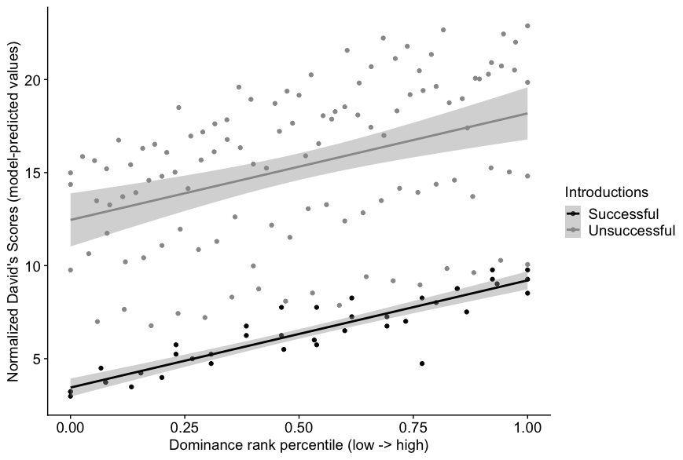
Figure A1. Relationship between dominance rank and Normalized David’s Scores that indicate significant differences in the slopes, i.e., in hierarchy steepness, for groups that experienced successful (black) versus unsuccessful (grey) male introductions.

Figure A2. Box and whisker plots showing the mean grooming clustering coefficients by period, for each of three groups that experienced successful male introductions.

