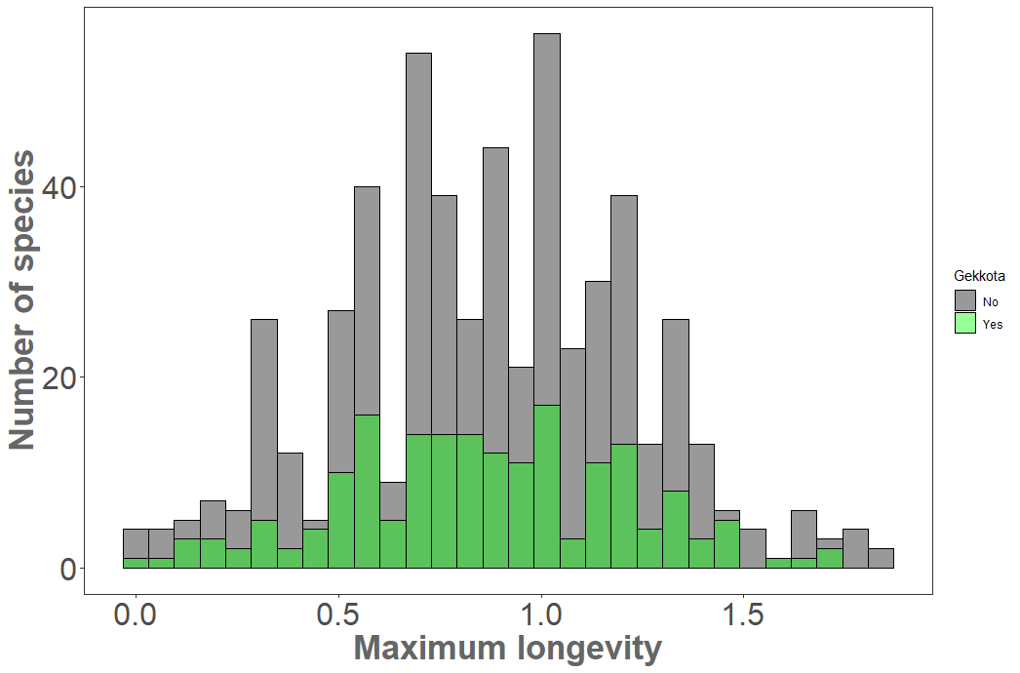
Figure S1. Distribution of the (log10) maximum longevity (in years) of the 740 lizard species. Gekkota species (n = 185) are represented by the green columns, and the non-gekkotan species (n = 555) are represented by the gray columns.

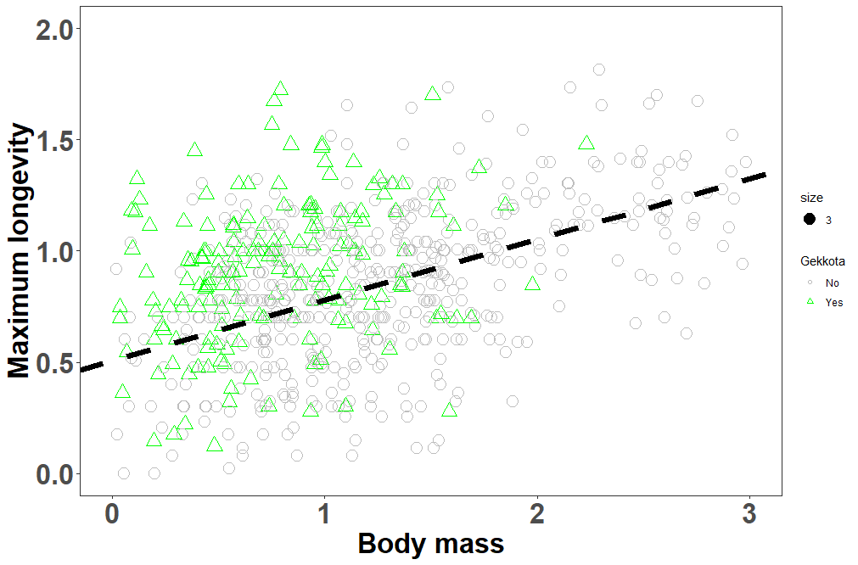
Figure S2. The relationship between maximum longevity (in years, log10 transformed), and body mass (in grams, log10 transformed) between gekkotan species and all the rest of the lizard clades. Gekkotan species (n = 185) are depicted in green triangles, and non-gekkotan lizards (n = 555) are depicted in gray circles. Regression (black dashed line) represents all lizard species together.

Figure S3. The relationship between maximum longevity (in years, log10 transformed), and body mass (in grams, log10 transformed), across activity levels (diurnal: orange triangles; nocturnal: black squares; cathemeral: purple circles). Regression (green dashed line) represents for : (A) All lizards, (B) Gekkotan species only.
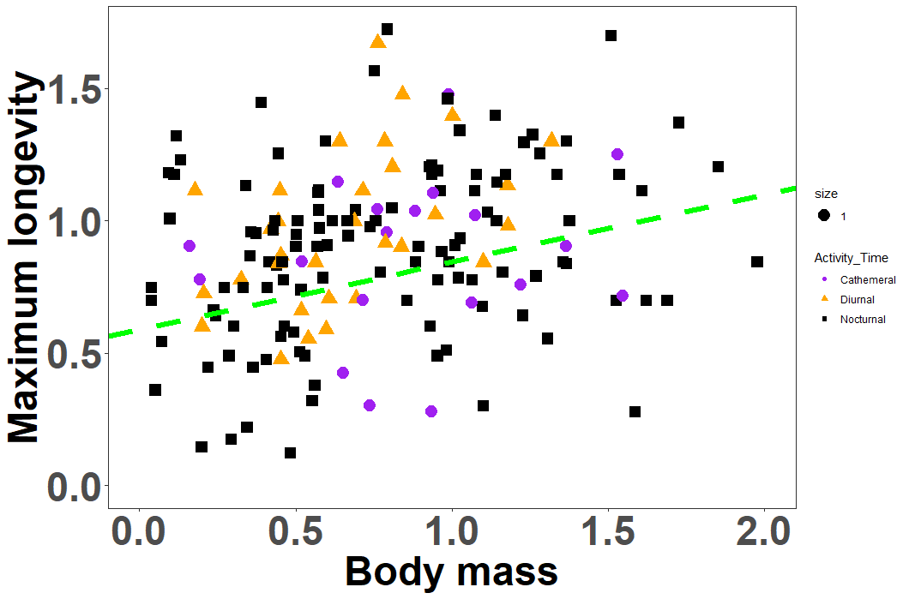
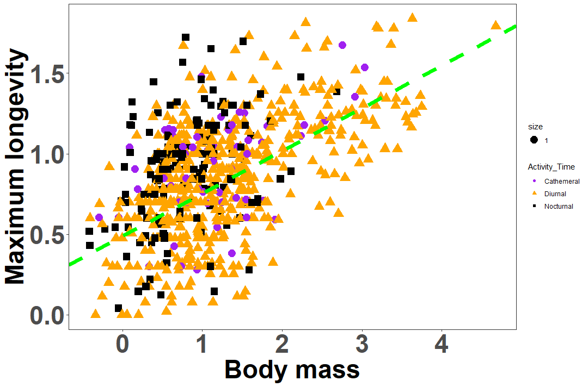
(A)
(B)

