APPENDIX A: MATHEMATICAL MODEL

The model of foreign policy alliance preference is given below as: π_{ij} = Pr {Yi = j}, which denotes the probability that the i-th response falls in the j-th category. For example, π_{i1} is the probability that the ith respondent prefers NATO; π_{i2} is the probability that the ith respondent prefers CSTO and π_{i3} is the probability that the ith respondent prefers both equally. We assume that the response categories are mutually exclusive and exhaustive, so we have Σ^{J}_{j=1} (π_{ij}) = 1 for each i. This means that the probabilities add up to one for each individual, and once we know the probability of two, we automatically know the remaining probability of the last category. This requires two equations. The missing contrast can be obtained in terms of the other two, since log (π_{i1} / π_{i2}) = log (π_{i1} / π_{i3}) - log (π_{i2} / π_{i3}).

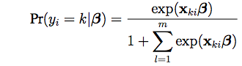

where is a (1 x r) dimensional covariate vector, and are unknown regression coefficients of dimension r. We assign normal default priors centered at 0 for the beta coefficients.

APPENDIX B: MULTINOMIAL REGRESSION TABLES

Table 4: Georgia: multinomial models of preferring alignment with CSTO and NATO. Base category: alignment with both. SDs in parentheses
Predictors | Model 1 |  | Model 2 |  | Model 3 |  | Model 4 |  | Model 5
 | CSTO | NATO | CSTO | NATO | CSTO | NATO | CSTO | NATO | CSTO | NATO
Threat Perception | -1.28*  (0.23) | 1.39*  (0.33) |  |  |  |  | -1.15*  (0.44) | 1.20*  (0.21) | -1.15*  (0.44) | 1.20*  (0.21)
Tensions | -0.16*  (0.06) | -0.02  (0.05) |  |  | -0.17*  (0.06) | 0.02  (0.05) |  |  | -0.18*  (0.07) | -0.02  (0.05)
Religiosity |  |  | -0.10  (0.06) | -0.01  (0.04) | -0.10  (0.05) | -0.01  (0.04) | -0.10  (0.06) | 0.01  (0.04) | -0.10  (0.06) | 0.00  (0.04)
Speak Russian |  |  | 0.30*  (.09) | -0.03  (0.07) | 0.31*  (0.10) | -0.03  (0.07) | 0.27*  (0.11) | 0.00  (0.07) | 0.28*  (0.11) | 0.01  (0.08)
Speak English |  |  | -0.31*  (0.11) | 0.36*  (0.06) | -0.33*  (0.11) | 0.36*  (0.06) | -0.31*  (0.11) | 0.34*  (0.07) | -0.32*  (0.12) | 0.35*  (0.07)
Education Level |  |  | -0.04  (0.06) | 0.10*  (0.04) | -0.04  (0.06) | 0.10*  (0.04) | -0.05  (0.06) | 0.11*  (0.04) | -0.04  (0.06) | 0.11*  (0.04)
Income Level |  |  | -0.02  (0.06) | 0.04  (0.05) | 0.01  (0.07) | 0.04  (0.05) | 0.07  (0.07) | 0.03  (0.05) | 0.01  (0.07) | 0.03  (0.05)
N | 1702 |  | 1702 |  | 1702 |  | 1702 |  | 1702
* p < .05

Table 5: Armenia: Multinomial models of preferring alignment with CSTO and NATO. Base category: Preferring alignment with both CSTO and NATO. SDs in parentheses
Predictors | Model 1 |  | Model 2 |  | Model 3 |  | Model 4 |  | Model 5
 | CSTO | NATO | CSTO | NATO | CSTO | NATO | CSTO | NATO | CSTO | NATO
Threat Perception | 0.44  (0.45) | -1.21*  (0.48) |  |  |  |  | 0.32  (0.47) | -1.25*  (0.48) | 0.30  (0.46) | -1.22*  (0.49)
Tensions | 0.04  (0.05) | -0.26*  (0.09) |  |  | 0.05  (0.05) | -0.25*  (0.09) |  |  | 0.05  (0.05) | -0.25*  (0.09)
Religiosity |  |  | -0.06  (0.04) | -0.02  (-0.08) | -0.06  (0.04) | -0.03  (0.08) | -0.06  (0.04) | -0.03  (0.08) | -0.06  (0.04) | 0.04  (0.08)
Speak Russian |  |  | 0.08  (0.10) | -0.03*  (0.19) | 0.07  (0.10) | -0.01  (0.19) | 0.08  (0.10) | -0.05  (0.19) | 0.07  (0.10) | -0.04  (0.19)
Speak English |  |  | -0.04  (0.08) | 0.33*  (0.14) | -0.04  (0.08) | 0.31*  (0.13) | -0.04  (0.08) | 0.33*  (0.13) | -0.04  (0.08) | 0.31*  (0.13)
Education Level |  |  | -0.13*  (0.05) | -0.08  (0.10) | -0.13*  (0.05) | -0.06  (0.09) | -0.12*  (0.05) | -0.09  (0.09) | -0.12*  (0.05) | -0.07  (0.10)
Income Level |  |  | -0.08  (0.05) | 0.12  (0.09) | -0.08  (0.05) | 0.12  (0.09) | -0.08  (0.05) | 0.12  (0.09) | -0.09  (0.05) | 0.12  (0.09)
N | 1367 |  | 1367 |  | 1367 |  | 1367 |  | 1367

APPENDIX C: FIRST DIFFERENCES PLOTS
Figure 1: First Differences: Marginal Effects of Predictors in Georgia
1. First Differences: Threat Perception Variable
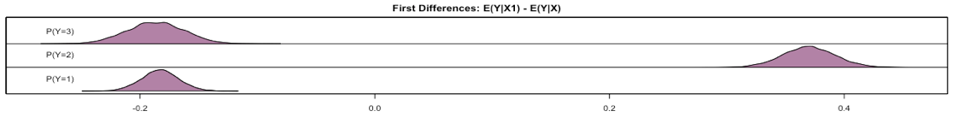
Note: The graph illustrates the first differences given the presence and absence of threat perception effect. It provides visual information about the distribution of the first differences in three expected probabilities whether Georgians will prefer CSTO, NATO or both organizations when they are disposed to perceive threat from Russia. The horizontal line shows the distribution of probability and the vertical line presents three different categories of the dependent variable. Preferring CSTO, NATO or both organizations are given in the top, middle and bottom levels respectively.

2. First Differences: Tensions Variable
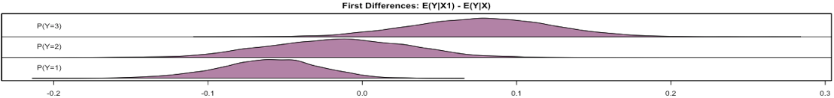
Note: The graph visualizes the first differences given the high and low values of the tensions variable. It provides visual information about the distribution of the first differences in three expected probabilities whether Georgians will prefer CSTO, NATO or both organizations when they are disposed to view the West-Russian tensions detrimental to Georgia. The horizontal line shows the distribution of probability and the vertical line presents the three different categories of the dependent variable. Preferring CSTO, NATO or both organizations are given in the top, middle and bottom levels respectively.

Figure 2: First Differences: Marginal Effects of Predictors in Armenia
1. First Differences: Threat Perception Variable
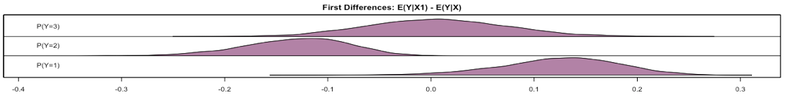
Note: The graph illustrates the first differences given the presence and absence of the threat perception effect. It provides visual information about the distribution of the first differences in three expected probabilities whether Armenians will prefer CSTO, NATO or both organizations when they are disposed to perceive threat from Azerbaijan or Turkey. The horizontal line shows the distribution of probability and the vertical line presents three different categories of the dependent variable. Preferring CSTO, NATO or both organizations are given in the top, middle and bottom levels respectively.

2. First Differences: Tensions Variable
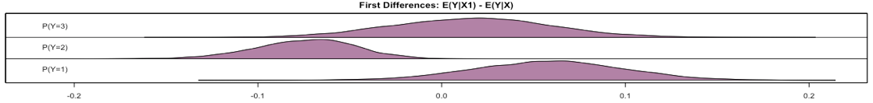
Note: The graph visualizes the first differences given the high and low values of the tensions variable. It provides visual information about the distribution of the first differences in three expected probabilities whether Armenians will prefer CSTO, NATO or both organizations when they are disposed to view the West-Russian tensions detrimental to Armenia. The horizontal line shows the distribution of probability and the vertical line presents three different categories of the dependent variable. Preferring CSTO, NATO or both organizations are given in the top, middle and bottom levels respectively.
APPENDIX D: CLUSTERING IN THE SAMPLING
The Multi-stage cluster sampling with preliminary stratification is used in the survey designs of both the Caucasus Barometer 2017 Georgia and Armenia. The survey mode is Computer-assisted personal interview (CAPI). To address the survey design effect on the standard errors, we estimated the models, in which the survey design effects were taken into consideration. These models provided identical results as the standard errors and slope coefficients were the same. Table 6(Georgia) and Table 7(Armenia) present the results of these models.

Table 6: Georgia: Multinomial models of preferring alignment with CSTO and NATO
Predictors | Model 1 |  | Model 1 with Weights |  | Model 1 with Strata
 | CSTO | NATO | CSTO | NATO | CSTO | NATO
Threat Perception | -1.28*  (0.23) | 1.39 *  (0.33) | -1.28*  (0.23) | 1.39 *  (0.33) | -1.28*  (0.23) | 1.39 *  (0.33)
Tensions | -0.16* (0.06) | -0.02  (0.05) | -0.16*  (0.06) | -0.02  (0.05) | -0.16*  (0.06) | -0.02  (0.05)
N | 1702 |  | 1702 |  | 1702
* p < .05
Note: the table presents the results of three versions of Model 1. The first version just estimates the effect of two independent variables without the survey design effect. The second version estimates the effect of two independent variables with the weights effect. The third version estimates the effect of the independent variables with the stratification effect. All three versions provide identical results (the same standard errors and slope coefficients). Base category: preferring alignment with both CSTO and NATO. SEs are in parentheses.

Table 7: Armenia: Multinomial models of preferring alignment with CSTO and NATO
Predictors | Model 1 |  | Model 1 with Weights |  | Model 1 with Strata
 | CSTO | NATO | CSTO | NATO | CSTO | NATO
Threat Perception | 0.44 (0.45) | -1.21*  (0.48) | 0.44  (0.45) | -1.21*  (0.48) | 0.44  (0.45) | -1.21*  (0.48)
Tensions | 0.04 (0.05) | -0.26 *  (0.09) | 0.04  (0.05) | -0.26*  (0.09) | 0.04  (0.05) | -0.26*  (0.09)
N |  | 1367 |  | 1367 |  | 1367
* p < .05
Note: the table presents the results of three versions of Model 1. The first version just estimates the effect of two independent variables without the survey design effect. The second version estimates the effect of two independent variables with the weights effect. The third version estimates the effect of the independent variables with the stratification effect. All three versions provide identical results (the same standard errors and slope coefficients). Base category: preferring alignment with both CSTO and NATO. SEs are in parentheses.

