APPENDIX D
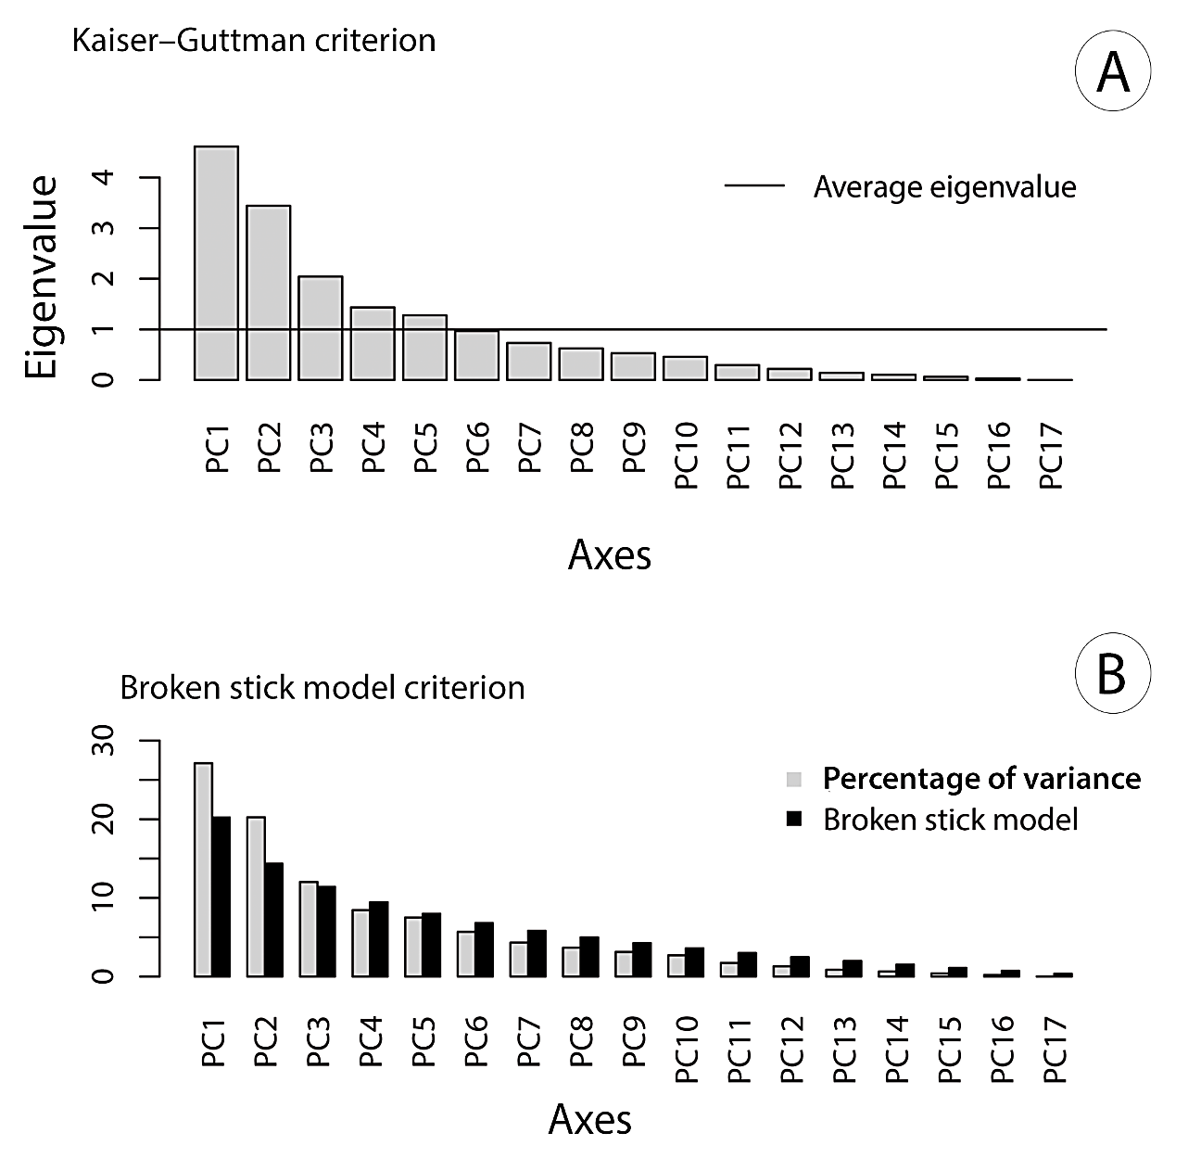
Fig. D1. Kaiser–Guttman (A) and broken-stick (B) plots to assess the number of interpretable axes in PCA of Moquiniastrum polymorphum.

COMMENTS
- The Kaiser–Guttman criterion consists in estimating the mean eigenvalues of all axes and considering only the axes whose eigenvalues are higher than that mean. Thus, for M. polymorphum, the first five axes should be interpreted in the PCA.
- The broken stick model criterion consists in randomly divide a stick of unit length into the same number of pieces as there are PCA axes, then the pieces are organized in order of decreasing length. These pieces are compared to the eigenvalues e the axes that should be interpreted are those whose eigenvalues are higher than the length of the corresponding piece of the stick. Thus, for M. polymorphum, the first three axes should be interpreted in the PCA.
- Both criteria were performed using the script provided by Borcard et al. (2011).

REFERENCE
Borcard D, Gillet F, Legendre P. 2011. Numerical Ecology with R. Springer, Berlin. DOI 10.1007/978-1-4419-7976-6

