APPENDIX F

Detailed qualitative anatomy description of the vascular system of Moquiniastrum polymorphum and Zanthoxylum rhoifolium

Moquiniastrum polymorphum
Secondary xylem – Vessels: wood diffuse-porous; vessels with different diameters (Fig. F1); vessels in tangential bands at the beginning of the growth ring and in diagonal or dendritic pattern along the tree ring (Fig. F2A); heartwood vessels with brownish and blackish content in trees from savanna (dry 1) and woodland savanna (dry 3; Fig. F2A). We did not reach the heartwood in tress of semi-deciduous seasonal forest (dry 2) and rainforest (wet). Simple perforation plates (Fig. F2F); intervessel pits alternate and circular shape (Fig. F2B); vessel-ray pits with distinct borders, similar to intervessel pits in size and shape throughout the ray cells (Fig. F2C); helical thickening throughout body of vessel elements (Figs. F2B, C). Fibers: simple to minutely bordered pits in both radial and tangential walls (Fig. F2D). Axial parenchyma: predominantly paratracheal vasicentric and confluent (Fig. F2A); 2–4 cells per parenchyma strand (Fig. F2E). Rays: 1–3 cells width (Fig. F2E); body ray cells procumbent with one row of square marginal cells (Fig. F2F); perforated rays cells with helical thickening present (Fig. F2G).
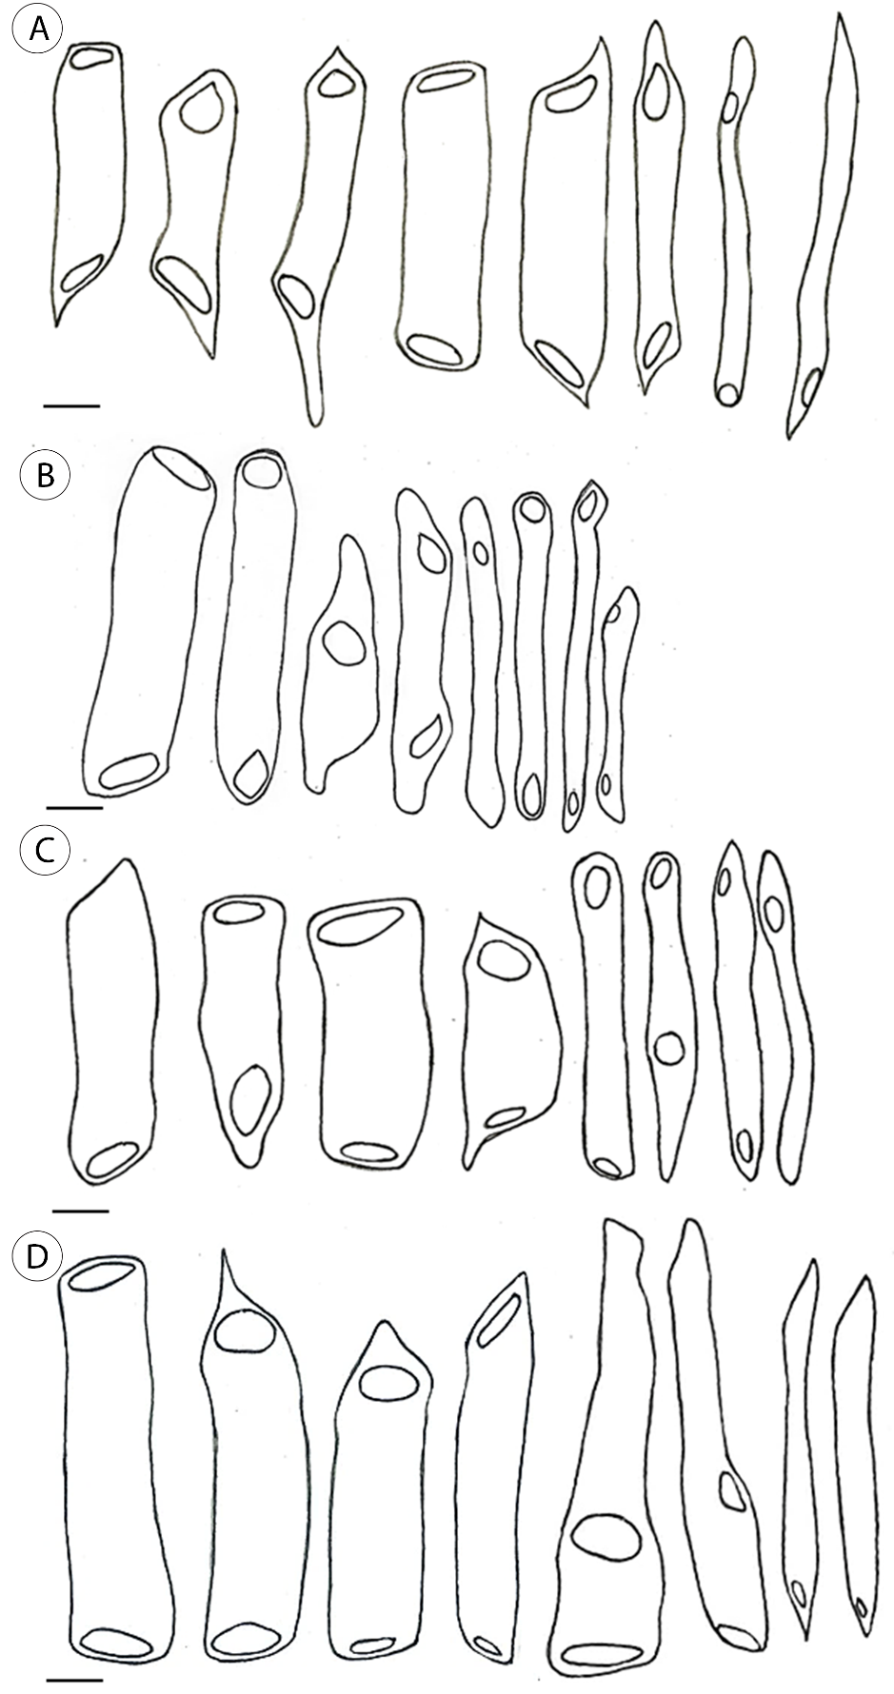
Figure F1. Drawing of vessel elements with different diameters in dissociated material from (A) savanna, dry1; (B) woodland savanna, dry3; (C) semi-deciduous seasonal forest, dry2; (D) rainforest, wet in Moquiniastrum polymorphum. Scale bars: 50 μm.
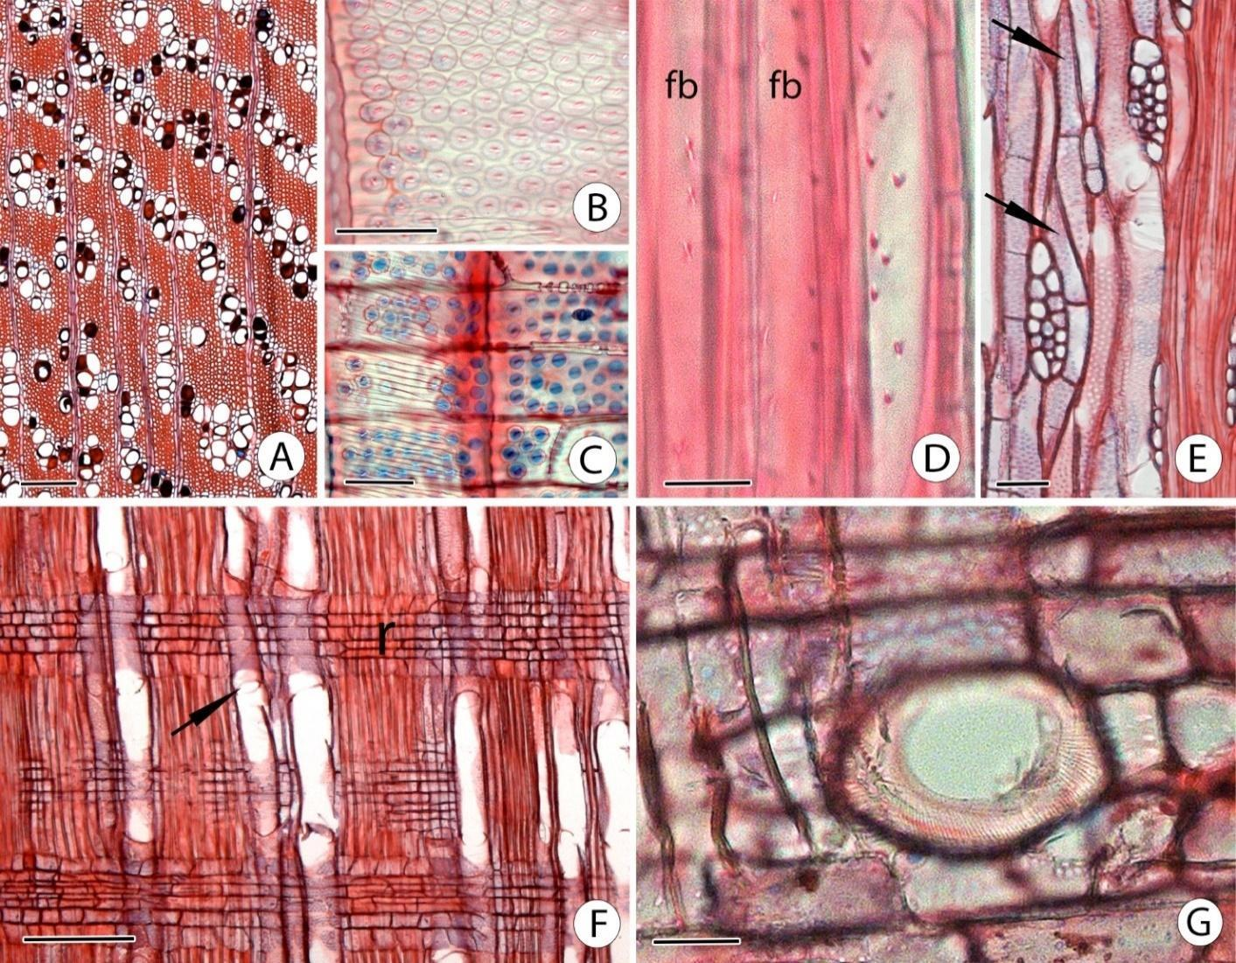
Figure F2. Secondary xylem of Moquiniastrum polymorphum. (A) Heartwood vessels with brownish and blackish content in transverse section. (B) Intervessel pits alternate and helical thickening in a vessel element wall in tangential longitudinal section. (C) Vessel-ray pits similar to intervessel pits and evidenced helical thickening in the wall of the left vessel element in radial longitudinal section. (D) Fibers (fb) with simple to minutely bordered pits in radial longitudinal section. (E) Parenchyma strands with 2 cells (up arrow) and 3 cells (down arrow) in tangetial longitudinal section. (F) Simple perforation plate (arrow) and rays with procumbent body cells and one row of square marginal cells in radial longitudinal section. (G) Perforated ray cells in radial longitudinal section. Scale bars: A, F = 200 µm; B, C, G = 20 µm; D = 10 µm; E = 50 µm.

Secondary phloem – Composed of conducting and nonconducting phloem (Fig. F3B). Open pores in the sieve areas of mature sieve elements characterized the conducting phloem, callose was presented around the pores. Callose plugging the pores of the sieve areas (definitive callose) and collapsed sieve tubes and companion cells characterized the nonconducting phloem (Fig. F3A, B). Sieve tubes: solitary and in small groups (2–3 cells) randomly scattered among the other phloem cell types (Fig. F3A); transversal (Fig. F3B) or slightly inclined (Fig. F4A) simple sieve plates and strongly inclined scalariform sieve plate with 2–9 areas per plate (Fig. F3B); non-dispersive P-protein (Fig. F3B). Companion cells: 1–2 in transverse section (Fig. F3A); one cell or strands of two cells in longitudinal sections (Fig. F4A); shorter or with the same length of the sieve-tube elements (Fig. F4A). Axial parenchyma: diffuse and diffuse-in-aggregates distribution (Fig. F3A); 2–4 cells per parenchyma strand (Fig. F4B). Rays: straight rays; 1–4 cells wide (Fig. F4B); body ray cells procumbent with one row of upright and/or square marginal cells (Fig. F3B); ray sieve-tube element present (Fig. F4C); ray cells sclerified when touching sclerenchyma cells (Fig. F3A, B). Sclerenchyma: at the tissue level: fiber-sclereids (Fig. F3C) with diffuse and diffuse-in-aggregate arrangement (Fig. F3A) in the conducting phloem, discontinuous tangential bands of sclerenchyma in nonconducting phloem were found exclusively in populations from the dry3 and wet sites; and sclereids and fibro-sclereids in the non-conducting phloem (Fig. F3C). Storied structure: rays and axial elements irregularly storied (Fig. F4B).

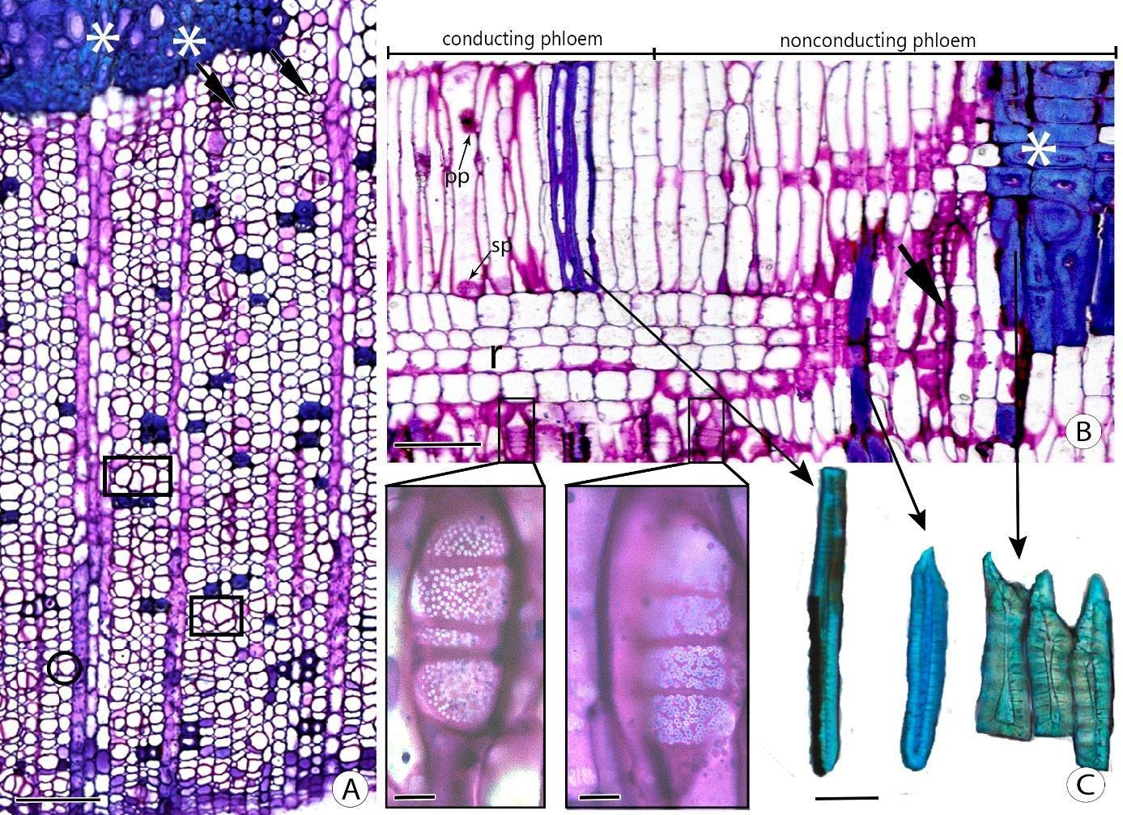
Figure F3. Secondary phloem of Moquiniastrum polymorphum in transverse section (A), radial longitudinal section (B) and dissociated material (C). A. A sieve tube and two companion cells (circle); grouping of two and three sieve tubes (polygons); obliterated sieve tubes and companion cells (arrows); sclerifying ray cells (*); axial parenchyma and fiber-sclereids with diffuse and diffuse-in-aggregate arrangement. B. A portion of the conducting phloem and the nonconducting phloem. In detail, and to the left, the open pores of a scalariform sieve plate, and to the right, the pores of a scalariform sieve plate plugged by callose; non-dispersive P-protein (pp) and transversal simple sieve plate (sp) in a sieve-tube element; obliterated sieve-tube elements and companion cells (arrows); ray (r) with procumbent body cells and upright marginal cells; and sclerifying ray cells (*). C. A fiber-sclereid to the left and sclereids to the right. Scale bars: 50 µm; detail of B = 10 µm.

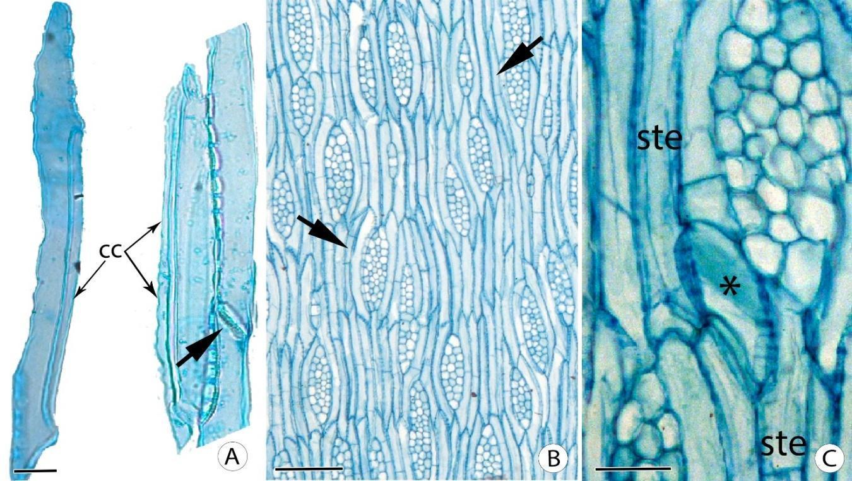
Figure F4. Secondary phloem of Moquiniastrum polymorphum. A. Sieve-tube elements with one shorter companion cell (cc) and a strand of two companion cells (cc) with the same length of the sieve-tube element; and a slightly inclined simple sieve plate (arrow) in the dissociated material. B. Rays with one to four cells wide; rays and axial elements irregularly storied; and parenchyma strands with two (up arrow) and three (down arrow) cells in tangential longitudinal section. C. Ray sieve-tube element (*) connecting two sieve tubes (ste) in tangential longitudinal section. Scale bars: A= 50 µm; B = 100 µm; C = 20 µm.

Zanthoxylum rhoifolium
Secondary xylem – Vessels: wood diffuse-porous; simple perforation plate; intervessel pits alternate and circular shape (Fig. F5B); vessel-ray pits with distinct borders, similar to intervessel pits in size and shape throughout the ray cell (Fig. F5C). Fibers: simple to minutely bordered pits in both radial and tangential walls (Fig. F5D); gelatinous fibers (Fig. F5A) present only in trees from woodland savanna (dry 3) and semi-deciduous seasonal forest (dry 2). Axial parenchyma: axial parenchyma scanty paratracheal (Fig. F5A); 2–4 cells per parenchyma strand (Fig. F5F). Rays: 1–3 cells width (Fig. F5F); body ray cells procumbent with one or two rows of square marginal cells (Fig. F5E). Secretory elements: intercellular canals of traumatic origin with a random distribution (Fig. F5E) present in trees from savanna (dry1), woodland savanna (dry3) and semi-deciduous seasonal forest (dry2). Mineral inclusions: prismatic crystals in chambered axial parenchyma cells next to the intercellular canals of traumatic origin (Fig. F5E) in trees from savanna (dry1).

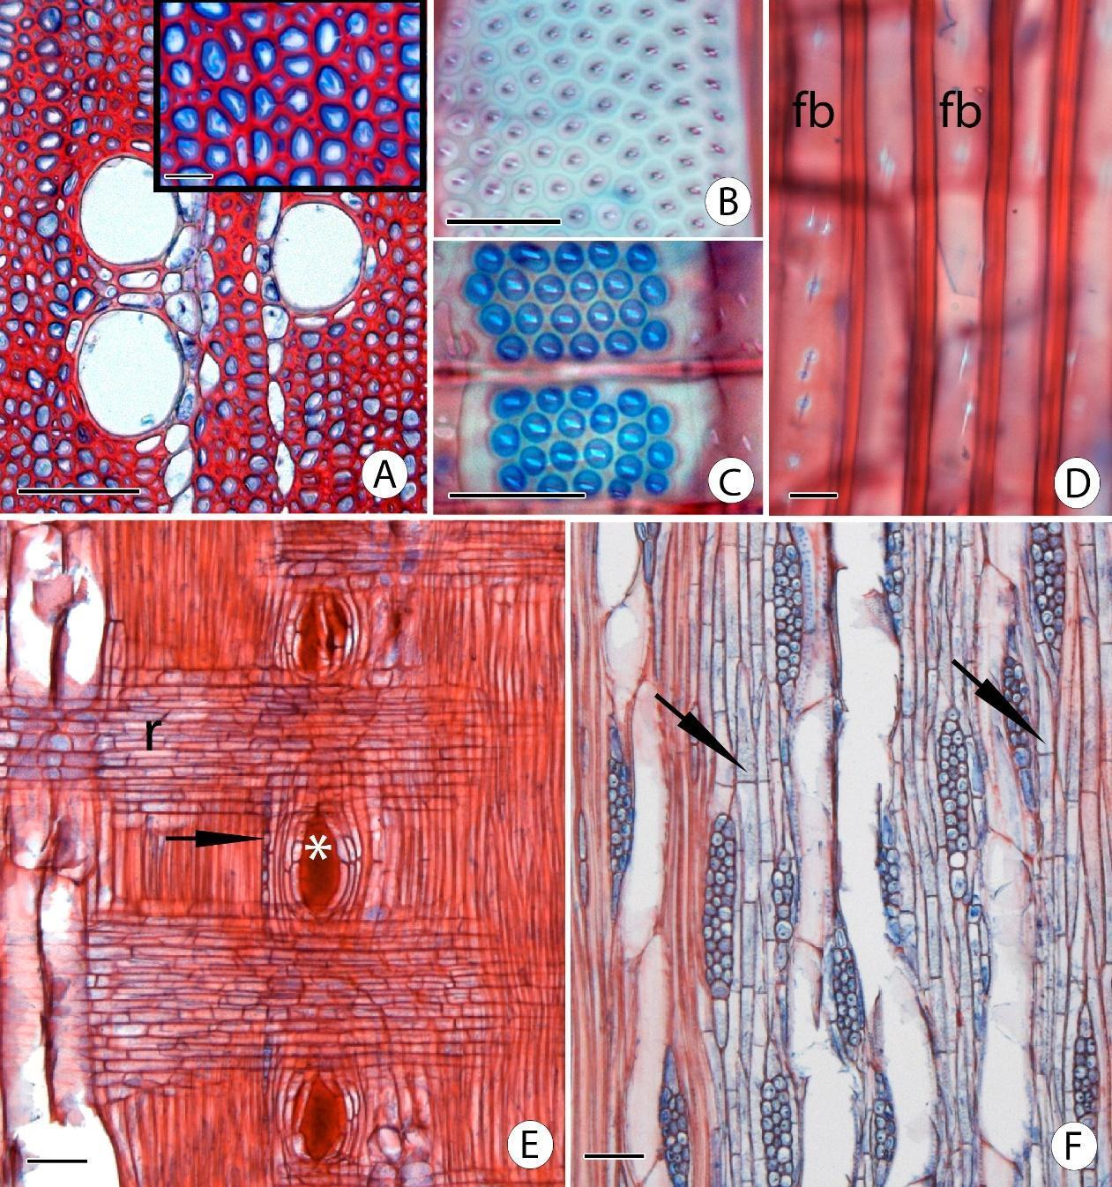
Figure F5. Secondary xylem of Zanthoxylum rhoifolium. (A) Axial parenchyma scanty paratracheal and detail of gelatinous fibers in transverse section. (B) Intervessel pits alternate in tangential longitudinal section. (C) Vessel-ray pits similar to intervessel pits in radial longitudinal section. (D) Fibers (fb) with simple to minutely bordered pits in radial longitudinal section. (E) Intercellular canals of traumatic origin (*); prismatic crystals in chambered axial parenchyma cells (arrow); and ray (r) composed by procumbent body cells and one row of square marginal cells in radial longitudinal section. (F) Rays with two and three cells wide; axial parenchyma strands with two cells (right arrow) and with four cells (left arrow) in tangential longitudinal section. Scale bars: A, E, F = 100 µm; detail of A, B, C = 20 µm; D = 10 µm.

Secondary phloem – Composed of conducting and nonconducting phloem (Fig. F6B). The conducting phloem was characterized by open pores in the sieve areas of mature sieve elements, callose was presented around the pores of the sieve plates (Fig. F6B). Callose plugging the pores of the sieve areas (definitive callose) (Fig. F6B) and collapsed sieve tubes and companion cells (Fig. F6A, B) characterized the nonconducting phloem. Sieve tubes: solitary and in small groups (2–4 cells) randomly scattered among the other phloem cell types (Fig. F6A); transversal or slightly inclined (Fig. F6B) simple sieve plates and strongly inclined scalariform sieve plate with 2–8 sieve areas (Fig. F7A, C); sieve areas present throughout the body of sieve-tube element (Fig. F7A). Companion cells: 1–3 cells in transverse section (Fig. F6A); one cell shorter than sieved tube elements in longitudinal sections (Fig. F7C). Axial parenchyma: 2–4 cells per parenchyma strand (Fig. F7A). Rays: wavy rays; 1–3 cells wide (Fig. F7A); body ray cells procumbent with one row of upright and/or square marginal cells (Fig. F6B). Sclerenchyma: at the cellular level: fibers with rounded to polygonal shape in transversal section (Fig. F6A) in conducting phloem and fibers and sclereids in the nonconducting phloem; gelatinous fibers is presented in all sites (Fig. F6A). Sclerenchyma: at the tissue level: fibers in tangential bands in the conducting phloem and fibers in tangential bands plus sclereids groups in diffuse and diffuse-in-aggregates arrangement in the nonconducting phloem. Secretory structures: secretory cells (idioblasts) in the axial parenchyma and in the rays. Mineral inclusions: prismatic crystals in chambered axial parenchyma cells next to fiber bands (Fig. F6B); acicular crystals in sheaf-like aggregates (Fig. F7B) in axial and radial parenchymas (Fig. F6B).

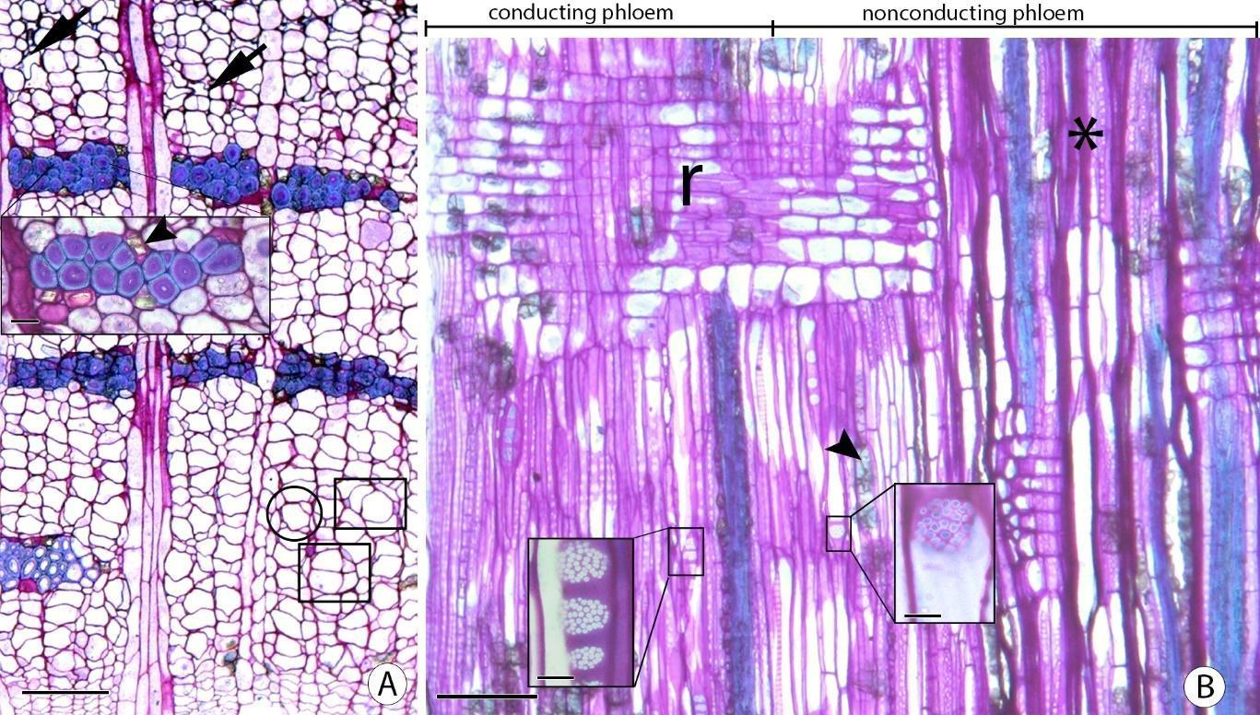
Figure F6. Secondary phloem in Zanthoxylum rhoifolium in transverse section (A) and radial longitudinal section (B). (A) Groupings of two and four sieve tubes (polygons); solitary sieve tube with three companion cells (circle); obliterated sieve tubes and companion cells (arrows); fibers with rounded to polygonal shape; and, in detail, gelatinous fibers and prismatic crystals (arrowhead) next to fiber bands. (B) A portion of the conducting phloem and the nonconducting phloem. In the left detail, the open pores of a scalariform sieve plate, and in the right detail, the pores of a simple and slightly inclined sieve plate plugged by callose; obliterated sieve tubes and companion cell (*); prismatic crystals (arrowhead) in axial parenchyma cells; and ray (r) composed by procumbent body cells and one row of upright and/or square marginal cells with acicular crystals. Scale bars: 50 µm; details = 20 µm.

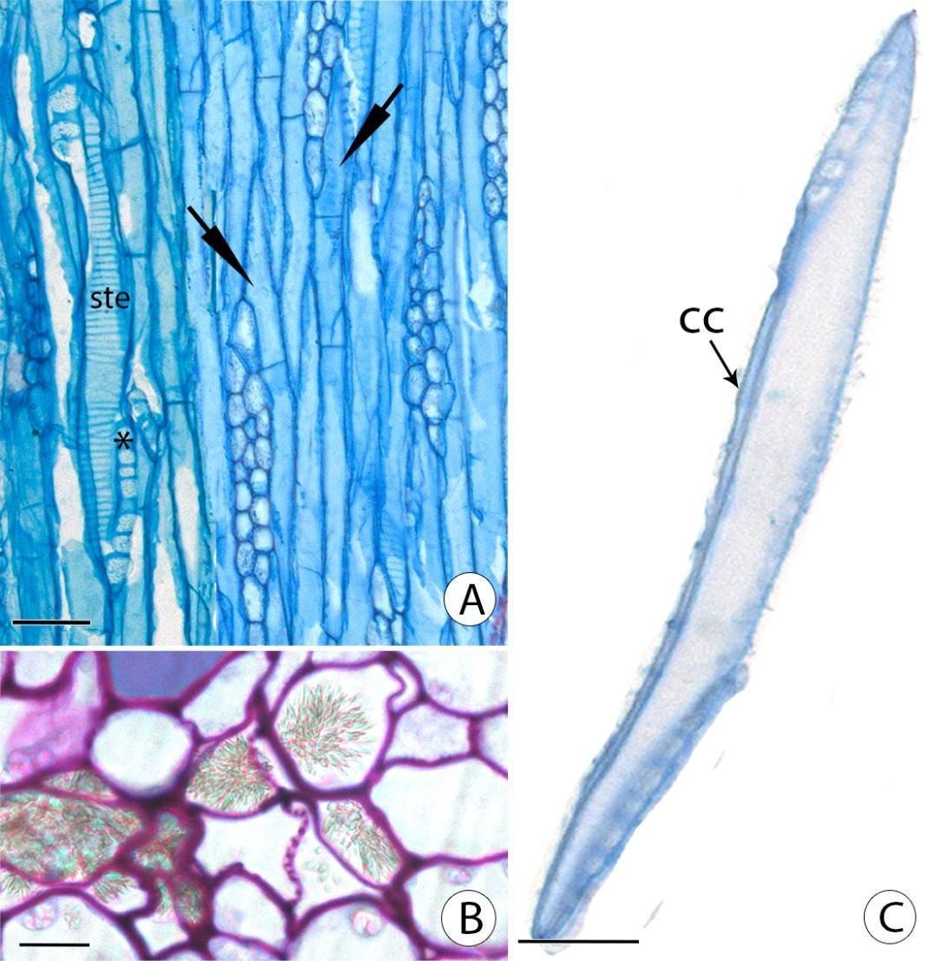
Figure F7. Secondary phloem in Zanthoxylum rhoifolium. (A) Rays with three cells wide; inclined and scalariform sieve plates (*); sieve areas throughout the body of a sieve-tube element (ste); and axial parenchyma strands with two and three cells (arrow) in tangential longitudinal section. (B) Acicular crystals in sheaf-like aggregates in the axial parenchyma in transverse section. (C) Sieve-tube element with one companion cell (cc) and strongly inclined scalariform sieve plate in dissociated material. Scale bars: A, C = 50 µm; B = 10 µm.

