Appendix

A1. Reproductive behaviour
During courtships, males typically called from a concealed place in the leaf litter or on perches up to 53 cm above the ground. In general, when a female approached a calling male, he stopped calling and led her to the oviposition site. Leading to oviposition sites sometimes involved prolonged exploration of the leaf litter. Males travelled up to 2 m from the original site to find the appropriate place to oviposit, which always occurred in the leaf litter. While guided, the female repeatedly stroked the male’s back. Occasionally, when they moved through the leaves, the female began to touch the male more frequently on his back, and even climbed up him rubbing his head as courtship progressed. When a female ceased to follow the male, he turned back toward her and started calling until she resumed walking. If males took a long time to find a suitable site for oviposition, females stopped following him and/or went to another close calling male. In cases when a male detected a close female and she did not respond to the male’s call, he approached and faced her, calling intensely.
We observed 25 courtship events in the field. Mating leading to oviposition was observed in eight occasions and lasted between 66 and 140 min (98 ± 30.8). When the male chose the right place under the leaf litter, the female sat on the leaf and began to contract the stomach and moved her hind legs while laying eggs. Meanwhile, the male stayed near the female, but in some cases left the site and started calling when another male was close. On occasion, the male touched the female with his forelimb or walked over her. Males were observed stroking the female while she was laying eggs. Normally, a female laid 1–2 eggs (1.1 ± 0.35, n = 8 clutches) and once she finished the male landed on the eggs, most likely fertilizing them. After that, the couple separated, and the male stayed near the eggs.
Individuals were observed courting with different mates (n = 6). Nonetheless, in two scenarios males were found breeding with the same female. In one of these events the male succeeded to oviposit with the female initially, but during the second encounter the female rejected him. Males were observed courting with other females even when the female had recently laid eggs. Usually, males remained near the place where they oviposited which may allow them to care for more than one clutch simultaneously. Thus, the male could attract other females while the eggs developed. On one occasion, we observed a male breeding with a female that laid eggs a few centimetres away from a previous mate. Males did not court with females during tadpole transportation. Two females were observed trying to court males with tadpoles (n = 2); females approached males and did tactile stimulation; however, the males did not respond.
We observed 14 male–male competitions for female attention. Usually, both males started a calling interaction and, ultimately, physical bouts (n = 3). As this occurred, the female stayed close to both males. Occasionally, when two males courted the same female, she corresponded by touching both males (n = 2).

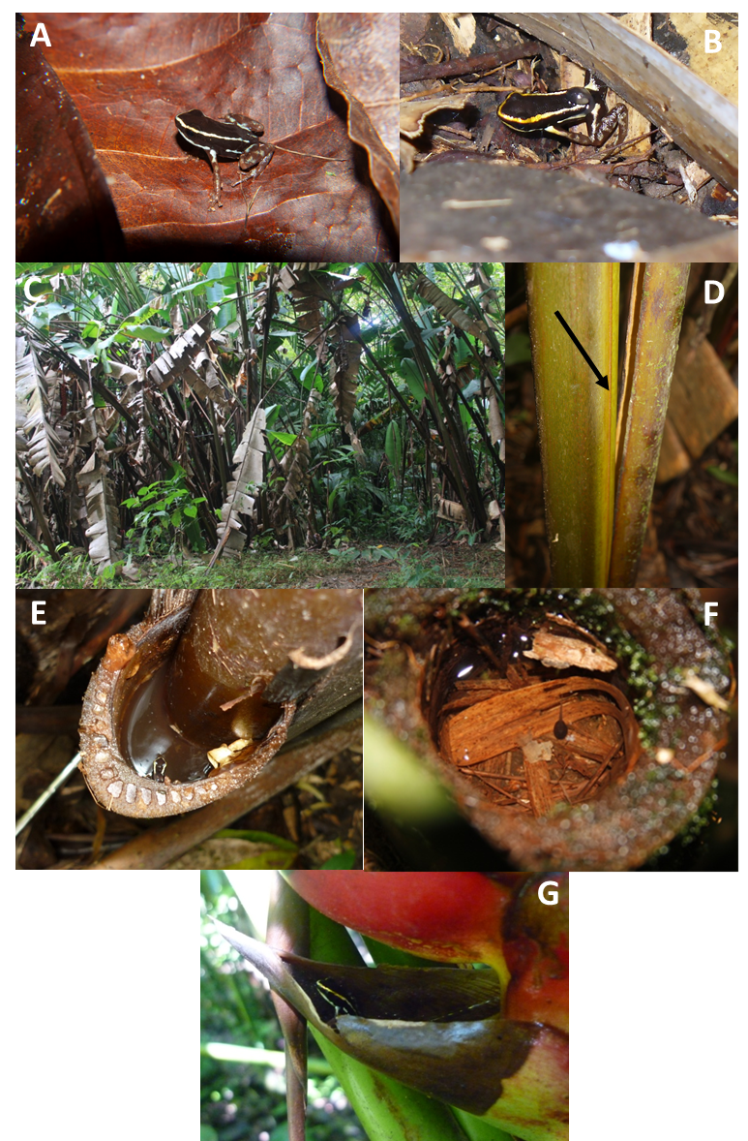
Figure A1. Photographs illustrating the plants used for tadpole deposition by Andinobates claudiae. (A) Individual of A. claudiae, (B) male transporting a tadpole, (C) example of a large clump of Heliconia mariae within our study site, (D) stem axil formed in a H. mariae as the stem grows, (E) male A. claudiae carrying a tadpole inside the stem axil of H. mariae, (F) A. claudiae tadpole inside a bamboo node, and (G) a male A. claudiae inspecting an axil leaf of Heliconia imbricata.

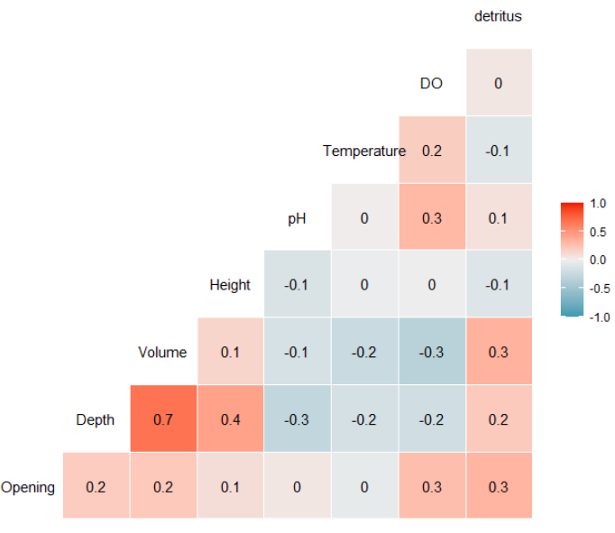
Figure A2. Correlation matrix of the parameters measured in every phytotelmata. The graph shows the correlation coefficient between each variable.

Table A1. Values resulting from the ‘drop1’ function computed on the full model testing the following predictor variables.
Variable | df | AIC | LRT | Pr(>Chi)
Opening | 1 | 75.85 | 0.14 | 0.71
Height | 1 | 82.45 | 6.74 | 0.01
Water volume | 1 | 80.78 | 5.07 | 0.02
pH | 1 | 78.47 | 2.76 | 0.10
Temperature | 1 | 77.44 | 1.72 | 0.20
Dissolved oxygen | 1 | 76.09 | 0.38 | 0.54
Detritus | 1 | 77.30 | 1.58 | 0.21
Plant species | 1 | 77.88 | 2.16 | 0.14
Variables in italics of each row indicate variables that contribute significant to the model.

Table A2. Model selection results after information-theoretic-based model selection.
Rank | Model | AICc | Δ AICc | Weights
1 | tads ~ H + V | 76.21 | 0.00 | 0.93
2 | tads ~ O+ H + V +pH + T + DO + DT + P | 81.24 | 5.04 | 0.07
Models are ranked by their corrected Akaike’s information criteria (AICc). Variables: tads (number of tadpoles deposited), O (phytotelm size opening), H (height), V (water volume), pH (water pH), T (wate temperature), DO (water dissolved oxygen), DT (amount of detritus), P (plant species).

