Appendix
Encounter with embedded food influences its processing by an urbanizing macaque species
A1. Methods
A1.1 Study groups
Based on McKinney's (2015) anthropogenic influence classification system on primate populations, the Bull temple group was coded as F₃J₃G₃B_{2,3} (F, protected area but with major habitat modification, such as macaque temples or other high-contact tourist sites; 3, with significant variation within the study group’s home range; J, apparent dependence (>75% of total diet) on stolen or provisioned human foods; G, researchers plus (primarily) tourists; daily proximity; intensive interactions, such as taking food from hands or climbing on people; B, human predation absent; indigenous predator population reduced; 2, with significant social variation (by age, sex, or rank)). We coded the FH group as F₃J_{2,3}F_{2,3}B₂ (3rd F, researchers plus (primarily) tourists; daily proximity; moderate interactions, such as occasional provisioning). We coded TB group as L_{1,3}H_{1,2,3}N₃N₃ (L, non-protected agricultural area; agricultural landscape that allows for foraging or travel pathways; 1, with significant seasonal variation; H, regular addition (>25% of total diet) of both crops and stolen/provisioned human foods; N, researchers plus (primarily) local people; proximity with humans less frequently than daily; minor interactions, such as photographing animals or anthropogenic noise; N, human predation for the purposes of pest management only).

A1.2. Experimental design
Volunteer experimenters were chosen if he/she did not visit the locations of the study groups at least 4 months prior to the experiment. To ensure moderate levels of familiarity, the volunteer experimenters remained within 5–15 m vicinity of the target macaque till no evasive movements (such as walking away) and/or threats (such as open mouth threat) were directed at the experimenter. This exercise was termed ‘familiarization’. Experimenters received strict guidelines and protocol to follow during familiarization. Except in cases of bulk offering of peanuts in the TB group, familiarization typically lasted between 3 and 20 minutes.
A2. Discussion
Mechanistically, PR and RG require advanced perceptual-motor and sensory-motor skills that comprise of the following steps: (1) Orienting nut (PR, on palm; RG, on horizontal smooth substratum) along the sagittal plane mediated by visual cues and static tactile cues; (2) positioning processing hand (PR, non-contact hand over the other hand; RG, processing hand over substratum) such that the nut is in contact with the palm(s) controlled by static tactile cues, (3) rubbing nuts (PR, against palms; RG, rolling nuts against substratum) through perception of dynamic pressure and dynamic tactile cues followed by a cognitive prediction of the nut condition; and (4) cessation of rubbing/rolling based on either, visual/auditory/tactile cue of the separation of skin or cognitive prediction. As a result, we found young individuals struggle to use PR and RG, which denoted an ontogenetic constraint in the use of these methods.

Table A1. Model summary of the multilevel generalized mixed modelling to determine factors influencing duration of peanut processing methods.
Variable | Category | β | SE β | z | p
Constant | - | 5.788 | 0.192 | 30.135 | <0.001
Age | Adult (ref.) | – | – | – | –
 | Young | 0.233 | 0.387 | 0.603 | 0.546
Encounter | High (ref.) | – | – | – | –
 | Low | -0.252 | 0.268 | -0.943 | 0.346
 | Moderate | -0.272 | 0.220 | -1.235 | 0.217
Method | M (ref.) | – | – | – | –
 | HM | 0.135 | 0.144 | 0.936 | 0.349
 | NB | -1.315 | 0.184 | -7.153 | <0.001
Model summary: -2*Log-likelihood = 1398.20, N_{SS} = 117. Random effects: ID (Intercept) σ² = 0.127, N_{ID} = 21. Factors used as independent variables included age of macaque (young and adult), encounter with peanuts (high, moderate and low) and method of peanut processing (M, mouth; HM, hand and Mouth; NB, novel behaviour (NB), obtained by combining palm-rubbing and rubbing-on-ground methods of peanut processing) were considered. The identity of individuals (ID) was used as random factor. Model fit used maximum likelihood with Laplace approximation. Ref., reference category; Adult, reference category within ‘Age’; High, reference category within ‘Encounter’ with peanuts; M, reference category within ‘Methods’; SS, sample size.

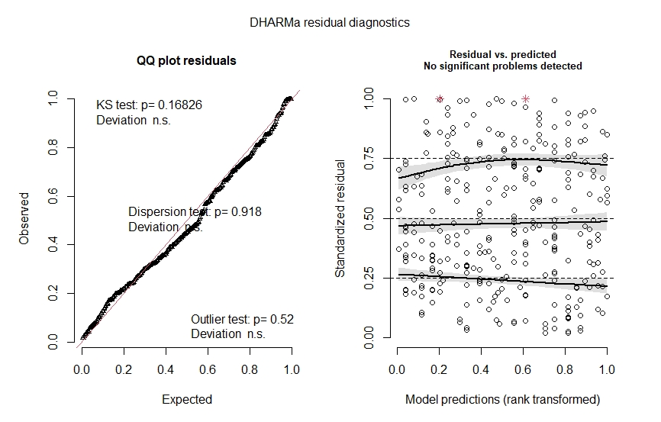

Figure A1. Model diagnostics of the following model, Latency ~ Age + Encounter + Form + State + Encounter*State + Encounter*Form. Latency is modelled as negative binomial distribution using the glmmTMB() function.

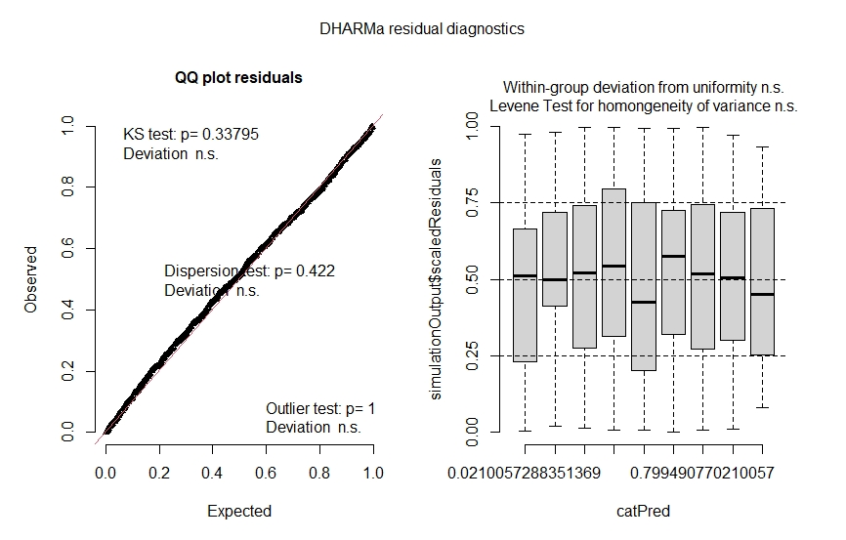

Figure A2. Model diagnostics of the following model, Processing (Present/Absent) ~ Encounter + State + Encounter*State. Occurrence of peanut processing (binary categorical variable) is modelled as binomial distribution using the glmer() function.

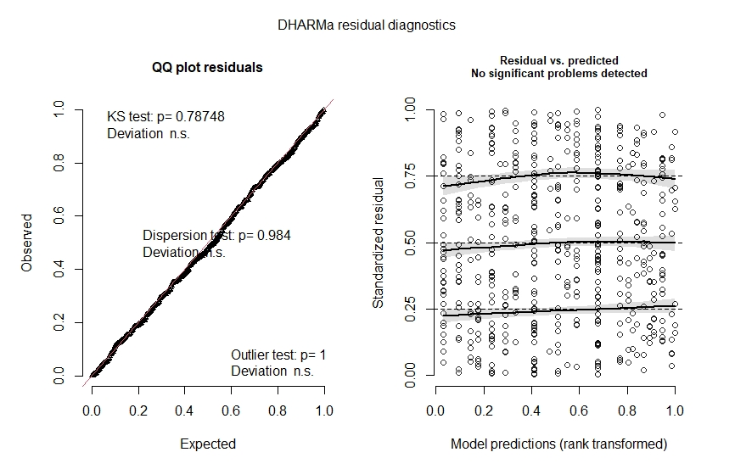

Figure A3. Model diagnostics of the following model, Method ~ Age + Encounter + State. Method (M/HM) is modelled as binomial distribution using the glmer() function.

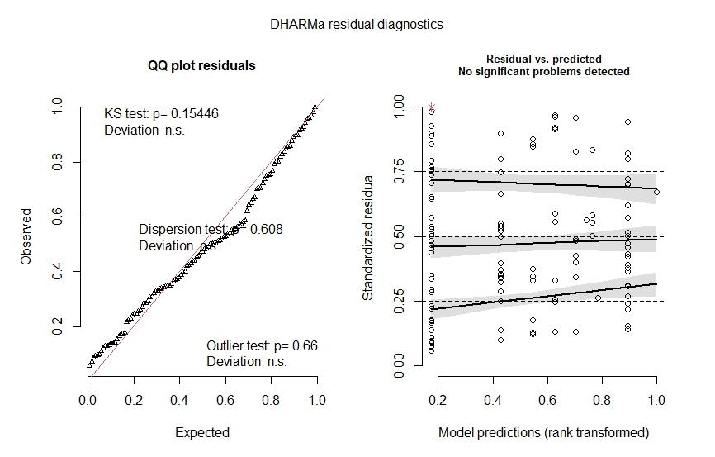

Figure A4. Model diagnostics of the following model, Duration ~ Age + Encounter + Method. Duration is modelled as negative binomial distribution using the glmmTMB() function.

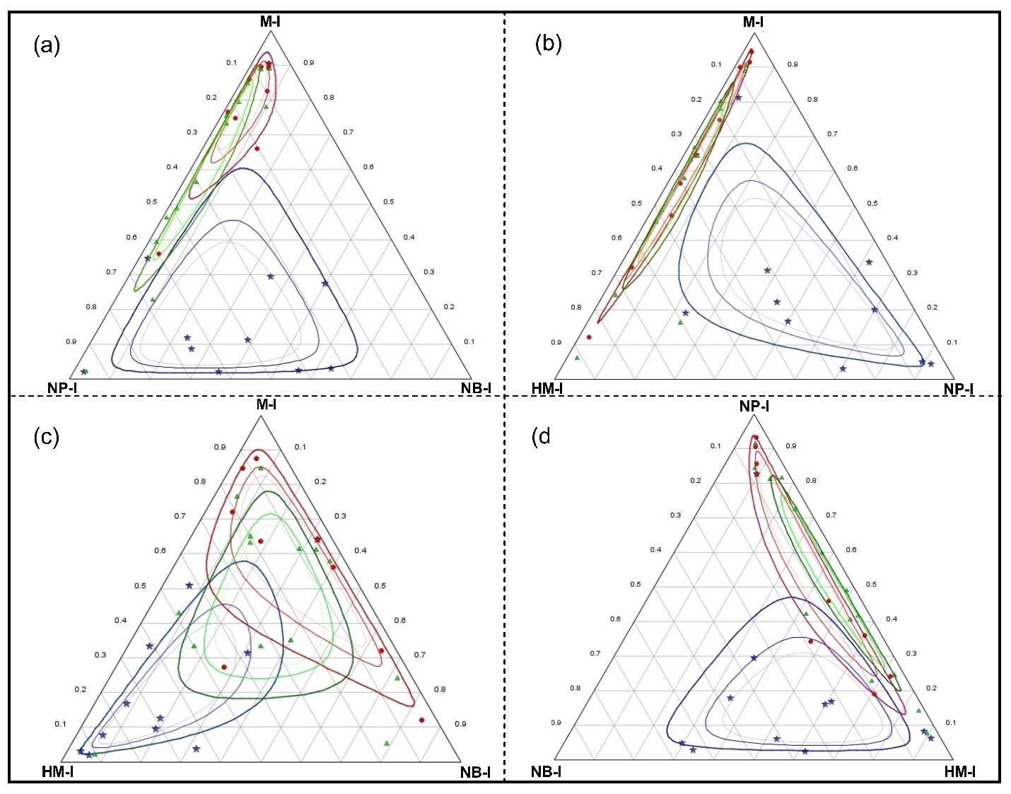
Figure A5. Ternary plots representing relative processing responses/methods of three bonnet macaque groups (blue star, Bull Temple; green triangle, Foot hills; red circle, Talakadu Bettahalli) to shelled-roasted peanuts. Each dot represents a macaque. M, mouth; HM, hand and Mouth (HM); NP, not processed; NB, novel behaviour; I, imputation.

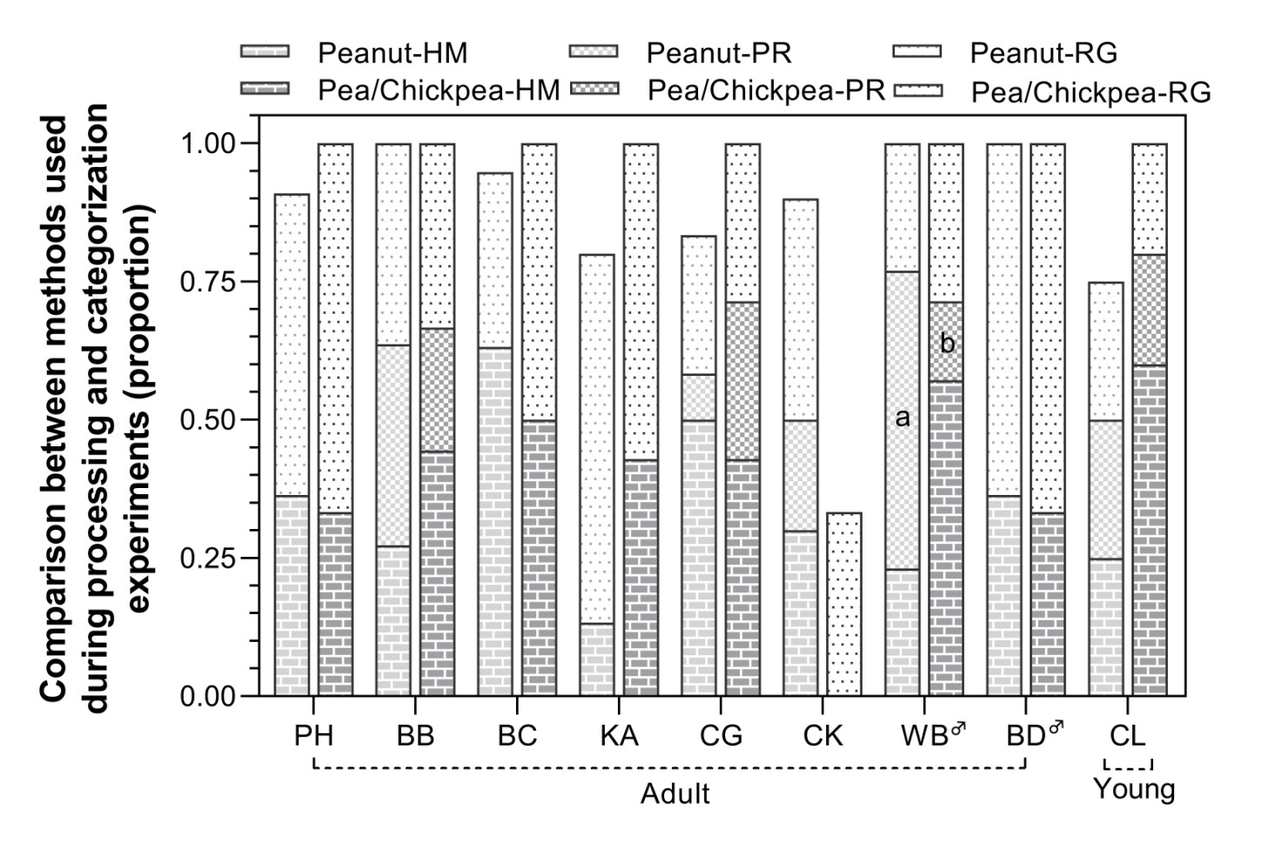

Figure A6. Results of the categorization experiment showing near equivalence of methods used by Bull Temple group in the ‘introductory’ phase (1st bar) and in the ‘flexibility assessment’ phase (2nd bar). The introductory phase used shelled-roasted peanut and the flexibility assessment phase used roasted peas and roasted chickpeas. The methods used by the macaques were HM (hand-mouth), PR (palm rub), RG (rub against ground/substratum) and M (mouth) but only the first three methods are demarcated in the legend. Inclusion of peanut processing by mouth will result in the summation of proportion of each individual to identity. The two alphabets printed within bars depict statistical difference between PR in the introductory phase and PR in the flexibility phase (α=95%). All the remaining paired comparisons between the methods used in the two phases by a macaque reveal statistical equivalence and are not shown. Male macaques are identified by the male symbol in the superscript form.

