Appendix

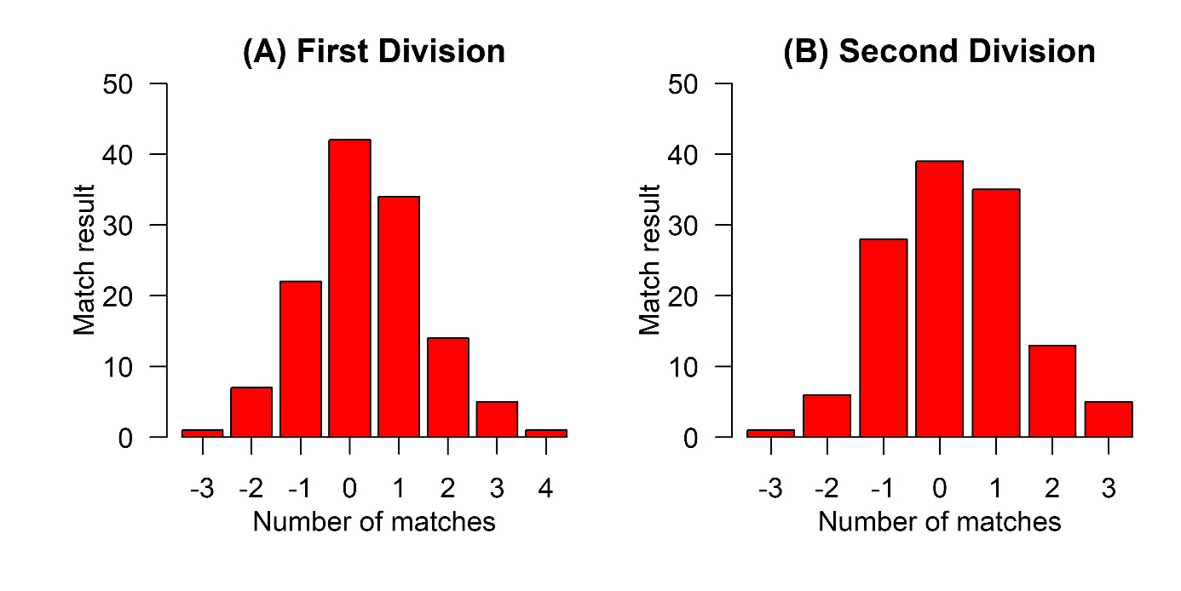

Figure A1. Number of occurrences of each match result (match result: goals scored by home team minus goals scored by away team) in the First Division (A) and in the Second Division (B) of the Brazilian Football Championship (men’s professional leagues) in 2020.

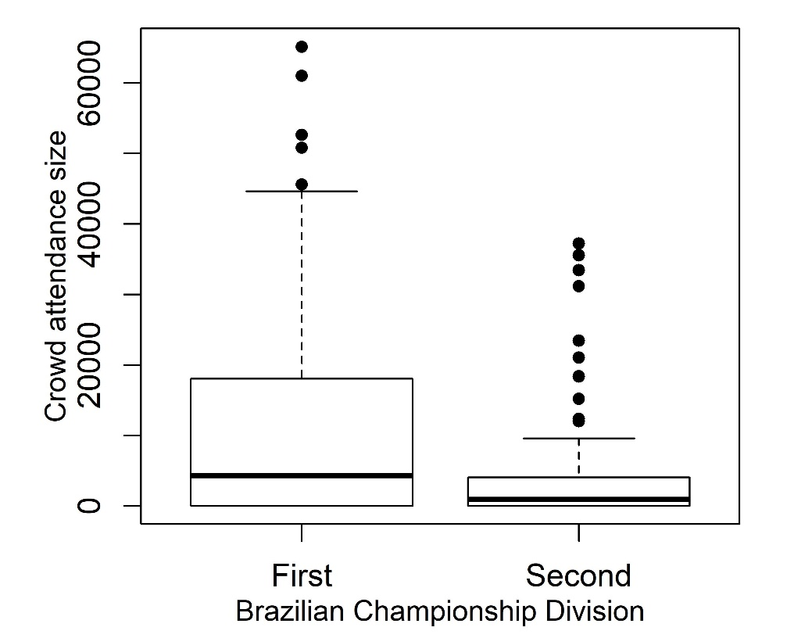

Figure A2. Crowd attendance size in the First and Second Divisions of the 2019 Brazilian Championship (men’s professional leagues). Bold horizontal line, median value; box, the superior limit of the first quartile and the inferior limit of the fourth quartile; whiskers, values range; black dots, outliers.

A1. Data distribution
To test Hypotheses 1, 2, 3 and 4, I tested which data distribution better fits match result values. I contrasted geometric, negative binomial, Poisson, exponential, gamma, normal, and log-normal distributions, using the gofstat function, from the fitdistrplus package (Delignette-Muller & Dutang 2015). I selected the distribution that better fits the data by using the Akaike’s Information Criteria (AIC; Akaike, 1974; Burnham & Anderson 2002). Because some distributions require positive values, for each model, I transformed match result values by setting the lowest value to zero. For all models, the normal distribution is the distribution that better fits the data (i.e., lower AIC values; Table A1). Given that the normal distribution is the one that best fitted the data, even after data transformation (which allowed to fit distributions that do not allow non-positive values), and because data distribution presents a bell shape, I ran linear (mixed) models when analysing what modulates matches’ results in the Brazilian Championship.
Table A1.
AIC values obtained for each distribution type per division (1st and/or 2nd Division).
Division | AIC value
 | Geometric | Neg. binomial | Poisson | Exponential | Gamma | Normal | Log-normal
1st + 2nd | 1099.33 | 236.32 | 234.32 | 1009.05 | 21.64 | 0 | 61.31
1st | 528.72 | 101.12 | 99.12 | 484.56 | 5.71 | 0 | 23.86
2nd | 576.42 | 141.97 | 139.97 | 530.27 | 19.43 | 0 | 42.11

A2. All tests and comparisons made
All models are described according to what is being tested, the Brazilian Championship editions included (year: 2019 or 2020), the Division (1st or 2nd), and the response, predictor and random variables. Models with two predictor variables allowed these variables to interact. Random variables were included provided they allowed model fitting. Hypothesis 1: home advantage is higher when there is crowd attendance (i.e., year 2019). Hypothesis 2: larger crowd attendances promote higher levels of home advantage. Hypothesis 3: the probability of scoring the first goal is higher for home teams when there is crowd attendance (i.e., year 2019). Hypothesis 4: the probability of scoring the first goal is higher for home teams as larger is the crowd attendance. MR, match result; RS, teams’ relative strength; Team class, home team (HT) or away team (AT); HSF, whether the home team scored first (0, no; 1, yes); HSF, whether the home team scored a goal other than the first goal (0, no; 1, yes).
Table A2.
All tests and comparisons made.

Test | Year | Division | Response variable | Predictor variable(s) | Random variable
Hypothesis 1 | Both | Both | MR | RS and year | HT identity
Hypothesis 1 | Both | 1st | MR | RS and year | None
Hypothesis 1 | Both | 2nd | MR | RS and year | None
Hypothesis 2 | Both | Both | MR | Crowd size and RS | None
Hypothesis 2 | Both | 1st | MR | Crowd size and RS | None
Hypothesis 2 | Both | 2nd | MR | Crowd size and RS | None
Hypothesis 3 | Both | Both | HSF | RS and year | HT identity
Hypothesis 3 | Both | 1st | HSF | RS and year | HT identity
Hypothesis 3 | Both | 2nd | HSF | RS and year | HT identity
Hypothesis 3 | Both | Both | HSO | RS and year | HT identity
Hypothesis 3 | Both | 1st | HSO | RS and year | HT identity
Hypothesis 3 | Both | 2nd | HSO | RS and year | None
Hypothesis 4 | Both | Both | HSF | Crowd size and RS | HT identity
Hypothesis 4 | Both | 1st | HSF | Crowd size and RS | HT identity
Hypothesis 4 | Both | 2nd | HSF | Crowd size and RS | None
Hypothesis 4 | Both | Both | HSF | Crowd size and RS | HT identity
Hypothesis 4 | Both | 1st | HSF | Crowd size and RS | HT identity
Hypothesis 4 | Both | 2nd | HSF | Crowd size and RS | None
Is home advantage higher in the 1st Division than in the 2nd Division? | Both | Both | MR | Division and RS | None
Does Crowd size differ between the 1st and the 2nd Division? | 2019 | Both | Crowd size | Division and RS | HT and AT identities
Does HT strength influence Crowd size? | 2019 | Both | Crowd size | HT strength | HT and AT identities
Does AT strength influence Crowd size? | 2019 | Both | Crowd size | AT strength | HT and AT identities
Does RS influence Crowd size? | 2019 | Both | Crowd size | RS | HT and AT identities
Does HT strength influence Crowd size? | 2019 | 1st | Crowd size | HT strength | HT and AT identities
Does AT strength influence Crowd size? | 2019 | 1st | Crowd size | AT strength | HT and AT identities
Does RS influence Crowd size? | 2019 | 1st | Crowd size | RS | HT and AT identities
Does HT strength influence Crowd size? | 2019 | 2nd | Crowd size | HT strength | HT and AT identities
Does AT strength influence Crowd size? | 2019 | 2nd | Crowd size | AT strength | HT and AT identities
Does RS influence Crowd size? | 2019 | 2nd | Crowd size | RS | HT and AT identities

A3. Results: Hypothesis 1

Main analysis and results (reported in the main text)
Linear mixed models were used to test the influence of crowd presence on matches’ results in the first 13 rounds of First and/or Second Divisions of the Brazilian Football Championship (men’s professional leagues) in 2019 and 2020. Crowd attendance in the Brazilian Championships was allowed in 2019 but not in 2020, due to the Coronavirus disease (COVID-19) pandemic. All models have match result (goals scored by home team minus goals scored by away team) as response variable, and year (2019 or 2020) and teams’ Relative strength (home team strength minus away team strength; mean centred) as predictor variables (interaction between predictor variables is allowed). The model comprising both Divisions also has home team identity as a random factor. Estimates are provided with respective standard errors (SE) and t values. The p-values for 2019 and 2019 × Relative strength show whether the respective slopes differ from zero. The p-values for contrasts show whether 2020 differs from 2019, and whether 2020 × Relative strength differs from 2019 × Relative strength.

Table A3.

Results: Hypothesis 1.

Divisions | Predictor variables | Estimate | SE | t | p
1st and 2nd | Year 2019 (intercept) | 0.419 | 0.082 | 5.113 | 1.31 × 10^{–6}
 | Year 2020 | 0.296 | 0.113 | -1.086 | 0.278
 | 2019 × Relative strength | 0.608 | 0.124 | 4.905 | 1.47 × 10^{–6}
 | 2020 × Relative strength | 0.237 | 0.194 | -1.915 | 0.056
1st | Year 2019 (intercept) | 0.632 | 0.116 | 5.455 | 1.17 × 10^{–7}
 | Year 2020 | 0.337 | 0.165 | -1.790 | 0.075
 | 2019 × Relative strength | 0.842 | 0.157 | 5.368 | 1.81 × 10^{–7}
 | 2020 × Relative strength | 0.203 | 0.267 | -2.390 | 0.018
2nd | Year 2019 (intercept) | 0.222 | 0.107 | 2.067 | 0.040
 | Year 2020 | 0.255 | 0.153 | 0.217 | 0.828
 | 2019 × Relative strength | 0.291 | 0.196 | 1.484 | 0.139
 | 2020 × Relative strength | 0.314 | 0.279 | 0.084 | 0.933

A4. Results: Hypothesis 1

Second proxy for match result (not reported in the main text)
Linear models testing the influence of crowd presence on matches’ results in the first 13 rounds of First and/or Second Divisions of the Brazilian Football Championship (men’s professional leagues) in 2019 and 2020. Crowd attendance in the Brazilian Championships was allowed in 2019 but not in 2020, due to the Coronavirus disease (COVID-19) pandemic. All models have as the response variable a second proxy for match result. Here, match result has a binomial distribution (0, the home team did not win; 1, the home team did win). In all models, year (2019 or 2020) and teams’ relative strength (home team strength minus away team strength; mean centred) are predictor variables (interaction between predictor variables is allowed). Estimates are provided with respective standard errors (SE) and z-values. The p-values for 2019 and 2019 × Relative strength show whether the respective slopes differ from zero. The p-values for contrasts show whether 2020 differs from 2019, and whether 2020 × Relative strength differs from 2019 × Relative strength.

Table A4.
Second proxy for match result
Divisions | Predictor variables | Estimate | SE | z | p
1st and 2nd | Year 2019 (intercept) | -0.096 | 0.127 | -0.754 | 0.451
 | Year 2020 | -0.215 | 0.180 | -1.199 | 0.231
 | 2019 × Relative strength | 0.641 | 0.202 | 3.182 | 0.001
 | 2020 × Relative strength | -0.518 | 0.309 | -1.676 | 0.094
1st | Year 2019 (intercept) | 0.143 | 0.188 | 0.759 | 0.448
 | Year 2020 | -0.433 | 0.261 | -1.662 | 0.097
 | 2019 × Relative strength | 1.050 | 0.282 | 3.718 | 0.000
 | 2020 × Relative strength | -1.188 | 0.436 | -2.727 | 0.006
2nd | Year 2019 (intercept) | -0.282 | 0.178 | -1.586 | 0.113
 | Year 2020 | -0.062 | 0.254 | -0.243 | 0.808
 | 2019 × Relative strength | 0.089 | 0.324 | 0.275 | 0.783
 | 2020 × Relative strength | 0.301 | 0.466 | 0.645 | 0.519

A5. Results – Hypothesis 2

Main analysis and results (reported in the main text)
Linear models were used to test the influence of Crowd size on matches’ results in the first 13 rounds of First and/or Second Divisions of the Brazilian Football Championship (men’s professional leagues) in 2019 and 2020. Crowd attendance in the Brazilian Championships was allowed in 2019 but not in 2020, due to the Coronavirus disease (COVID-19) pandemic. All models have match result (goals scored by home team minus goals scored by away team) as response variable, and Crowd size (mean centred) and teams’ relative strength (home team strength minus away team strength; mean centred) as predictor variables (which are allowed to interact). Estimates are provided with respective standard errors (SE) and t-values.

Table A5.
Results: Hypothesis 2
Divisions | Predictor variables | Estimate | SE | t | p
1st and 2nd | (intercept) | 0.354 | 0.056 | 6.298 | 6.54 × 10^{–10}
 | Crowd size | 0.145 | 0.056 | 2.571 | 0.010
 | Relative strength | 0.440 | 0.094 | 4.654 | 4.16 × 10^{–6}
 | Crowd size × Relative strength | 0.215 | 0.090 | 2.384 | 0.018
1st | (intercept) | 0.437 | 0.086 | 5.080 | 7.37 × 10^{–7}
 | Crowd size | 0.120 | 0.067 | 1.785 | 0.075
 | Relative strength | 0.500 | 0.139 | 3.594 | 3.92 × 10^{–4}
 | Crowd size × Relative strength | 0.211 | 0.107 | 1.975 | 0.049
2nd | (intercept) | 0.322 | 0.107 | 2.999 | 0.003
 | Crowd size | 0.204 | 0.189 | 1.077 | 0.283
 | Relative strength | 0.137 | 0.243 | 0.566 | 0.572
 | Crowd size × Relative strength | -0.367 | 0.482 | -0.762 | 0.447

A6. Results: Hypothesis 2

Second proxy for match result (not reported in the main text)
Linear models testing the influence of Crowd size on matches’ results in the first 13 rounds of First and/or Second Divisions of the Brazilian Football Championship (men’s professional leagues) in 2019 and 2020. Crowd attendance in the Brazilian Championships was allowed in 2019 but not in 2020, due to the Coronavirus disease (COVID-19) pandemic. All models have as the response variable a second proxy for match result. Here, match result has a binomial distribution (0, the home team did not win; 1, the home team won). Crowd size (mean centred) and teams’ relative strength (home team strength minus away team strength; mean centred) are predictor variables (which are allowed to interact). Estimates are provided with respective standard errors (SE) and z-values.

Table A6.
Second proxy for match result

Divisions | Predictor variables | Estimate | SE | z | p
1st and 2nd | (intercept) | -0.203 | 0.090 | -2.243 | 0.025
 | Crowd size | 0.191 | 0.097 | 1.964 | 0.050
 | Relative strength | 0.385 | 0.154 | 2.496 | 0.013
 | Crowd size × Relative strength | 0.369 | 0.168 | 2.199 | 0.028
1st | (intercept) | -0.135 | 0.132 | -1.021 | 0.307
 | Crowd size | 0.158 | 0.113 | 1.401 | 0.161
 | Relative strength | 0.390 | 0.218 | 1.785 | 0.074
 | Crowd size × Relative strength | 0.435 | 0.197 | 2.212 | 0.027
2nd | (intercept) | -0.081 | 0.185 | -0.439 | 0.661
 | Crowd size | 0.554 | 0.335 | 1.656 | 0.098
 | Relative strength | -0.266 | 0.417 | -0.638 | 0.524
 | Crowd size × Relative strength | -1.149 | 0.838 | -1.370 | 0.171

A7. Results: Hypothesis 3
Generalized linear models were used to test the influence of crowd presence on the probability of home teams scoring the first goal or any other goal in matches from the first 13 rounds of First and/or Second Divisions of the Brazilian Football Championship (men’s professional leagues) in 2019 and 2020. Crowd attendance in the Brazilian Championships was allowed in 2019 but not in 2020, due to the Coronavirus disease (COVID-19) pandemic. All models have year (2019 or 2020) and teams’ relative strength (home team strength minus away team strength, mean centred) as predictor variables (interaction between predictor variables is allowed). Home team identity is a random factor in all models but the model on the chances of scoring any other goal in the Second Division. Estimates for the intercepts (year 2019 and year 2019 × teams’ relative strength) and for the contrasts between 2019 and 2020 are provided with respective standard errors (SE) and t-values. The p-values for 2019 and 2019 × Relative strength show whether the respective slopes differ from zero. The p-values for contrasts show whether 2020 differs from 2019, and whether 2020 × Relative strength differs from 2019 × Relative strength.

Table A7.
Results: Hypothesis 3

Divisions | Response variable | Predictor variables | Estimate | SE | z | p
1st and 2nd | First goal | Year 2019 (intercept) | 0.215 | 0.137 | 1.569 | 0.117
 |  | Year 2020 | 0.122 | 0.183 | -0.507 | 0.612
 |  | 2019 × Relative strength | 0.820 | 0.217 | 3.770 | 1.63 × 10^{–4}
 |  | 2020 × Relative strength | -0.216 | 0.326 | -3.179 | 0.001
1st | First goal | Year 2019 (intercept) | 0.595 | 0.206 | 2.888 | 0.004
 |  | Year 2020 | 0.220 | 0.272 | -1.378 | 0.168
 |  | 2019 × Relative strength | 1.163 | 0.307 | 3.786 | 1.53 × 10^{–4}
 |  | 2020 × Relative strength | -0.238 | 0.461 | -3.041 | 0.002
2nd | First goal | Year 2019 (intercept) | -0.077 | 0.178 | -0.435 | 0.664
 |  | Year 2020 | 0.018 | 0.252 | 0.378 | 0.705
 |  | 2019 × Relative strength | 0.499 | 0.327 | 1.526 | 0.127
 |  | 2020 × Relative strength | -0.121 | 0.463 | -1.339 | 0.180
1st and 2nd | Other goal | Year 2019 (intercept) | -0.164 | 0.133 | -1.234 | 0.217
 |  | Year 2020 | -0.138 | 0.181 | 0.145 | 0.885
 |  | 2019 × Relative strength | 0.532 | 0.209 | 2.544 | 0.011
 |  | 2020 × Relative strength | 0.063 | 0.314 | -1.496 | 0.135
1st | Other goal | Year 2019 (intercept) | -0.002 | 0.199 | -0.010 | 0.992
 |  | Year 2020 | 0.161 | 0.263 | 0.621 | 0.535
 |  | 2019 × Relative strength | 0.670 | 0.274 | 2.447 | 0.014
 |  | 2020 × Relative strength | 0.387 | 0.441 | -0.642 | 0.521
2nd | Other goal | Year 2019 (intercept) | -0.324 | 0.179 | -1.811 | 0.070
 |  | Year 2020 | -0.430 | 0.255 | -0.414 | 0.679
 |  | 2019 × Relative strength | 0.370 | 0.327 | 1.131 | 0.258
 |  | 2020 × Relative strength | -0.272 | 0.469 | -1.368 | 0.171

A8. Results: Hypothesis 4
Generalized linear models were used to test the influence of Crowd size on the probability of home teams scoring the first goal or any other goal in matches from the first 13 rounds of First and/or Second Divisions of the Brazilian Football Championship (men’s professional leagues) in 2019 and 2020. Crowd attendance in the Brazilian Championships was allowed in 2019 but not in 2020, due to the Coronavirus disease (COVID-19) pandemic. All models have Crowd size (mean centred) and teams’ relative strength (home team strength minus away team strength; mean centred) as predictor variables (interaction between predictor variables is allowed, mean centred). Models combining both divisions and models on the First Division also have home team identity as a random factor. Estimates for the intercept and for the slopes of each predictor variable are provided with respective standard errors (SE) and t-values.

Table A8.
Results: Hypothesis 4.
Divisions | Response variable | Predictor variables | Estimate | SE | z | p
1st and 2nd | First goal | (intercept) | 0.168 | 0.098 | 1.701 | 0.089
 |  | Crowd size | 0.172 | 0.102 | 1.684 | 0.092
 |  | Relative strength | 0.347 | 0.161 | 2.160 | 0.031
 |  | Crowd size × Relative strength | 0.395 | 0.174 | 2.272 | 0.023
1st | First goal | (intercept) | 0.347 | 0.140 | 2.475 | 0.013
 |  | Crowd size | 0.087 | 0.114 | 0.760 | 0.447
 |  | Relative strength | 0.430 | 0.234 | 1.839 | 0.066
 |  | Crowd size × Relative strength | 0.329 | 0.195 | 1.688 | 0.091
2nd | First goal | (intercept) | 0.045 | 0.183 | 0.248 | 0.804
 |  | Crowd size | 0.266 | 0.330 | 0.807 | 0.420
 |  | Relative strength | 0.474 | 0.432 | 1.098 | 0.272
 |  | Crowd size × Relative strength | 0.776 | 0.865 | 0.898 | 0.369
1st and 2nd | Other goal | (intercept) | -0.151 | 0.095 | -1.595 | 0.111
 |  | Crowd size | 0.115 | 0.096 | 1.201 | 0.230
 |  | Relative strength | 0.315 | 0.158 | 1.994 | 0.046
 |  | Crowd size × Relative strength | 0.216 | 0.156 | 1.387 | 0.165
1st | Other goal | (intercept) | 0.087 | 0.150 | 0.582 | 0.561
 |  | Crowd size | -0.033 | 0.109 | -0.302 | 0.762
 |  | Relative strength | 0.518 | 0.246 | 2.108 | 0.035
 |  | Crowd size × Relative strength | 0.104 | 0.177 | 0.590 | 0.556
2nd | Other goal | (intercept) | -0.167 | 0.189 | -0.880 | 0.379
 |  | Crowd size | 0.589 | 0.346 | 1.702 | 0.089
 |  | Relative strength | 0.045 | 0.411 | 0.110 | 0.913
 |  | Crowd size × Relative strength | 0.123 | 0.824 | 0.149 | 0.882

A9. General description of results
Linear models testing (i) whether home advantage differs between the First and the Second Divisions, and testing (ii) the influence of home team strength, away team strength, and teams’ relative strength on crowd size in the first 13 rounds of the First and Second Divisions of the Brazilian Football Championship (men’s professional leagues). The model on match result (i.e. goals scored by home team minus goals scored by away team) includes data from 2019 and 2020. Models on crowd size include only data from 2019, when crowd attendance was allowed, and include home team and away team identities as random factors. Crowd size values were transformed to a normal distribution. For match result or crowd size, estimates are provided for the intercepts and for the contrast between each predictor variable and the intercept, with respective standard errors (SE) and t values. For the model with match result as response variable, p values for 1st Division and 1st Division × Relative strength show whether the respective slopes differ from zero. The p-values for contrasts show whether 2nd Division differs from 1st Division, and whether 2nd Division × Relative strength differs from 1st Division × Relative strength.

Table A9.

General description of results

Response variable | Divisions | Predictor variable | Estimate | SE | t | p
Match result | 1st and 2nd | 1st Division | 0.487 | 0.080 | 6.083 | 2.32 × 10^{–9}
 |  | 2nd Division | -0.248 | 0.113 | -2.196 | 0.0285
 |  | 1st Division × Relative strength | 0.620 | 0.123 | 5.037 | 6.58 × 10^{–7}
 |  | 2nd Division × Relative strength | -0.318 | 0.191 | -1.66 | 0.0967
Crowd size | 1st and 2nd | 1st Division | 0.694 | 0.145 | 4.776 | 2.35 × 10^{–5}
 |  | 2nd Division | -1.406 | 0.205 | -6.846 | 2.88 × 10^{–8}
 |  | 1st Division × Relative strength | -0.194 | 0.087 | -2.231 | 0.0299
 |  | 2nd Division × Relative strength | 0.296 | 0.140 | 2.113 | 0.0384
Crowd size | 1st and 2nd | (intercept) | -0.740 | 0.303 | -2.441 | 0.016
 |  | Home team strength | 0.551 | 0.201 | 2.741 | 0.007
Crowd size | 1st and 2nd | (intercept) | -0.289 | 0.181 | -1.592 | 0.116
 |  | Away team strength | 0.204 | 0.076 | 2.677 | 0.011
Crowd size | 1st and 2nd | (intercept) | -0.007 | 0.150 | -0.047 | 0.963
 |  | Team's relative strength | -0.104 | 0.074 | -1.409 | 0.164
Crowd size | 1st | (intercept) | -1.066 | 0.409 | -2.603 | 0.015
 |  | Home team strength | 0.801 | 0.277 | 2.889 | 0.007
Crowd size | 1st | (intercept) | -0.650 | 0.276 | -2.360 | 0.024
 |  | Away team strength | 0.464 | 0.146 | 3.186 | 0.005
Crowd size | 1st | (intercept) | -0.039 | 0.199 | -0.019 | 0.985
 |  | Team's relative strength | -0.171 | 0.148 | -1.153 | 0.259
Crowd size | 2nd | (intercept) | -0.959 | 0.477 | -2.009 | 0.050
 |  | Home team strength | 0.071 | 0.332 | 2.130 | 0.037
Crowd size | 2nd | (intercept) | -0.026 | 0.283 | -0.093 | 0.927
 |  | Away team strength | 0.006 | 0.145 | 0.045 | 0.965
Crowd size | 2nd | (intercept) | -0.019 | 0.199 | -0.094 | 0.926
 |  | Team's relative strength | 0.089 | 0.132 | 0.670 | 0.507

References
Akaike, H. (1974). A new look at the statistical model identification — IEEE Trans. Automat. Contr. 19: 716-723.
Burnham K.P. & Anderson, D.R. (2002). Model selection and multimodel inference: A practical information-theoretic approach. — Springer, Berlin.
Courneya, K.S. & Carron, A.V. (1992). The home advantage in sport competitions: A literature review. — J. Sport Exerc. Psychol. 14: 13-27.
Delignette-Muller, M.L. & Dutang, C. (2015). fitdistrplus: An R package for fitting distributions. — J. Stat. Softw. 64: 1-34.
Pollard, R. (2002). Evidence of a reduced home advantage when a team moves to a new stadium. — J. Sports Sci. 20: 969-973.

