Colour, location and movement: what do models tell us about predation on colour morphs of a poison frog from eastern Amazonia?

Appendix

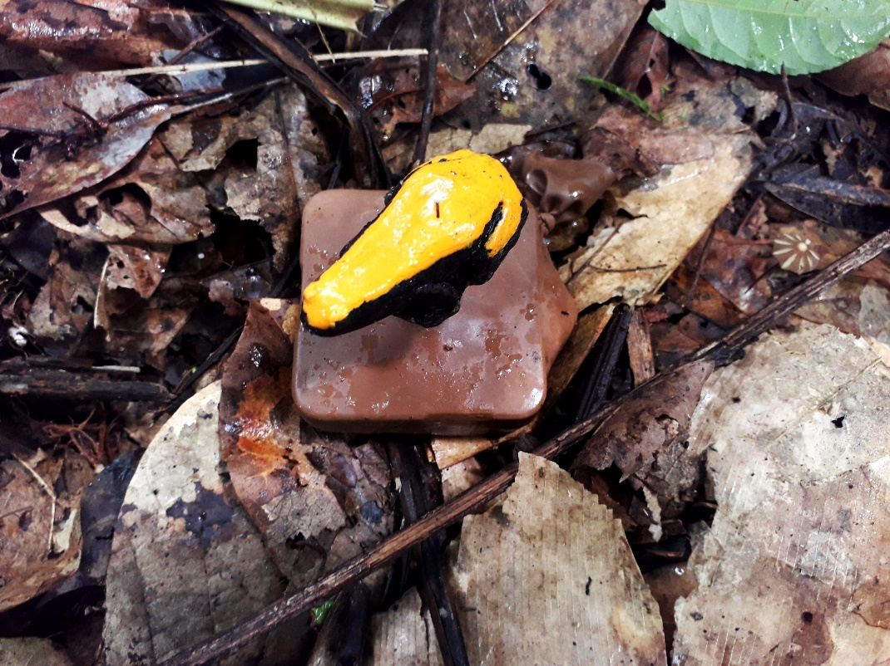
Figure A1. Photograph of model in in the field.

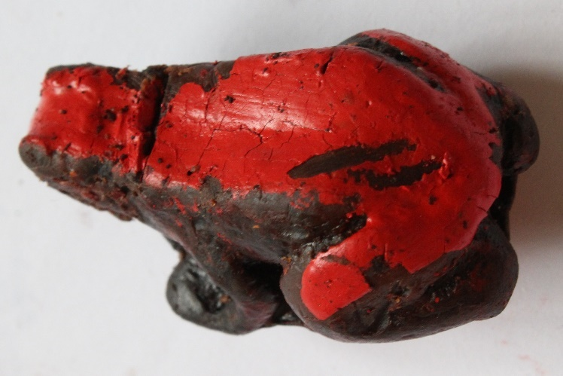
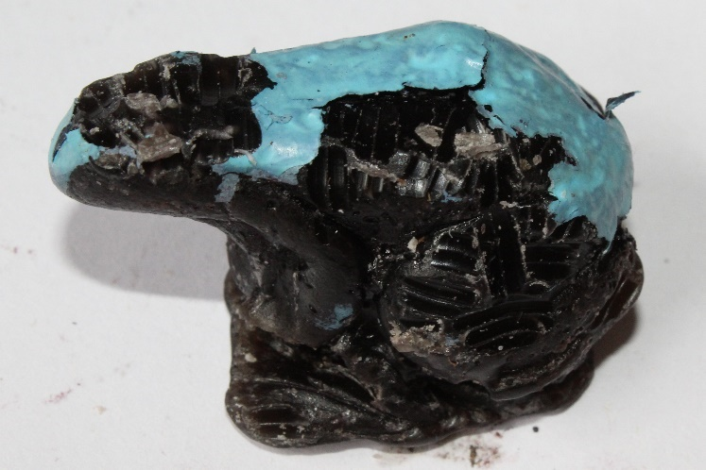
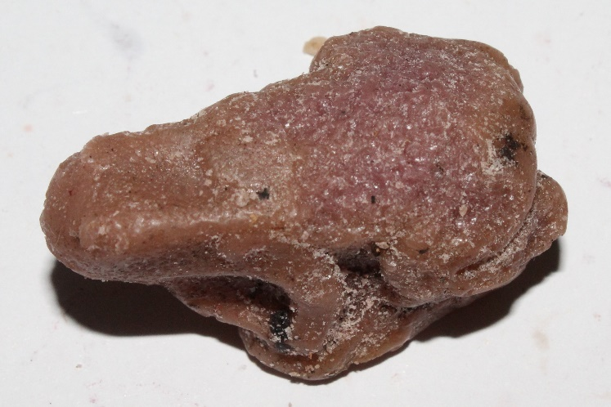
Figure A2. Photographs of examples of attack marks. From top to bottom: Bird attack, mammal attack, invertebrate attack.

Table A1. Results of GLM and Tukey test between predation of each type of predator for colour category and location

 | Estimate | SE | z value | p value
GLM: Bird attack
Intercept | -1.9399 | 0.2477 | -7.831 | –
Colour
Non-local–cryptic | 0.1708 | 0.3214 | 0.531 | 0.595
Local–cryptic | 0.2314 | 0.3190 | 0.726 | 0.468
Location (Brasil Novo, Trairão) | -1.3176 | 0.2954 | -4.460 | <0.001
Tukey test: Bird attack
Non-local –cryptic | 0.17082 | 0.32144 | 0.531 | 0.856
Local –cryptic | 0.23145 | 0.31898 | 0.726 | 0.748
Local –non-local | 0.06062 | 0.30555 | 0.198 | 0.979
GLM: Mammal attack
Intercept | -4.5782 | 0.7375 | -6.208 | –
Colour
Non-local–cryptic | 1.3867 | 0.7960 | 1.742 | 0.0815
Local–cryptic | 1.1006 | 0.8218 | 1.339 | 0.1805
Location (Brasil Novo, Trairão) | -0.5272 | 0.5228 | -1.009 | 0.3132
Tukey test: Mammal Attack
Non-local –cryptic | 1.3867 | 0.7960 | 1.742 | 0.185
Local –cryptic | 1.1006 | 0.8218 | 1.339 | 0.367
Local –non-local | -0.2861 | 0.5481 | -0.522 | 0.858
GLM: Invertebrate Attack
Intercept | -3.1939 | 0.4213 | -7.581 | –
Colour
Non-local–cryptic | 1.3063 | 0.4755 | 2.747 | 0.006
Local–cryptic | 1.5646 | 0.4660 | 3.357 | <0.001
Location (Brasil Novo, Trairão) | -1.4559 | 0.3493 | -4.169 | <0.001
Tukey test: Invertebrate Attack
Non-local–cryptic | 1.3063 | 0.4755 | 2.747 | 0.016
Local–cryptic | 1.5646 | 0.4660 | 3.357 | 0.002
Local–non-local | 0.2583 | 0.3135 | 0.824 | 0.683

