Appendix to BEH 3765: An observation of attempted infanticide and female–female cooperation in wild plains zebras (Equus quagga)

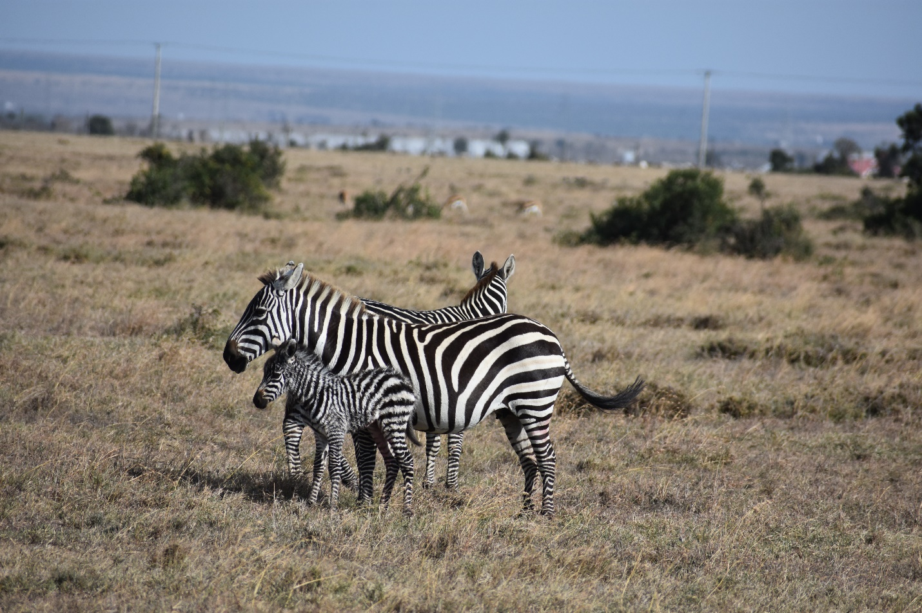
Figure A1. Matilda (front) and Elanor (back) when first sighted. Photo by S. Hex.

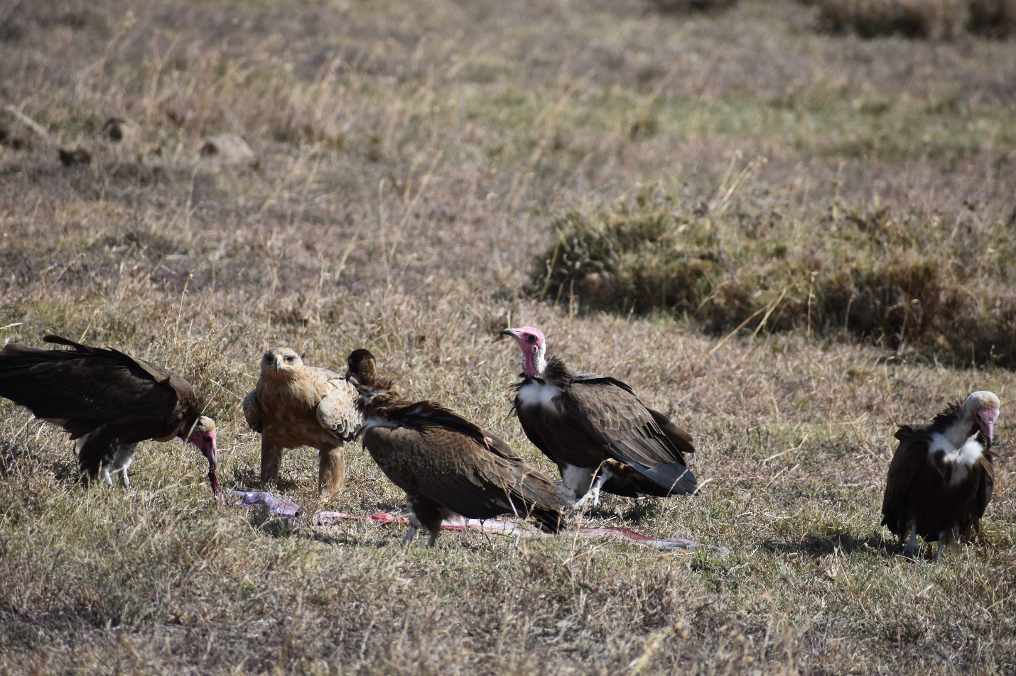
Figure A2. White-headed vultures (Triconoceps occipitalis) and a raptor feeding on fresh placenta. Photo by S. Hex.

Video A1. Example of Matilda (right) interposing between the foal and Aethelwulf (left). Video by M. Ng’aske. https://youtu.be/LCPVy6KspEQ
Video A2. Matilda (right) attacking Aethelwulf (left), who attacks at 0.12 seconds. Elanor interposes at 0.15 seconds. Video by M. Ng’aske. https://youtu.be/v4ZSzC3DCQ4
Video A3. Aethelwulf pursues and attacks Matilda, who swings her rump into him and kicks while keeping herself between him and the foal. Video by M. Ng’aske. https://youtu.be/IoAJq2EgBTE
Video A4. Aethelwulf pursues and attacks Matilda as she tries to pass him. Video by M. Ng’aske. https://youtu.be/JvMP5xNGa2E

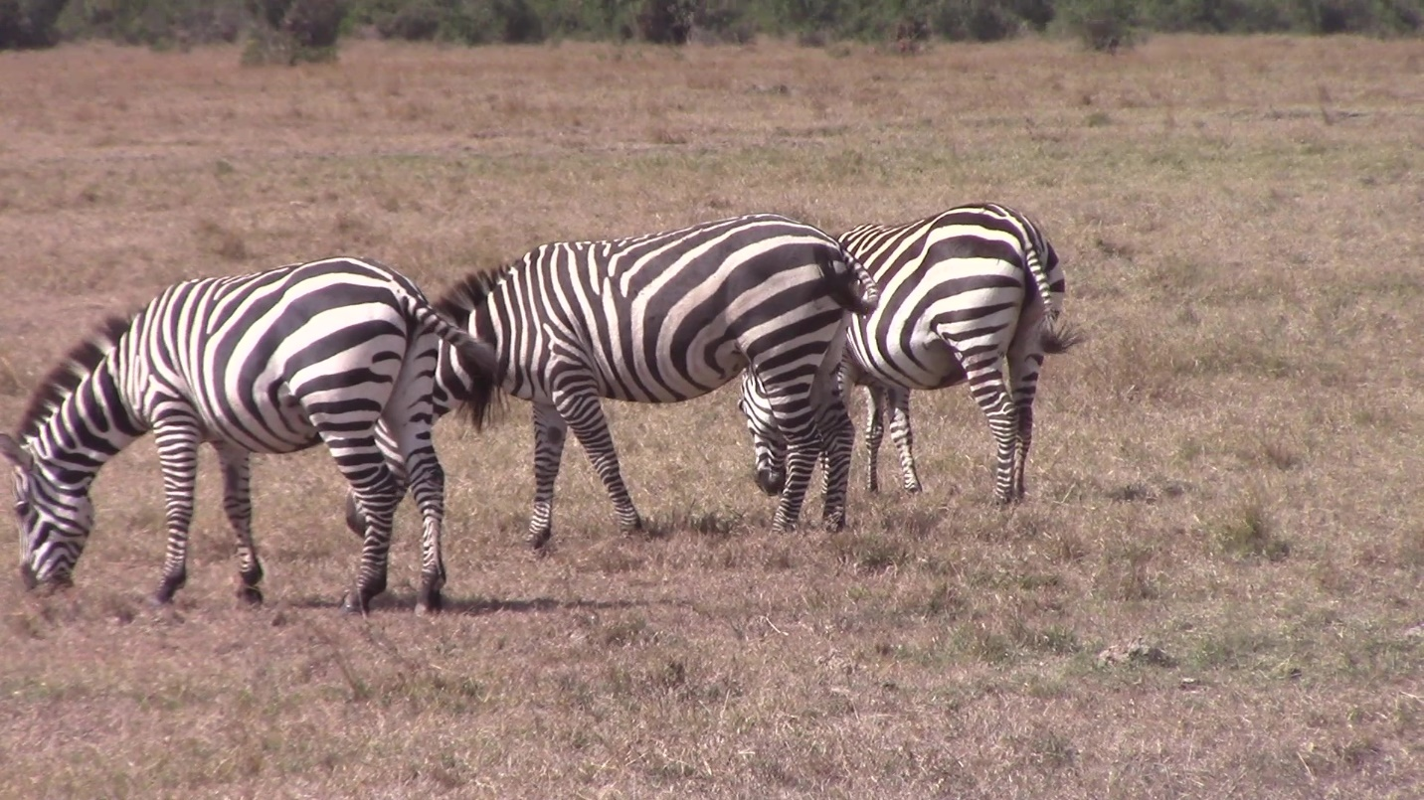
Figure A3. Elanor (middle) interposed between Aethelwulf (left) and Matilda (right) while grazing. Still from video by M. Ng’aske.

Video A5. Elanor (center) interposing between Matilda (left) and Aethelwulf (right). Video by M. Ng’aske. https://youtu.be/CLF6JOrZ3vg
Video A6. Elanor remaining interposed between Aethelwulf (front) and Matilda (back) as she moves locations. Video by M. Ng’aske. https://youtu.be/HmnXCgbdkgo
Video A7. Elanor remaining between Matilda (background) and Aethelwulf (foreground) as Matilda begins to travel. She pushes Aethelwulf away at 0.12 seconds. Video by M. Ng’aske. https://youtu.be/-kuUGBPRI9c
Video A8. Elanor interposes and kicks at Aethelwulf as Matilda moves past. Aethelwulf attacks Matilda at 0.07 seconds and Elanor interposes at 0.12 seconds. At 0.33 seconds Matilda tries to run past Aethelwulf and Elanor interposes, kicking Aethelwulf as they pass. At 0.45 seconds Aethelwulf attacks Elanor. Video by M. Ng’aske. https://youtu.be/9bF7nvax6S4
Video A9. Elanor with a foal born on August 20th, 2021, to Victoria of the Aristocrat’s harem. Video by S. Hex. https://youtu.be/DRl4zKw29Ig

Figure A4. Habitat preferences by harems and bachelor groups. Habitat preferences are calculated using Ivlev’s Electivity Index (Ivlev, 1961), calculated as E_{i} = (r_{i}–p_{i})/(r_{i}+p_{i}), where r_{i} equals proportion of time that the group is found in the i-th habitat, and p_{i} equals the proportion of the i-th habitat in the environment. Values range from +1 to –1, where positive values indicate strong preference, and negative values indicate strong avoidance. We denote strong differences from the null pattern of no selectivity as greater or less than 10%.

Reference
Ivlev. V.S. (1961). Experimental ecology of the feeding of fishes. — Yale University Press, New Haven, CT.

