Appendix

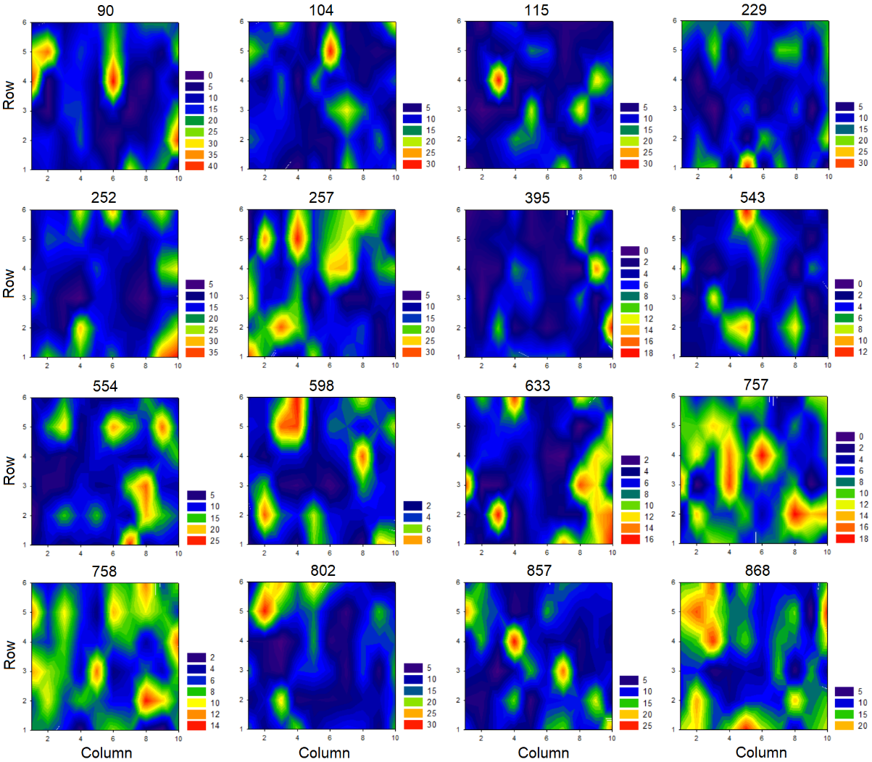
Figure A1. Mean distribution of pecks across days 8 to 10 at post-test for each pigeon. It is important to note that, contrary to similar figures in the paper, the legends are not equivalent for each individual (e.g., red does not necessarily correspond to the same number of pecks between two individuals). So, the pigeons cannot be compared directly. Here, the point is to visualize the distribution of their pecks within their own range of responses. Homogenizing the legends would lead to problematic loss of information in this respect.

