Supplementary Material

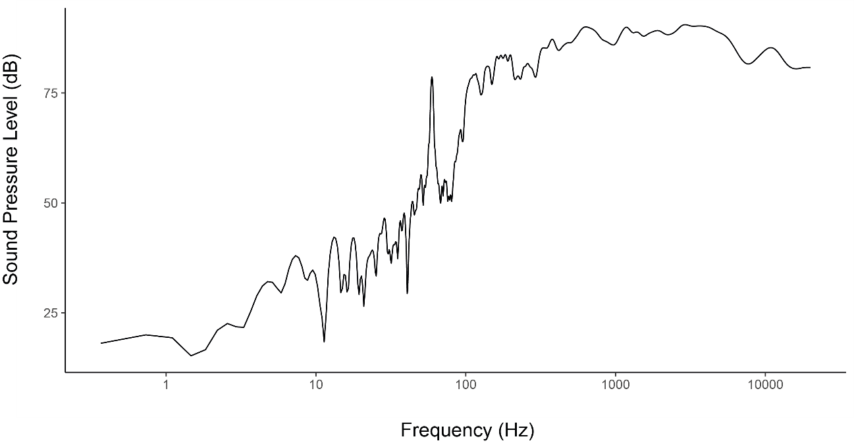
Figure A1. Frequency response of speakers used in the experiment (Frequency axis is in log scale).

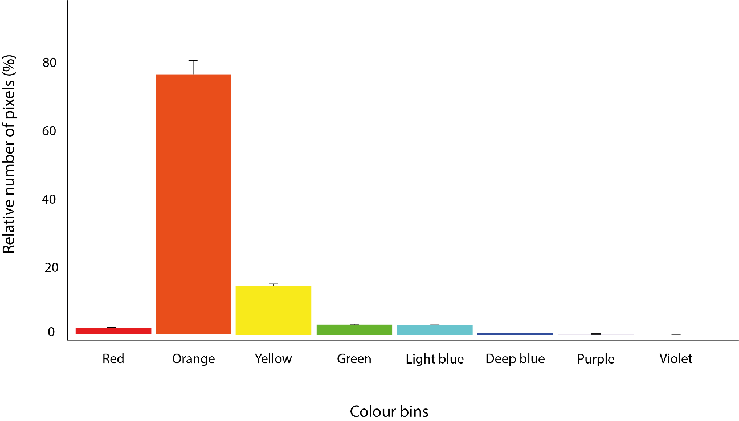
Figure A2. Average percentage of pixels in each colour bin of photographs with their respective 5% confidence interval.

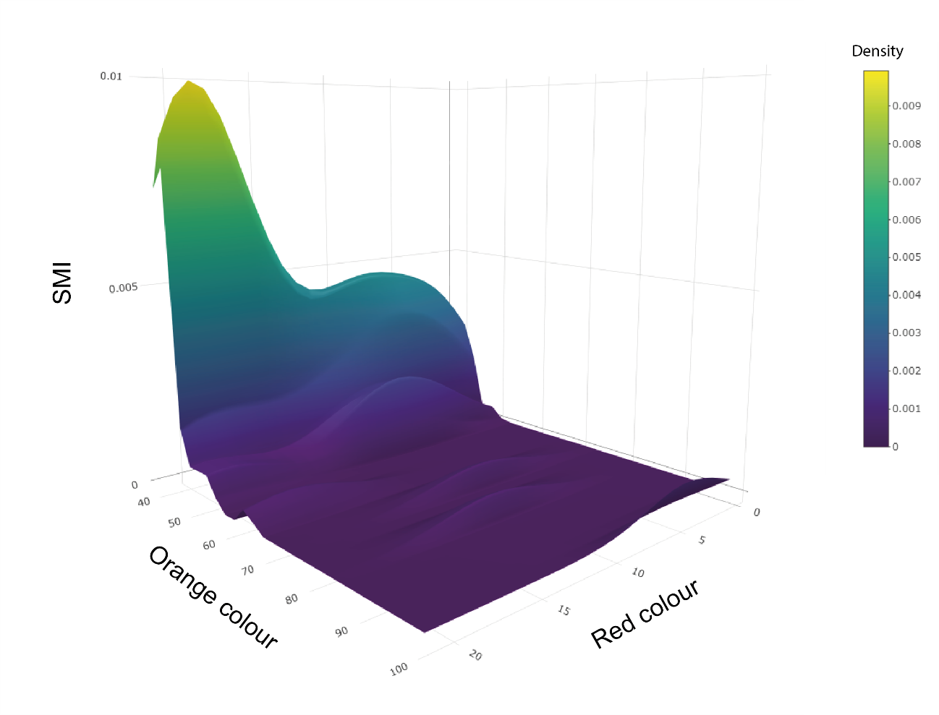
Figure A3. Density plot between Scaled Mass Index (SMI) and orange and red colours.

